Candy Crushers

STUDENT TARGETS
- Skill: I will work to stand up or knock down as many cones as possible during the activity.
- Cognitive: I will identify ways to move safely in the activity space during the activity.
- Fitness: I will work to stay actively engaged and increase my heart rate.
- Social/Emotional: I will use positive and encouraging communication with my classmates.

EQUIPMENT & SET-UP | 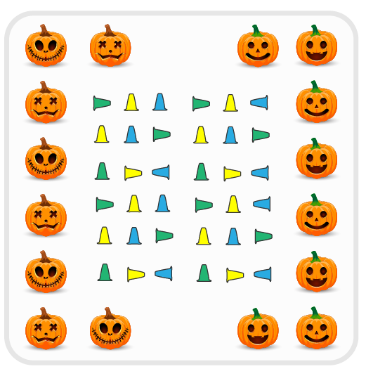
Equipment:
- As many cones as possible
- Music and music player

Set-Up:
- Divide the class in half and create two teams.
- Scatter cones throughout the activity space, with half of them standing up and half of them laying on their side (knocked over).
- Set up a boundary around the perimeter of the activity space. Students will begin outside of the boundary markers, spaced safely apart from each other.
ACTIVITY PROCEDURES
- This activity is called Candy Crushers! The object of the game is to either stand up or knock down as many pieces of candy (cones) as you can for your team. You do that by safely using one hand to either pick up or knock down a cone, depending on what role your team has been assigned.
- One team will be the Candy Crushers, who will be trying to knock down as many cones as they can while the music plays. The other team will be the Candy Creators, and they will be standing up as many cones as possible while the music plays.
- When the music starts, the Candy Crushers will begin using one hand to knock cones over and the Candy Creators will work to stand up the cones as all of you move safely through the activity space.
- When the music stops, we will work together to count how many cones are standing up and how many are knocked down. The team with the most cones up or down wins!
- We will switch roles for the second round before we play again.

DEBRIEF QUESTIONS
- DOK 1: What does positive and encouraging communication sound like?
- DOK 2: What is an example of positive or encouraging communication you heard during the game?
- DOK 3: How does positive and encouraging communication impact the way a team interacts and works together?

PRIORITY OUTCOMES
Social Interaction:
- Grades K-2: Discusses ways to encourage others to be physically active with friends.
- Grades 3-5: Describes the positive social interactions that come when engaged with others in physical activity.

