Pass the Pumpkin Relay

STUDENT TARGETS
- Skill: I will successfully complete basketball bounce passes with my teammates.
- Cognitive: I will discuss the importance of aerobic capacity.
- Fitness: I will pace my activity to try and work within my target heart rate zone.
- Social/Emotional: I will cooperate with and encourage my teammates during the activity.

EQUIPMENT & SET-UP | 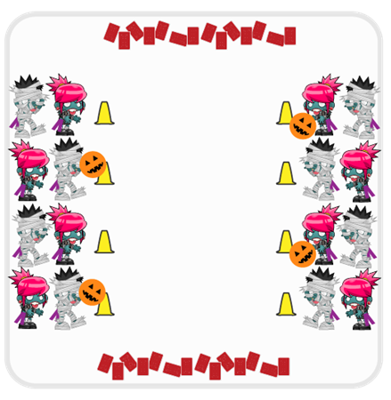
Equipment:
- 1 playground ball or basketball per team
- 2 cones per team
- Decks of playing cards

Set-Up:
- Create teams of 4 players.
- Create two parallel lines of cones on opposite sides of activity area. Each team of 4 will have 2 students start on each side of the activity area at a cone directly across from each other.
- One side of the activity area will have a ball by each cone.
- Scatter playing cards on each end of the parallel lines of cones face down.
ACTIVITY PROCEDURES
- This activity is called Pass the Pumpkin Relay! The object of the game is to pass the pumpkin (ball) across the activity area as many times as possible so you can collect playing cards. You do that by working together with your teammates relay-race style to take turns passing the pumpkin.
- Your team of 4 is split into two smaller groups that are directly across from each other.
- On the start signal, one player from each team uses a basketball bounce pass to pass the pumpkin (ball) across the activity area to their teammates. After the pass, they will go to the back of the line and their teammate will move to the front and get ready to receive a pass.
- Once the pumpkin is passed successfully to a teammate 3 times, the passer will then go to the card area and choose one playing card and bring it back to their cone. A successful pass is one where the ball bounces only 1 time before a teammate catches it. Passes do not have to be in a row.
- Teams continue to pass the pumpkin back and forth and collect playing cards until you hear the stop signal.
- Each team will then add up all of the points from the playing cards you collected. A 3 of hearts equals 3 points, etc. and all face cards are worth 10 points! The team with the most points wins that round.

DEBRIEF QUESTIONS
- DOK 1: What is aerobic capacity?
- DOK 2: How is aerobic capacity related to your ability to do the things you like to do?
- DOK 3: What are some ways you could improve your aerobic capacity?

PRIORITY OUTCOMES
Fitness Knowledge:
- Grades K-2: Identifies physical activities that contribute to fitness.
- Grades 3-5: Describes the concept of fitness and provides examples of physical activity to enhance fitness.

