Pumpkin Tic-Tac-Toe

STUDENT TARGETS
- Skill: I will move safely to and from the starting cone to the game grid.
- Cognitive: I will discuss why it is important to have self-control during the activity.
- Fitness: I will work to increase my heart rate during this activity.
- Social/Emotional: I will demonstrate self-control while competing and having fun.

EQUIPMENT & SET-UP | 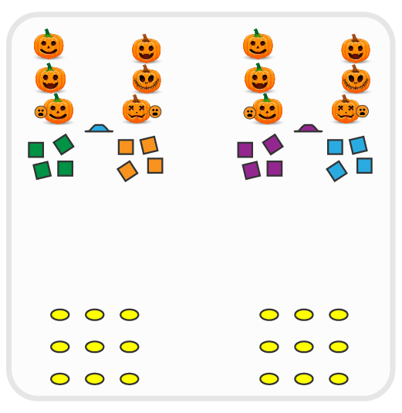
Equipment:
- 9 spot markers per 2 teams of students
- 4 beanbags of a matching color per team
- 1 low profile cone per 2 teams
- 1 basketball or playground ball per team

Set-Up:
- For each team, place 1 set of 9 spot markers in a 3X3 grid on one end of the activity area.
- Place 1 low profile cone 10 yards (or more) from the spots as a starting line.
- Organize 2 teams of 2-4 students at each cone. Each team has a set of 5 bean bags of a matching color, but different than their opponent, and one ball.

ACTIVITY PROCEDURES
- This activity is called Pumpkin Tic-Tac-Toe. The object of the game is for your team use your bean bags to create tic-tac-toe and win the game.
- On the start signal, the first player on each team will dribble the pumpkin (ball) to the pumpkin patch (game grid) and place a bean bag on a spot marker.
- Teacher Note: you could have students dribble a foam ball with their feet versus dribbling with their hands if needed.
- As soon as the first player returns and gives the second player the ball, the second player dribbles down with another bean bag and places it strategically on the game grid.
- Both teams continue in this way until the game grid is full or a team creates tic-tac-toe.
- If a game is completed before the stop signal sounds, clear the game grid and start a new game.

DEBRIEF QUESTIONS
- DOK 1: What is self-control?
- DOK 2: How did you demonstrate self-control during this game?
- DOK 3: If you or a teammate was not demonstrating self-control during the game, how could that impact your team’s ability work together?

PRIORITY OUTCOMES
Personal Responsibility and Safety:
- Grades K-2: Works independently and safely in physical education.
- Grades 3-5: Exhibits responsible behavior in independent group situations.

