Hungry Pumpkins

STUDENT TARGETS
- Skill: I will apply chasing, fleeing, and dodging strategies during the activity.
- Cognitive: I will identify the muscles being strengthened during the activity.
- Fitness: I will continue moving during the game in an effort to increase my heart rate.
- Social/Emotional: I will demonstrate good sportsmanship if tagged.

EQUIPMENT & SET-UP | 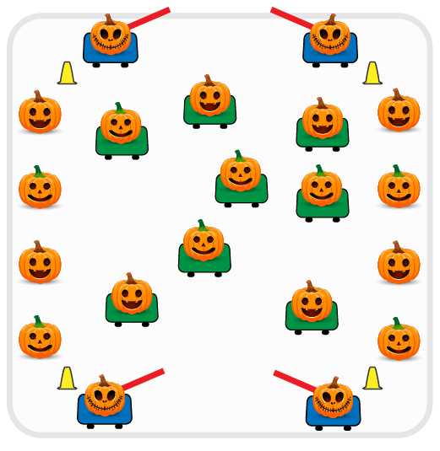
Equipment:
- 4 foam noodles for taggers
- 4 scooters for taggers, and 1 scooter per team of 2 students
- Cones for boundaries
Set-Up:
- Identify 4 students to begin as taggers and have them sit on scooters just outside of the boundary cones, holding foam noodles.
- Place cones around perimeter of activity area, scooters spread out inside of boundary cones.
- Create teams of 2 players. Each team of 2 will have one person begin on the scooter in the middle, and the remaining teammate stands outside of the boundary cones.
ACTIVITY PROCEDURES
- This activity is called Hungry Pumpkins! The object of the game is to use chasing, fleeing and dodging skills to tag as many people as possible or avoid being tagged. You do that by moving in various pathways and directions while on a scooter.
- Get ready by having one teammate on a scooter in the middle, and the other teammate will stand just outside of the boundary cones.
- On the start signal, the Hungry Pumpkins (4 taggers) will begin looking for their dinner by trying to tag players on a scooter with the foam noodles. If a player is tagged, they have been turned into dinner for the hungry pumpkins! The tagged player must stand up and carry their scooter outside of the activity area in order to trade places with their teammate. Their teammate will join in the game by sitting down on the scooter and trying to avoid being tagged by the hungry pumpkins. The tagged player will skip one lap around the perimeter of the boundary cones, and then cheer on their teammate to encourage them to not be caught by the hungry pumpkins!
- Teacher Note: If you have enough scooters, you can have the entire class participate at once versus rotating with a partner.
- Teams will continue to trade places each time a teammate is tagged until you hear the stop signal. We will switch out the taggers every few minutes and start a new game.

DEBRIEF QUESTIONS
- DOK 1: Which muscles did you feel were working the hardest while you were on a scooter?
- DOK 2: Which component(s) of health-related fitness were we working to enhance today?

PRIORITY OUTCOMES
Fitness Knowledge:
- Grades K-2: Identifies physical activities that contribute to fitness.
- Grades 3-5: Identifies activities that require and/or improve the components of fitness.

