The Great Pumpkin Hunt

STUDENT TARGETS
- Skill: I will demonstrate safe behaviors while hunting for pumpkins.
- Cognitive: I will discuss grit and determination with my classmates.
- Fitness: I will increase my heart rate during this activity.
- Social/Emotional: I will demonstrate determination by working with my team to hunt for pumpkins.

EQUIPMENT & SET-UP | 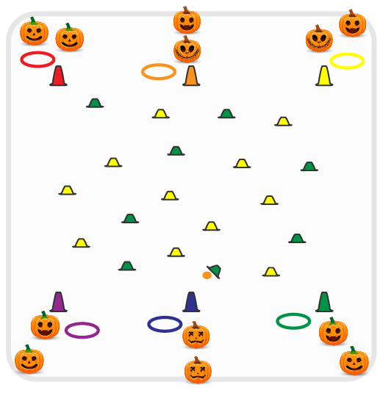
Equipment:
- As many cones as possible (50-100)
- As many colored yarn balls or bean bags as there are cones, with 10 of them orange yarn balls or “pumpkins”
- 1 cone and hula hoop per team
Set-Up:
- Create teams of 2 students. Each team begins at a cone with a hoop.
- Scatter cones in center of activity area with colored or orange yarn balls/bean bags hidden under each of the cones.
- Place starting cones and a hula hoop for each team around the perimeter of the activity area.
ACTIVITY PROCEDURES
- This activity is called The Great Pumpkin Hunt! The object of the game is for your team to collect as many pumpkins (orange yarn balls) as you can.
- On the start signal, teams will send 1 student (relay race format) out into the pumpkin patch to hunt for pumpkins. Student will choose one cone to look under, hoping it is a pumpkin (orange yarn ball)!
- Whatever is hidden under that cone will be brought back and put into your team’s hula hoop by your starting cone. But remember, some cones won’t have anything hidden under them if another team has already chosen to look under that cone. If the cone you chose was empty, you can continue hunting for pumpkins until you find something to bring back for your team.
- When you return to your team’s cone, the next teammate moves out to hunt for a pumpkin.
- Continue rotating pumpkin hunters from your team until you hear the stop signal.
- The orange pumpkins (orange yarn balls) are worth 5 points, and all of the other pumpkins are worth 1 point. We will count to see which team has the most points after each round.

DEBRIEF QUESTIONS
- DOK 1: In your own words, what does determination mean?
- DOK 2: How does it make you feel if you (or your team) are successful during an activity?
- DOK 3: How are grit and determination related to success and how much you enjoy an activity?

PRIORITY OUTCOMES
Personal Enjoyment:
- Grades K-2: Describes positive feelings that result from physical activity participation.
- Grades 3-5: Reflects on the reasons for enjoying selected physical activities.

