FOOD COLLECTORS

STUDENT TARGETS
- Skill: I will demonstrate safe behaviors and pacing during the activity.
- Cognitive: I will discuss integrity and fair play.
- Fitness: I will increase my heart rate during this activity.
- Social/Emotional: I will demonstrate integrity by following all rules of the game.

EQUIPMENT & SET-UP | 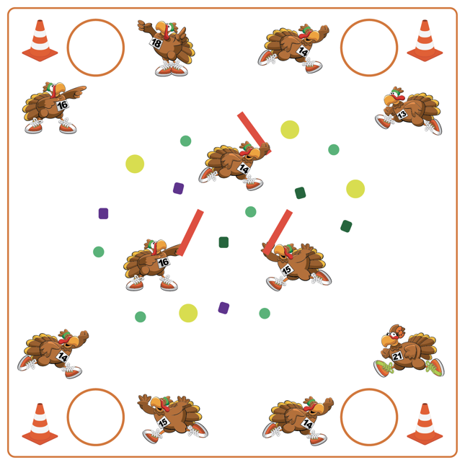
Equipment:
- 1 Hoop per team
- 1 Cone per team
- Variety of tossables (fluff balls, bean bags, etc.)
- 3-4 foam noodles for taggers
- Scooters (optional)

Set-Up:
- Use cones as the perimeter to build a “farm”. Scatter Garden Heroes, fluff balls, and bean bags throughout the center of the farm.
- Create teams of 2-3 students, with each team beginning at a cone. Place 1 food basket (hoop) by each team’s starting cone.
- Designate 2-4 students as farmers with noodles.

ACTIVITY PROCEDURES
- This activity is called Food Collectors! The object of the game is for each team to collect as many pieces of food as possible while avoiding the farmers.
- When the music starts, 1 player per team will enter the farm (either on foot or on scooters). The game is played in relay format. Students who are in the farm can collect 1 piece of food at a time and return it to their team’s food basket (hula hoop). If tagged by a farmer with a foam noodle, students must return to their team empty handed.
- When the music stops, we will count our food to see which team has the most.

DEBRIEF QUESTIONS
- DOK 1: What is integrity?
- DOK 2: How is integrity related to fair play during our games and activities?
- DOK 3: How does integrity help you be a better teammate?

PRIORITY OUTCOMES
Personal Responsibility and Safety:
- Grades K-2: Works independently and safely in physical education.
- Grades 3-5: Engages in physical activity with responsible interpersonal behavior (e.g., peer to peer and student to teacher).

