LET’S GIVE THANKS

STUDENT TARGETS
- Skill: I will perform each activity or task as described on the task card.
- Cognitive: I will define emotional health and discuss ways to enhance personal emotional health.
- Fitness: I will participate safely in each activity or task after rolling the dice.
- Social/Emotional: I will discuss the connections between physical activity and emotional health.

EQUIPMENT & SET-UP | 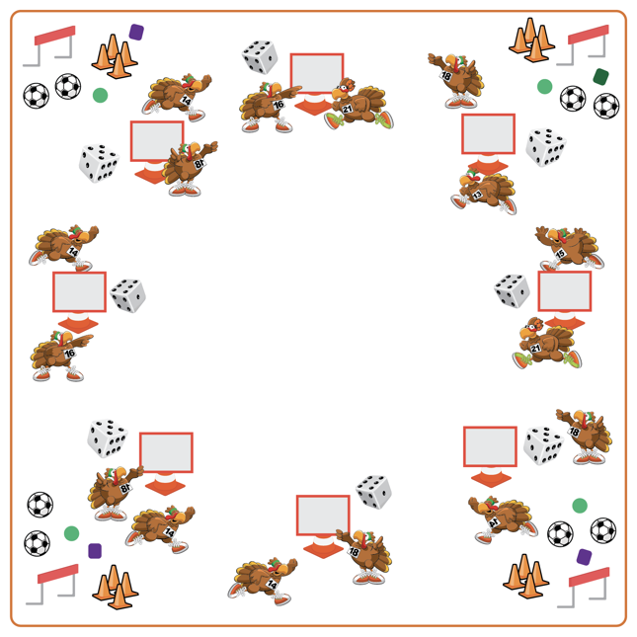
Equipment:
- Cones for boundaries
- Dice for each team of 3-4 students
- Tossables to throw/catch
- Hurdles
- Soccer balls and cones for soccer goals
- Let’s Give Thanks Task Card and Task Tent

Set-Up:
- Place cones in an activity circle. Place hurdles, tossables for throwing/catching, and soccer balls/cones for soccer goals in different areas outside of the cones.
- Create teams of 3-4. Each team at a cone.
- Each team with a Task Tent, Let’s Give Thanks Task Card, and one die at the starting cones.
ACTIVITY PROCEDURES
- This activity is called Let’s Give Thanks! The object of the game is to work with your team to complete the activities on the task card each time someone rolls the die.
- Get ready with your team by a cone. This is where you will take turns rolling the die and where you will come back to after completing each task.
- On the start signal, use the Let’s Give Thanks Task Card to identify activities that correspond to the number that was rolled, and then complete the activity displayed on the card. The entire team must complete the activity that corresponds to the number rolled. As soon as the activity is complete, your team will return to your starting cone and a new teammate will roll the die.
- The activity will continue until you hear the stop signal.

DEBRIEF QUESTIONS
- DOK 1: What is emotional health?
- DOK 2: How does physical activity affect emotional health?
- DOK 3: What personal experiences would you select to support physical activity’s effect on emotional health? Can you elaborate on why you chose that experience?

PRIORITY OUTCOMES
Etiquette:
- Grades K-2: Exhibits the established protocols for class activities without reminders.
- Grades 3-5: Exhibits etiquette and adherence to rules in a variety of physical activities.

