CATCH THE TURKEY

STUDENT TARGETS
- Skill: I will apply chasing, fleeing, and dodging strategies during the activity.
- Cognitive: I will identify the muscles being strengthened during the activity.
- Fitness: I will continue moving during the tag game in an effort to increase my heart rate.
- Social/Emotional: I will demonstrate good sportsmanship if tagged.

EQUIPMENT & SET-UP | 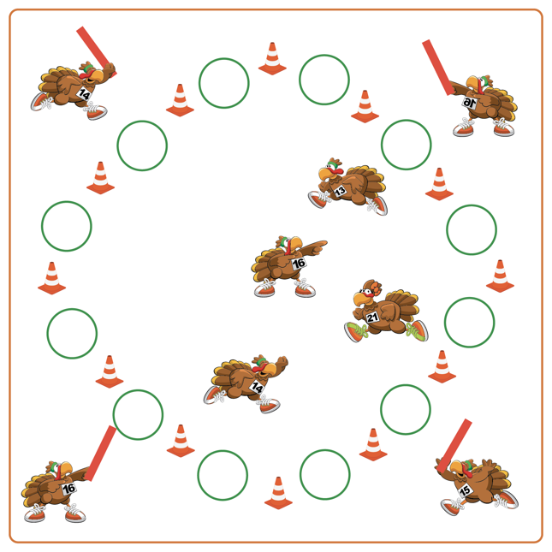
Equipment:
- 4 Foam noodles for taggers
- 12 Hoops
- 12 Cones for boundaries

Set-Up:
- Alternate cones and hoops to create a large activity circle. Students (Turkeys) spread out inside of the boundary cones/hoops.
- Teacher selects 4 students to begin as taggers. Taggers (Hunters) begin on the outside of the activity circle with a foam noodle.
ACTIVITY PROCEDURES
- This activity is called Catch the Turkey! The object of the game is for the Turkeys to avoid being tagged. You do that by using your chasing, fleeing, and dodging skills to avoid the Hunters who are trying to catch a Turkey for their family to have for Thanksgiving dinner.
- Hunters (taggers) stand just outside of the cones by the teacher while all of the Turkeys (other students) spread out in the activity area.
- On the start signal, Hunters (taggers) will use their foam noodles to tag as many Turkeys as they can. If a Turkey gets tagged, they will go to a turkey cage (hula hoop) and begin to perform squats. A Turkey can be released from their cage and return to the game if another Turkey gives them a high-5 and shares a healthy food you could eat on Thanksgiving.
- Hunters will continue to tag the Turkeys until you hear the stop signal. We will switch out the taggers every few minutes and start a new game.

DEBRIEF QUESTIONS
- DOK 1: Which muscles did you feel were working the hardest when you were tagged?
- DOK 2: Which component(s) of health-related fitness were we working to enhance today?

PRIORITY OUTCOMES
Fitness Knowledge:
- Grades K-2: Identifies physical activities that contribute to fitness.
- Grades 3-5: Identifies activities that require and/or improve the components of fitness.

