TURKEY BOWL

STUDENT TARGETS
- Skill: I will knock down the bowling target at least two times using the passing cues learned in class.
- Cognitive: I will list 3 reasons why sharing equipment and space is important in physical education as well as at other times during my day.
- Fitness: I will list at least 1 personal benefit to active participation in physical education class.
- Social/Emotional: I will list 1 reason why I enjoy being physically active – either by myself or with others.

EQUIPMENT & SET-UP | 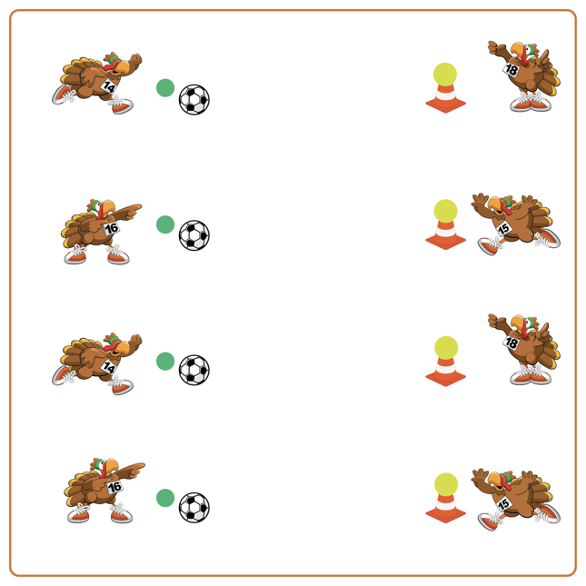
Equipment:
- 1 soccer ball for each team
- 1 foam ball for each team
- 1 cone for each team
- 1 spot marker for each team

Set-Up:
- Create 1 bowling lane for each team by placing a cone with a foam ball on top at 1 end and 1 soccer ball on a spot marker at the other end.
- Pair students in teams of 2. One student behind the cone and one student behind the soccer ball.
ACTIVITY PROCEDURES
- This activity is called Turkey Bowl! The object of the game is to see how many times out of 5 chances you can knock the turkey (ball) off of the cone using a controlled soccer pass.
- On the start signal, the first partner will attempt to pass the ball and knock the turkey down. Your partner will then return your ball and replace the turkey if it falls off the cone. After 5 tries, you and your partner will switch roles. You get one point for every turkey you knock down!
- We will continue attempting to knock down the turkeys until you hear the stop signal.

DEBRIEF QUESTIONS
- DOK 1: Why do you like being physically active?
- DOK 2: How does being physically active benefit you?
- DOK 2: How is Soccer Bowling similar to regular bowling? How is it different?
- DOK 3: How could we change this activity to create a different game that is even more active?

PRIORITY OUTCOMES
Personal Responsibility and Safety:
- Grades K-2: Follows directions for safe participation and proper use of equipment without reminders.
- Grades 3-5: Engages in physical activity with responsible interpersonal behavior (e.g., peer to peer, student to teacher).

