DRESS THE TURKEY

STUDENT TARGETS
- Skill: I will safely move in general space during the activity.
- Cognitive: I will discuss the importance of aerobic capacity.
- Fitness: I will pace my activity so that I try to work within my target heart rate zone.
- Social/Emotional: I will cooperate with and encourage my teammates during the activity.

EQUIPMENT & SET-UP | 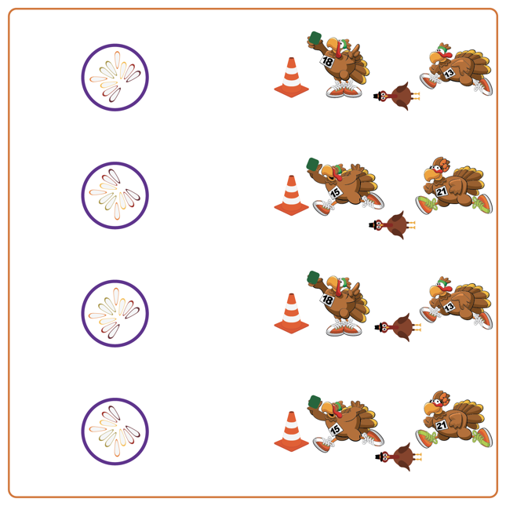
Equipment:
- 1 starting cone per team
- 1 hoop per team
- 1 Garden Heroes bean bag per team
- 1 Turkey and Feathers print out per team, and a writing utensil

Set-Up:
- Create teams of 2 players by each cone.
- Give each team a Garden Heroes bean bag and a target (e.g., hula hoop).
- Each team gets a turkey body and 10 feathers. Students write a different exercise on each feather (student choice). Place all feathers in or near the target and position students approximately 10 paces away from the target.

ACTIVITY PROCEDURES
- This activity is called Dress the Turkey! The object of the game is to complete your Turkey by collecting all of its feathers. You do that by working together with your teammates relay-race style to take turns tossing the Garden Heroes into your target (hoop) and collecting your Turkey feathers.
- On the start signal, one player from each team uses an underhand toss to attempt to toss the bean bag into the hoop. If successful, you will run to collect the bean bag and 1 feather. After returning to your cone, complete 10 reps of the exercise listed on the feather you collected (that you wrote down before we began). If you miss the target, you must walk like a turkey to get the bean bag but will not collect a feather.
- Teams continue the game until you collect all of your turkey feathers or hear the stop signal.
- Teachers: You can have exercises already written on each of the feathers (or use pictures of exercises) for K-2 students.

DEBRIEF QUESTIONS
- DOK 1: What is aerobic capacity?
- DOK 2: How is aerobic capacity related to your ability to do the things you like to do?

PRIORITY OUTCOMES
Fitness Knowledge:
- Grades K-2: Identifies physical activities that contribute to fitness.
- Grades 3-5: Describes the concept of fitness and provides examples of physical activity to enhance fitness.

