THANKSGIVING FEAST STATIONS

STUDENT TARGETS
- Skill: I will demonstrate proper form and attention to safety during each exercise.
- Cognitive: I will follow the instructions for each exercise in order to stay actively engaged.
- Fitness: I will work to keep moving and increase my heart rate during each exercise.
- Social/Emotional: I will exhibit personal responsibility during each exercise.

EQUIPMENT & SET-UP | 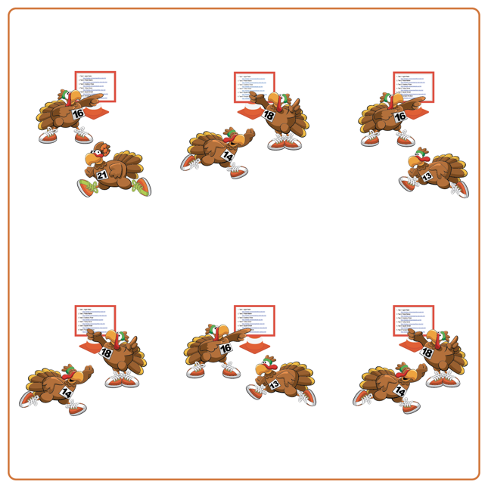
Equipment:
- Thanksgiving Feast Station Cards
(with Darebee.com links for each exercise)
- Interval music and music player
(Interval Music: Apple Music, Spotify)

Set-Up:
- Review and demonstrate each Darebee.com exercise that mimics making a feast on Thanksgiving Day.
- Have students spread out in the activity space (use spot markers if needed to identify safe distance between students).
ACTIVITY PROCEDURES
- This activity is called Thanksgiving Feast Stations! The object is to complete all of the interval stations for 30 seconds with 15 seconds of rest in between exercises.
- Teacher: Talk through and demonstrate each exercise from Darebee.com.
- When the music starts, begin completing the first Thanksgiving themed exercise for 30 seconds. We demonstrated each one earlier to help you remember the expectations and directions.
- When the music stops, you will have 15 seconds of rest before the next exercise begins. Wait until the music begins again to start the new activity.

DEBRIEF QUESTIONS
- DOK 1: Why is it important for you to be respectful and work together with your classmates to share space?
- DOK 2: What are some of the ways you exhibited personal responsibility and/or self-control during the interval activities?

PRIORITY OUTCOMES
Working with Others:
- Grades K-2: Accepts responsibility for class protocols with personal and cooperative behavior as well as performance actions.
- Grades 3-5: Accepts, recognizes, and actively involves others with both higher and lower skill abilities into physical activities and group projects.

