WILD TURKEY RALLY

STUDENT TARGETS
- Skill: I will demonstrate safe behaviors and pacing during the game.
- Cognitive: I will discuss the enjoyment of being active with family and friends.
- Fitness: I will increase my heart rate during this activity.
- Social/Emotional: I will describe the social benefits gained from participating in physical activity.

EQUIPMENT & SET-UP | 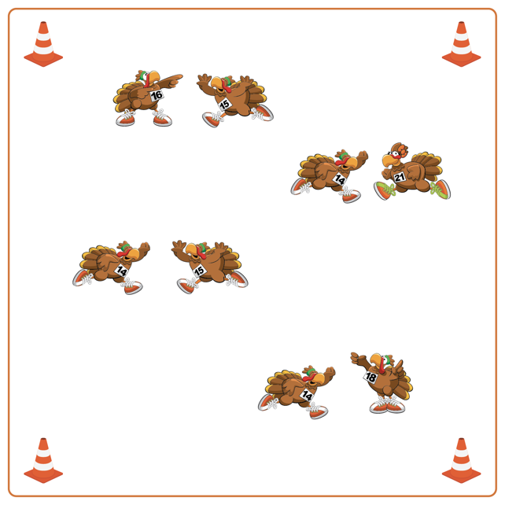
Equipment:
- Cones for boundaries
- Music player and music

Set-Up:
- Create a large activity area with cones.
- Students find a partner inside activity area, and face them ready to play Rock, Paper, Scissors.
ACTIVITY PROCEDURES
- This activity is called Wild Turkey Rally! The object of the game is to have the most consecutive Rock, Paper, Scissors victories before you hear the stop signal.
- This activity is a Thanksgiving version of Rock, Paper, Scissors. You can be a Turkey (use arms to make wings), a Pilgrim (use hands to make a hat), or an Acorn (use hands to make fists).
- Turkeys beat Acorns, Pilgrims beat Turkeys, and Acorns beat Pilgrims.
- When the music starts, you and your partner will jump 3 times and then make a symbol. The winner gets a point. You will play 3 rounds with your partner, and then move to find a new partner to compete against. Students add to their scores with each consecutive win. After a loss, you must start back at zero. Whoever has the highest score when the time ends wins!
- We will continue to play until you hear the music stop.

DEBRIEF QUESTIONS
- DOK 1: What is responsibility? How did you show responsibility during the game?
- DOK 2: Why is it important for a leader to demonstrate responsibility?

PRIORITY OUTCOMES
Social Interaction:
- Grades K-2: Discusses the enjoyment of playing with family and friends.
- Grades 3-5: Describes the social benefits gained from participating in physical activity.

