PASS THE JOY

STUDENT TARGETS
- Skill: I will perform movements with the beat and tempo of the music.
- Cognitive: I will perform dance movements in a creative dance while trying to stay with the rhythm of the music.
- Fitness: I will stay actively engaged while dancing to help improve my overall fitness level.
- Social/Emotional: I will demonstrate responsibility by moving safely and with consideration for others.

EQUIPMENT & SET-UP | 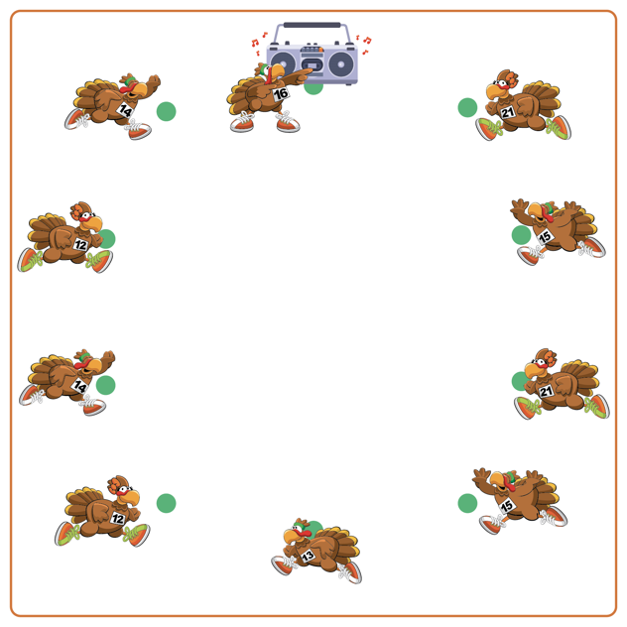
Equipment:
- 1 spot marker per student
- Music and music player for “DJ Booth”

Set-Up:
- Set up spot markers in a large circle to mimic sitting around a Thanksgiving table.
- Each student is sitting (or standing) on a spot marker.
- A “DJ Booth” is set up at one end of the Thanksgiving table where the music will be selected and played.
ACTIVITY PROCEDURES
- This activity is called Pass the Joy! The object is to take turns following the rhythm and dancing to the beat of a song as a way to celebrate everyone’s uniqueness, as well as the different ways everyone likes to dance.
- The person in charge of the music is called DJ Thanks. Everyone else will be seated (or standing) at their own spot marker that is set up in a circle like we are all sitting around a Thanksgiving table.
- DJ Thanks turns the music on, selects an appropriate song to play from a music platform, and ‘passes’ the opportunity to dance to someone else by pointing at them (or pretending to pass the Invisible Dancing Turkey, which gives the power to dance).
- As the music plays the Invisible Dancing Turkey is passed from person to person. When passed to you, dance for 8-16 beats of music and then pass to someone else. When the song is over, the last person dancing becomes DJ Thanks and gets to select a song.
- Teachers: At the end of the activity ask students to describe a dance move that someone else demonstrated that they enjoyed. We will continue to play until the music stops.

DEBRIEF QUESTIONS
- DOK 1: What movement did you most enjoy while dancing or while watching others dance?
- DOK 2: How did you choose your dance movements?
- DOK 3: Do you think your dance would have come out differently if you were given different music?

PRIORITY OUTCOMES
Personal Enjoyment:
- Grades K-2: Describes positive feelings that result from physical activity participation.
- Grades 3-5: Describes how moving competently creates enjoyment and self-expression.

