THE NIGHT BEFORE THANKSGIVING

STUDENT TARGETS
- Skill: I will actively engage in the movements during the story.
- Cognitive: I will recognize the role that etiquette plays when listening to the story.
- Fitness: I will safely participate in order to increase my heart rate and warm up my body.
- Social/Emotional: I will cooperate with my classmates in order to actively listen and move during the story.

EQUIPMENT & SET-UP | 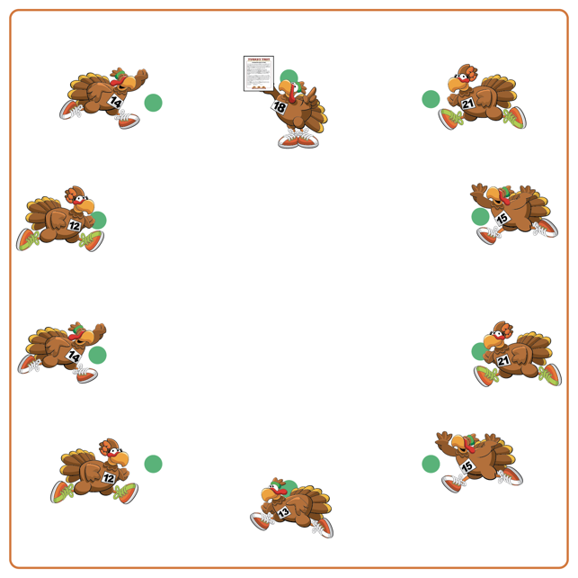
Equipment:
- 1 spot marker per student
- Copy of The Night Before Thanksgiving story

Set-Up:
- Students will each be on a spot marker, set up in a circle to mimic being seated around a Thanksgiving table.
- Teacher will have a copy of the story.
- Display list of words/movements for students around activity space.
ACTIVITY PROCEDURES
- This activity is called The Night Before Thanksgiving! The object is to practice listening skills and navigate different non-locomotor exercises and poses as a story clues you in on what movements to perform as it is being told.
- We are first going to first learn and practice all of the movements we will do as we hear them in the story. (Teachers: demonstrate each of the movements and what words they belong with, as well as post them around your teaching space if possible).
- As I read the story, you are going to demonstrate the movements that belong with each of the key words. For example, when you hear the word Turkey during the story you will demonstrate the movements that go with that word (squat down with feet shoulder width apart, chest tall, and hands outstretched like long feathers).
- Try and keep up with all of the movements during the story, and most importantly HAVE FUN!

DEBRIEF QUESTIONS
- DOK 1: What does etiquette mean?
- DOK 2: What can you share about the etiquette needed during the story?
- DOK 3: How is following activity etiquette related to being a good classmate?

PRIORITY OUTCOMES
Social Interaction:
- Grades K-2: Discusses the enjoyment of playing with family and friends.
- Grades 3-5: Describes the positive social interactions that come when engaged with others in physical activity.

