ROWS OF GRATITUDE

STUDENT TARGETS
- Skill: I will move safely in self-space to complete yoga poses.
- Cognitive: I will discuss the way my body is moving as I create shapes and balances.
- Physical Activity: I will demonstrate safe behaviors while being physically active.
- Social/Emotional: I will move safely and demonstrate concern for myself and my classmates.

EQUIPMENT & SET-UP | 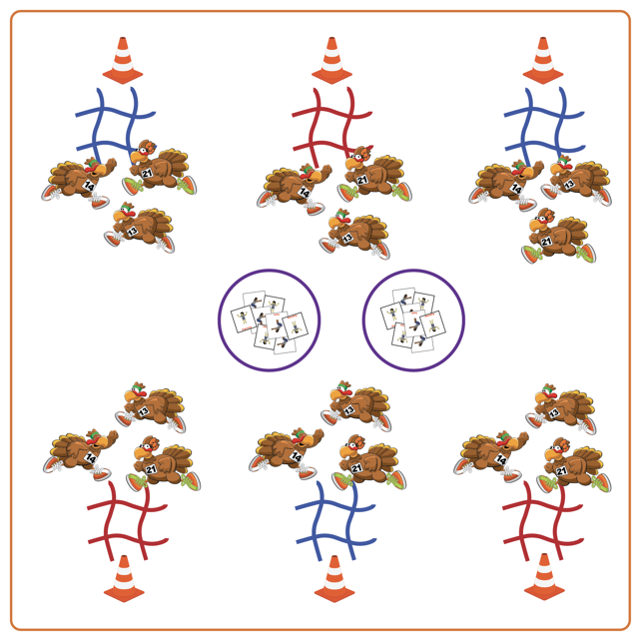
Equipment:
- Jump ropes (4 per group)
- Boundary cones/markers
- Yoga Pose Cards
- Hula hoops
Set-Up:
- Create equal teams of 3-4 students. Each team starts at a cone.
- Create a large activity area with cones around the perimeter.
- Each team should have a tic-tac-toe board made with jump ropes by their starting cone.
- Place hoops in the center of the area with Yoga Pose Cards face down.
ACTIVITY PROCEDURES
- This activity is called Rows of Gratitude! The object of the game is for a team to get three Yoga Pose Cards of the same color in a row horizontally, vertically, or diagonally for a tic-tac-toe on their board.
- On the start signal, each team sends one student at a time into the center to choose one Yoga Pose Card and bring it back to their team. The whole team does the yoga pose for 20 seconds, then decides where to place the Yoga Pose Card on the tic-tac-toe board. When done, the next team member goes to the middle for a Yoga Pose Card.
- This continues until tic-tac-toe with the same color yoga cards is achieved or the board is full.
- Yoga cards must be placed on the tic-tac-toe board each time. If board fills without getting three colors in a row, place cards back in the center of the area in a hoop (face down) and try again.

DEBRIEF QUESTIONS
- DOK 1: What does it mean to have gratitude?
- DOK 2: What are some ways you can show gratitude towards others?

PRIORITY OUTCOMES
Etiquette:
- Grades K-2: Exhibits the established protocols for class activities without reminders.
- Grades 3-5: Recognizes the role of rules and etiquette in physical activity with peers.

