GRATITUDE WREATH

STUDENT TARGETS
- Skill: I will move in general space using different pathways and speeds.
- Cognitive: I will identify the rules and etiquette for creating a gratitude wreath.
- Physical Activity: I will stay actively engaged in class in order to accumulate a maximum amount of physical activity minutes.
- Social/Emotional: I will demonstrate personal responsibility through teamwork and cooperation.

EQUIPMENT & SET-UP | 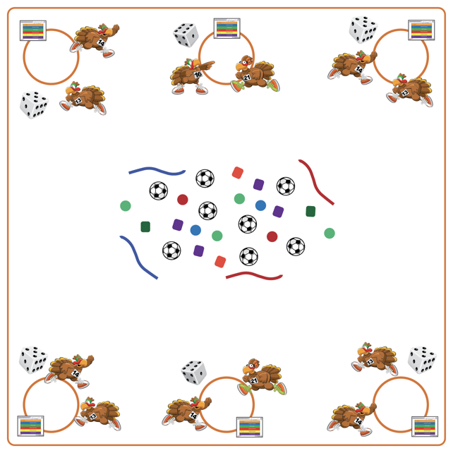
Equipment:
- Cones
- 1 hula hoop & 1 die per team
- Activity cards
- Variety of equipment to decorate wreaths (e.g., bean bags, fluff balls, jump ropes, scarves, deck rings, tennis balls)
Set-Up:
- Place a hula hoop (as base for wreath), activity card & die for each team around the perimeter of the activity space. Place a variety of equipment in the center of the teaching area for teams to choose the items they want to use to decorate their wreath.
- Create equal teams of 3-4 students. Each team starts at a hula hoop.
ACTIVITY PROCEDURES
- This activity is called Gratitude Wreath! The object is to work together as a team to create a unique gratitude wreath.
- On the start signal, one student from each team will roll the die. The entire team will perform the activity determined by the number rolled/exercise identified on the activity card. The team’s movement “earns” them one item to add to their gratitude wreath. One student from the team goes to the center of the activity area and brings one item back to add to the team’s wreath. Continue this process until wreaths are complete or until you hear the stop signal.
- Students should rotate who gets to roll the dice and which student gets to choose (and place) the item added to the wreath.

DEBRIEF QUESTIONS
- DOK 1: What does it mean to be grateful?
- DOK 2: Can someone share something about one of their group members that they are grateful for?

PRIORITY OUTCOMES
Personal Responsibility and Safety:
- Grades K-2: Works independently and safely in physical education.
- Grades 3-5: Engages in physical activity with responsible interpersonal behavior (e.g., peer to peer and student to teacher).

