THANKFUL TURKEY TOSS

STUDENT TARGETS
- Skill: I will accurately toss and catch with a partner.
- Cognitive: I will identify offensive strategies to assist with moving to open space to receive a toss.
- Physical Activity: I will recognize the positive effects that being physically active has on my body.
- Social/Emotional: I will use communication skills to help establish a positive learning environment for myself and others.

EQUIPMENT & SET-UP | 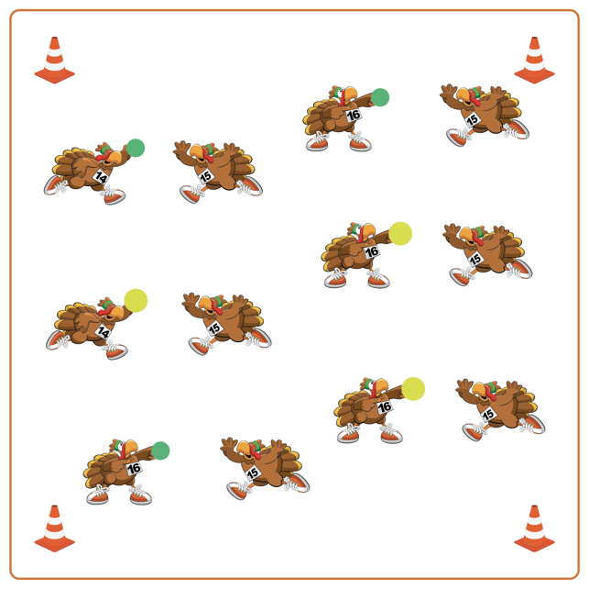
Equipment:
- 1 ball (or tossable) per 2 students
- Boundary cones/markers

Set-Up:
- Create a large activity area with cones around the perimeter.
- Students get a partner and 1 ball/tossable for the group.
- Each group will begin facing their partner, and spread out in general space inside the cones.
ACTIVITY PROCEDURES
- This activity is called Thankful Turkey Toss! The object is to overhand (for grades 3-5) or underhand (for grades K-2) toss with as many different partners as possible.
- When the music begins, the partner with the ball/tossable will begin with an overhand toss (or underhand for grades K-2) to their partner. Each pair will make 3 tosses, with the person tossing the ball stating something they are grateful for each time they toss. The partner who has the ball after 3 tosses will travel and find a new partner who does not have a ball.
- Continue to play until you hear the music stop.

DEBRIEF QUESTIONS
DOK 1: What are some things you are grateful for?
DOK 2: What are some ways you can show someone, with your words or actions, that you are grateful for them?

PRIORITY OUTCOMES
Manipulative Skills:
- Grades K-2: Demonstrates control while combining locomotor and manipulative skills in self-space and general space.
- Grades 3-5: Demonstrates manipulative skills using mature patterns for accuracy and control.

