FOOD COLLECTORS

STUDENT TARGETS
- Skill: I will demonstrate safe behaviors and pacing during the activity.
- Cognitive: I will discuss integrity and fair play.
- Fitness: I will increase my heart rate during this activity.
- Social/Emotional: I will demonstrate integrity by following all rules of the game.

EQUIPMENT & SET-UP | 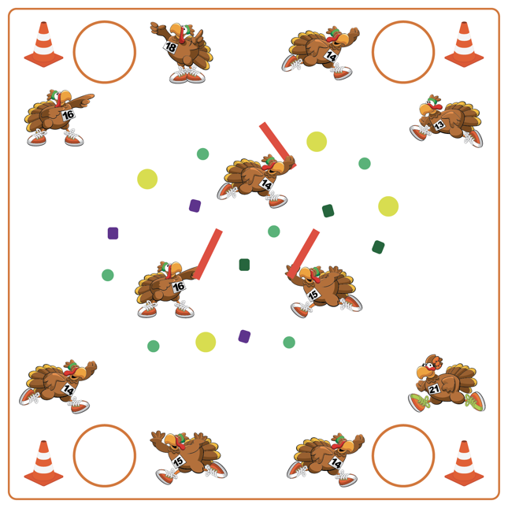
Equipment:
- 1 Hoop per team
- 1 Cone per team
- Variety of tossables (fluff balls, bean bags, etc.)
- 3-4 foam noodles for taggers
- Scooters (optional)

Set-Up:
- Use cones as the perimeter to build a “farm”. Scatter Garden Heroes, fluff balls, and bean bags throughout the center of the farm.
- Create teams of 2-3 students, with each team beginning at a cone. Place 1 food basket (hoop) by each team’s starting cone.
- Designate 2-4 students as farmers with noodles.

ACTIVITY PROCEDURES
- This activity is called Food Collectors! The object of the game is for each team to collect as many pieces of food as possible while avoiding the farmers.
- When the music starts, 1 player per team will enter the farm (either on foot or on scooters). The game is played in relay format. Students who are in the farm can collect 1 piece of food at a time and return it to their team’s food basket (hula hoop). If tagged by a farmer with a foam noodle, students must return to their team empty handed.
- When the music stops, we will count our food to see which team has the most.

DEBRIEF QUESTIONS
- DOK 1: What is integrity?
- DOK 2: How is integrity related to fair play during our games and activities?
- DOK 3: How does integrity help you be a better teammate?

PRIORITY OUTCOMES
Personal Responsibility and Safety:
- Grades K-2: Works independently and safely in physical education.
- Grades 3-5: Engages in physical activity with responsible interpersonal behavior (e.g., peer to peer and student to teacher).

LET’S GIVE THANKS

STUDENT TARGETS
- Skill: I will perform each activity or task as described on the task card.
- Cognitive: I will define emotional health and discuss ways to enhance personal emotional health.
- Fitness: I will participate safely in each activity or task after rolling the dice.
- Social/Emotional: I will discuss the connections between physical activity and emotional health.

EQUIPMENT & SET-UP | 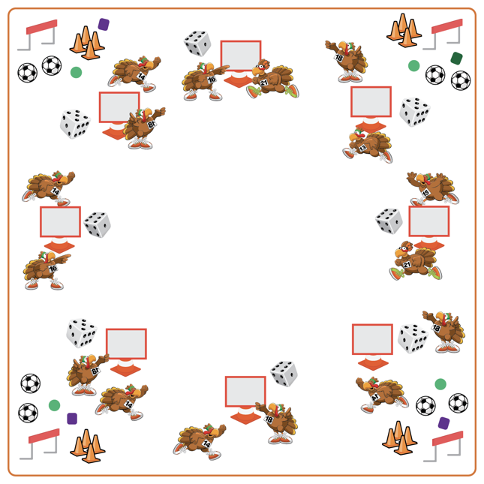
Equipment:
- Cones for boundaries
- Dice for each team of 3-4 students
- Tossables to throw/catch
- Hurdles
- Soccer balls and cones for soccer goals
- Let’s Give Thanks Task Card and Task Tent

Set-Up:
- Place cones in an activity circle. Place hurdles, tossables for throwing/catching, and soccer balls/cones for soccer goals in different areas outside of the cones.
- Create teams of 3-4. Each team at a cone.
- Each team with a Task Tent, Let’s Give Thanks Task Card, and one die at the starting cones.
ACTIVITY PROCEDURES
- This activity is called Let’s Give Thanks! The object of the game is to work with your team to complete the activities on the task card each time someone rolls the die.
- Get ready with your team by a cone. This is where you will take turns rolling the die and where you will come back to after completing each task.
- On the start signal, use the Let’s Give Thanks Task Card to identify activities that correspond to the number that was rolled, and then complete the activity displayed on the card. The entire team must complete the activity that corresponds to the number rolled. As soon as the activity is complete, your team will return to your starting cone and a new teammate will roll the die.
- The activity will continue until you hear the stop signal.

DEBRIEF QUESTIONS
- DOK 1: What is emotional health?
- DOK 2: How does physical activity affect emotional health?
- DOK 3: What personal experiences would you select to support physical activity’s effect on emotional health? Can you elaborate on why you chose that experience?

PRIORITY OUTCOMES
Etiquette:
- Grades K-2: Exhibits the established protocols for class activities without reminders.
- Grades 3-5: Exhibits etiquette and adherence to rules in a variety of physical activities.

CATCH THE TURKEY

STUDENT TARGETS
- Skill: I will apply chasing, fleeing, and dodging strategies during the activity.
- Cognitive: I will identify the muscles being strengthened during the activity.
- Fitness: I will continue moving during the tag game in an effort to increase my heart rate.
- Social/Emotional: I will demonstrate good sportsmanship if tagged.

EQUIPMENT & SET-UP | 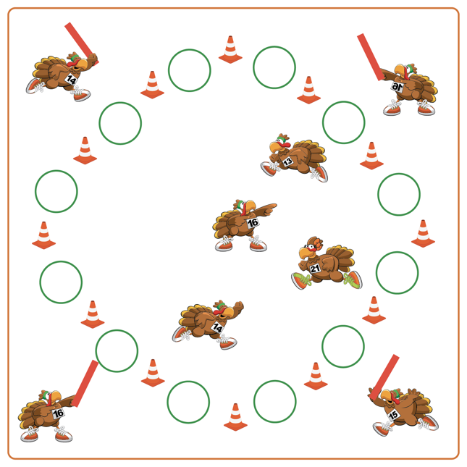
Equipment:
- 4 Foam noodles for taggers
- 12 Hoops
- 12 Cones for boundaries

Set-Up:
- Alternate cones and hoops to create a large activity circle. Students (Turkeys) spread out inside of the boundary cones/hoops.
- Teacher selects 4 students to begin as taggers. Taggers (Hunters) begin on the outside of the activity circle with a foam noodle.
ACTIVITY PROCEDURES
- This activity is called Catch the Turkey! The object of the game is for the Turkeys to avoid being tagged. You do that by using your chasing, fleeing, and dodging skills to avoid the Hunters who are trying to catch a Turkey for their family to have for Thanksgiving dinner.
- Hunters (taggers) stand just outside of the cones by the teacher while all of the Turkeys (other students) spread out in the activity area.
- On the start signal, Hunters (taggers) will use their foam noodles to tag as many Turkeys as they can. If a Turkey gets tagged, they will go to a turkey cage (hula hoop) and begin to perform squats. A Turkey can be released from their cage and return to the game if another Turkey gives them a high-5 and shares a healthy food you could eat on Thanksgiving.
- Hunters will continue to tag the Turkeys until you hear the stop signal. We will switch out the taggers every few minutes and start a new game.

DEBRIEF QUESTIONS
- DOK 1: Which muscles did you feel were working the hardest when you were tagged?
- DOK 2: Which component(s) of health-related fitness were we working to enhance today?

PRIORITY OUTCOMES
Fitness Knowledge:
- Grades K-2: Identifies physical activities that contribute to fitness.
- Grades 3-5: Identifies activities that require and/or improve the components of fitness.

TURKEY BOWL

STUDENT TARGETS
- Skill: I will knock down the bowling target at least two times using the passing cues learned in class.
- Cognitive: I will list 3 reasons why sharing equipment and space is important in physical education as well as at other times during my day.
- Fitness: I will list at least 1 personal benefit to active participation in physical education class.
- Social/Emotional: I will list 1 reason why I enjoy being physically active – either by myself or with others.

EQUIPMENT & SET-UP | 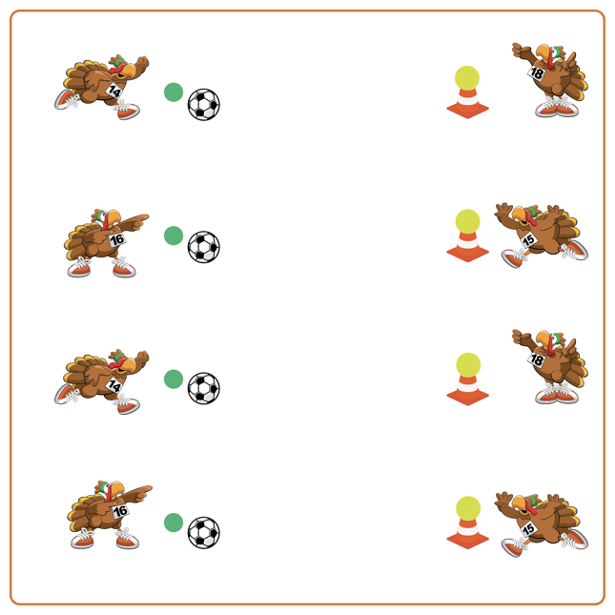
Equipment:
- 1 soccer ball for each team
- 1 foam ball for each team
- 1 cone for each team
- 1 spot marker for each team

Set-Up:
- Create 1 bowling lane for each team by placing a cone with a foam ball on top at 1 end and 1 soccer ball on a spot marker at the other end.
- Pair students in teams of 2. One student behind the cone and one student behind the soccer ball.
ACTIVITY PROCEDURES
- This activity is called Turkey Bowl! The object of the game is to see how many times out of 5 chances you can knock the turkey (ball) off of the cone using a controlled soccer pass.
- On the start signal, the first partner will attempt to pass the ball and knock the turkey down. Your partner will then return your ball and replace the turkey if it falls off the cone. After 5 tries, you and your partner will switch roles. You get one point for every turkey you knock down!
- We will continue attempting to knock down the turkeys until you hear the stop signal.

DEBRIEF QUESTIONS
- DOK 1: Why do you like being physically active?
- DOK 2: How does being physically active benefit you?
- DOK 2: How is Soccer Bowling similar to regular bowling? How is it different?
- DOK 3: How could we change this activity to create a different game that is even more active?

PRIORITY OUTCOMES
Personal Responsibility and Safety:
- Grades K-2: Follows directions for safe participation and proper use of equipment without reminders.
- Grades 3-5: Engages in physical activity with responsible interpersonal behavior (e.g., peer to peer, student to teacher).

DRESS THE TURKEY

STUDENT TARGETS
- Skill: I will safely move in general space during the activity.
- Cognitive: I will discuss the importance of aerobic capacity.
- Fitness: I will pace my activity so that I try to work within my target heart rate zone.
- Social/Emotional: I will cooperate with and encourage my teammates during the activity.

EQUIPMENT & SET-UP | 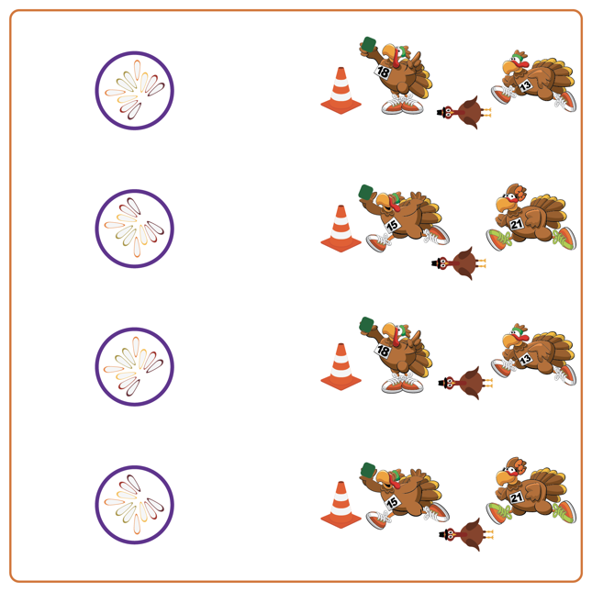
Equipment:
- 1 starting cone per team
- 1 hoop per team
- 1 Garden Heroes bean bag per team
- 1 Turkey and Feathers print out per team, and a writing utensil

Set-Up:
- Create teams of 2 players by each cone.
- Give each team a Garden Heroes bean bag and a target (e.g., hula hoop).
- Each team gets a turkey body and 10 feathers. Students write a different exercise on each feather (student choice). Place all feathers in or near the target and position students approximately 10 paces away from the target.

ACTIVITY PROCEDURES
- This activity is called Dress the Turkey! The object of the game is to complete your Turkey by collecting all of its feathers. You do that by working together with your teammates relay-race style to take turns tossing the Garden Heroes into your target (hoop) and collecting your Turkey feathers.
- On the start signal, one player from each team uses an underhand toss to attempt to toss the bean bag into the hoop. If successful, you will run to collect the bean bag and 1 feather. After returning to your cone, complete 10 reps of the exercise listed on the feather you collected (that you wrote down before we began). If you miss the target, you must walk like a turkey to get the bean bag but will not collect a feather.
- Teams continue the game until you collect all of your turkey feathers or hear the stop signal.
- Teachers: You can have exercises already written on each of the feathers (or use pictures of exercises) for K-2 students.

DEBRIEF QUESTIONS
- DOK 1: What is aerobic capacity?
- DOK 2: How is aerobic capacity related to your ability to do the things you like to do?

PRIORITY OUTCOMES
Fitness Knowledge:
- Grades K-2: Identifies physical activities that contribute to fitness.
- Grades 3-5: Describes the concept of fitness and provides examples of physical activity to enhance fitness.

THANKSGIVING FEAST STATIONS

STUDENT TARGETS
- Skill: I will demonstrate proper form and attention to safety during each exercise.
- Cognitive: I will follow the instructions for each exercise in order to stay actively engaged.
- Fitness: I will work to keep moving and increase my heart rate during each exercise.
- Social/Emotional: I will exhibit personal responsibility during each exercise.

EQUIPMENT & SET-UP | 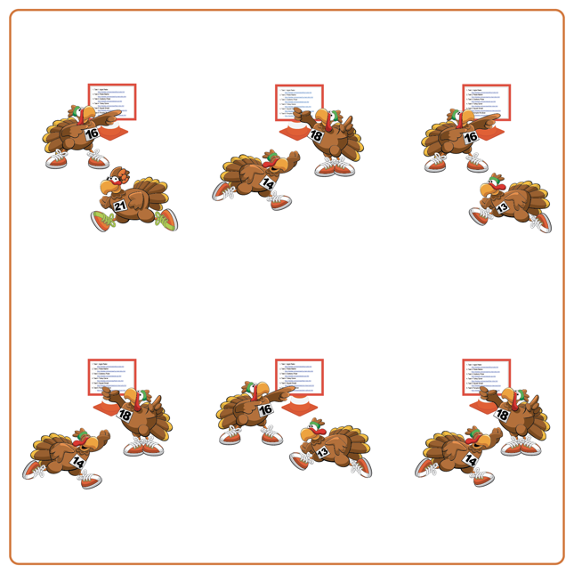
Equipment:
- Thanksgiving Feast Station Cards
(with Darebee.com links for each exercise)
- Interval music and music player
(Interval Music: Apple Music, Spotify)

Set-Up:
- Review and demonstrate each Darebee.com exercise that mimics making a feast on Thanksgiving Day.
- Have students spread out in the activity space (use spot markers if needed to identify safe distance between students).
ACTIVITY PROCEDURES
- This activity is called Thanksgiving Feast Stations! The object is to complete all of the interval stations for 30 seconds with 15 seconds of rest in between exercises.
- Teacher: Talk through and demonstrate each exercise from Darebee.com.
- When the music starts, begin completing the first Thanksgiving themed exercise for 30 seconds. We demonstrated each one earlier to help you remember the expectations and directions.
- When the music stops, you will have 15 seconds of rest before the next exercise begins. Wait until the music begins again to start the new activity.

DEBRIEF QUESTIONS
- DOK 1: Why is it important for you to be respectful and work together with your classmates to share space?
- DOK 2: What are some of the ways you exhibited personal responsibility and/or self-control during the interval activities?

PRIORITY OUTCOMES
Working with Others:
- Grades K-2: Accepts responsibility for class protocols with personal and cooperative behavior as well as performance actions.
- Grades 3-5: Accepts, recognizes, and actively involves others with both higher and lower skill abilities into physical activities and group projects.

WILD TURKEY RALLY

STUDENT TARGETS
- Skill: I will demonstrate safe behaviors and pacing during the game.
- Cognitive: I will discuss the enjoyment of being active with family and friends.
- Fitness: I will increase my heart rate during this activity.
- Social/Emotional: I will describe the social benefits gained from participating in physical activity.

EQUIPMENT & SET-UP | 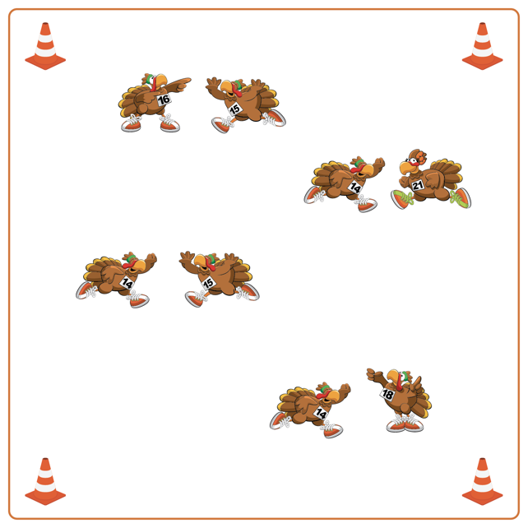
Equipment:
- Cones for boundaries
- Music player and music

Set-Up:
- Create a large activity area with cones.
- Students find a partner inside activity area, and face them ready to play Rock, Paper, Scissors.
ACTIVITY PROCEDURES
- This activity is called Wild Turkey Rally! The object of the game is to have the most consecutive Rock, Paper, Scissors victories before you hear the stop signal.
- This activity is a Thanksgiving version of Rock, Paper, Scissors. You can be a Turkey (use arms to make wings), a Pilgrim (use hands to make a hat), or an Acorn (use hands to make fists).
- Turkeys beat Acorns, Pilgrims beat Turkeys, and Acorns beat Pilgrims.
- When the music starts, you and your partner will jump 3 times and then make a symbol. The winner gets a point. You will play 3 rounds with your partner, and then move to find a new partner to compete against. Students add to their scores with each consecutive win. After a loss, you must start back at zero. Whoever has the highest score when the time ends wins!
- We will continue to play until you hear the music stop.

DEBRIEF QUESTIONS
- DOK 1: What is responsibility? How did you show responsibility during the game?
- DOK 2: Why is it important for a leader to demonstrate responsibility?

PRIORITY OUTCOMES
Social Interaction:
- Grades K-2: Discusses the enjoyment of playing with family and friends.
- Grades 3-5: Describes the social benefits gained from participating in physical activity.

PASS THE JOY

STUDENT TARGETS
- Skill: I will perform movements with the beat and tempo of the music.
- Cognitive: I will perform dance movements in a creative dance while trying to stay with the rhythm of the music.
- Fitness: I will stay actively engaged while dancing to help improve my overall fitness level.
- Social/Emotional: I will demonstrate responsibility by moving safely and with consideration for others.

EQUIPMENT & SET-UP | 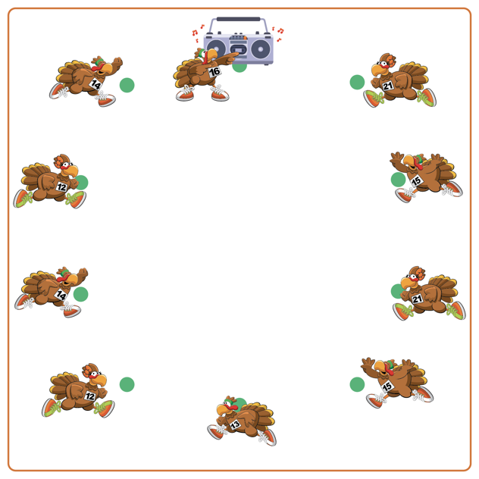
Equipment:
- 1 spot marker per student
- Music and music player for “DJ Booth”

Set-Up:
- Set up spot markers in a large circle to mimic sitting around a Thanksgiving table.
- Each student is sitting (or standing) on a spot marker.
- A “DJ Booth” is set up at one end of the Thanksgiving table where the music will be selected and played.
ACTIVITY PROCEDURES
- This activity is called Pass the Joy! The object is to take turns following the rhythm and dancing to the beat of a song as a way to celebrate everyone’s uniqueness, as well as the different ways everyone likes to dance.
- The person in charge of the music is called DJ Thanks. Everyone else will be seated (or standing) at their own spot marker that is set up in a circle like we are all sitting around a Thanksgiving table.
- DJ Thanks turns the music on, selects an appropriate song to play from a music platform, and ‘passes’ the opportunity to dance to someone else by pointing at them (or pretending to pass the Invisible Dancing Turkey, which gives the power to dance).
- As the music plays the Invisible Dancing Turkey is passed from person to person. When passed to you, dance for 8-16 beats of music and then pass to someone else. When the song is over, the last person dancing becomes DJ Thanks and gets to select a song.
- Teachers: At the end of the activity ask students to describe a dance move that someone else demonstrated that they enjoyed. We will continue to play until the music stops.

DEBRIEF QUESTIONS
- DOK 1: What movement did you most enjoy while dancing or while watching others dance?
- DOK 2: How did you choose your dance movements?
- DOK 3: Do you think your dance would have come out differently if you were given different music?

PRIORITY OUTCOMES
Personal Enjoyment:
- Grades K-2: Describes positive feelings that result from physical activity participation.
- Grades 3-5: Describes how moving competently creates enjoyment and self-expression.

THE NIGHT BEFORE THANKSGIVING

STUDENT TARGETS
- Skill: I will actively engage in the movements during the story.
- Cognitive: I will recognize the role that etiquette plays when listening to the story.
- Fitness: I will safely participate in order to increase my heart rate and warm up my body.
- Social/Emotional: I will cooperate with my classmates in order to actively listen and move during the story.

EQUIPMENT & SET-UP | 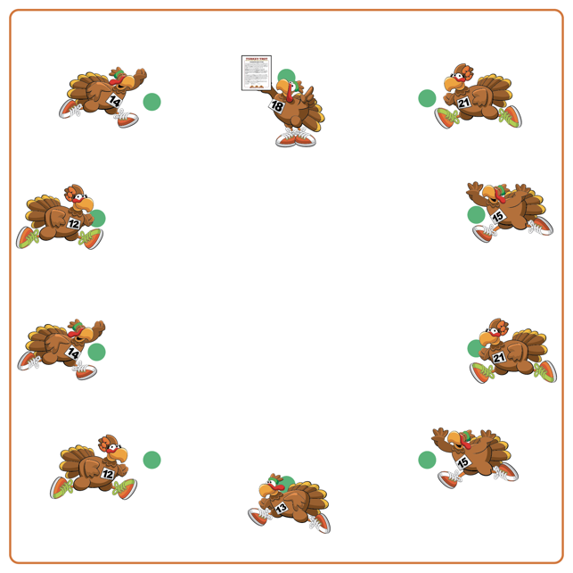
Equipment:
- 1 spot marker per student
- Copy of The Night Before Thanksgiving story

Set-Up:
- Students will each be on a spot marker, set up in a circle to mimic being seated around a Thanksgiving table.
- Teacher will have a copy of the story.
- Display list of words/movements for students around activity space.
ACTIVITY PROCEDURES
- This activity is called The Night Before Thanksgiving! The object is to practice listening skills and navigate different non-locomotor exercises and poses as a story clues you in on what movements to perform as it is being told.
- We are first going to first learn and practice all of the movements we will do as we hear them in the story. (Teachers: demonstrate each of the movements and what words they belong with, as well as post them around your teaching space if possible).
- As I read the story, you are going to demonstrate the movements that belong with each of the key words. For example, when you hear the word Turkey during the story you will demonstrate the movements that go with that word (squat down with feet shoulder width apart, chest tall, and hands outstretched like long feathers).
- Try and keep up with all of the movements during the story, and most importantly HAVE FUN!

DEBRIEF QUESTIONS
- DOK 1: What does etiquette mean?
- DOK 2: What can you share about the etiquette needed during the story?
- DOK 3: How is following activity etiquette related to being a good classmate?

PRIORITY OUTCOMES
Social Interaction:
- Grades K-2: Discusses the enjoyment of playing with family and friends.
- Grades 3-5: Describes the positive social interactions that come when engaged with others in physical activity.

ROWS OF GRATITUDE

STUDENT TARGETS
- Skill: I will move safely in self-space to complete yoga poses.
- Cognitive: I will discuss the way my body is moving as I create shapes and balances.
- Physical Activity: I will demonstrate safe behaviors while being physically active.
- Social/Emotional: I will move safely and demonstrate concern for myself and my classmates.

EQUIPMENT & SET-UP | 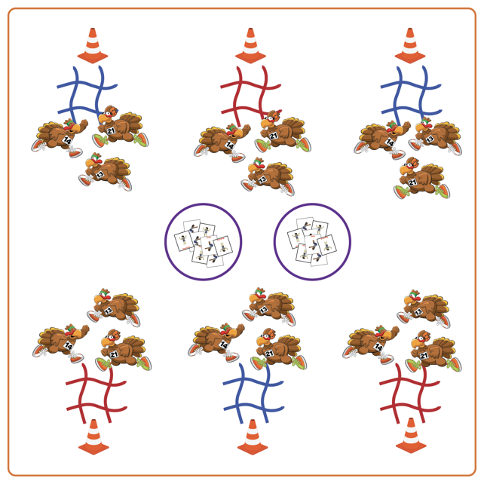
Equipment:
- Jump ropes (4 per group)
- Boundary cones/markers
- Yoga Pose Cards
- Hula hoops
Set-Up:
- Create equal teams of 3-4 students. Each team starts at a cone.
- Create a large activity area with cones around the perimeter.
- Each team should have a tic-tac-toe board made with jump ropes by their starting cone.
- Place hoops in the center of the area with Yoga Pose Cards face down.
ACTIVITY PROCEDURES
- This activity is called Rows of Gratitude! The object of the game is for a team to get three Yoga Pose Cards of the same color in a row horizontally, vertically, or diagonally for a tic-tac-toe on their board.
- On the start signal, each team sends one student at a time into the center to choose one Yoga Pose Card and bring it back to their team. The whole team does the yoga pose for 20 seconds, then decides where to place the Yoga Pose Card on the tic-tac-toe board. When done, the next team member goes to the middle for a Yoga Pose Card.
- This continues until tic-tac-toe with the same color yoga cards is achieved or the board is full.
- Yoga cards must be placed on the tic-tac-toe board each time. If board fills without getting three colors in a row, place cards back in the center of the area in a hoop (face down) and try again.

DEBRIEF QUESTIONS
- DOK 1: What does it mean to have gratitude?
- DOK 2: What are some ways you can show gratitude towards others?

PRIORITY OUTCOMES
Etiquette:
- Grades K-2: Exhibits the established protocols for class activities without reminders.
- Grades 3-5: Recognizes the role of rules and etiquette in physical activity with peers.

GRATITUDE WREATH

STUDENT TARGETS
- Skill: I will move in general space using different pathways and speeds.
- Cognitive: I will identify the rules and etiquette for creating a gratitude wreath.
- Physical Activity: I will stay actively engaged in class in order to accumulate a maximum amount of physical activity minutes.
- Social/Emotional: I will demonstrate personal responsibility through teamwork and cooperation.

EQUIPMENT & SET-UP | 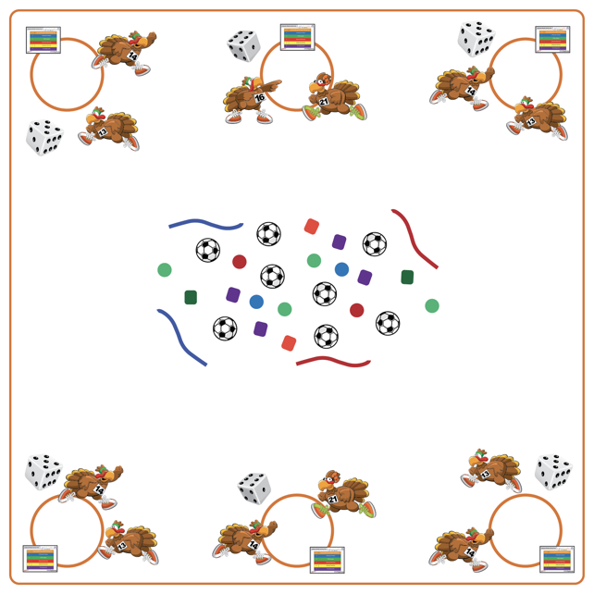
Equipment:
- Cones
- 1 hula hoop & 1 die per team
- Activity cards
- Variety of equipment to decorate wreaths (e.g., bean bags, fluff balls, jump ropes, scarves, deck rings, tennis balls)
Set-Up:
- Place a hula hoop (as base for wreath), activity card & die for each team around the perimeter of the activity space. Place a variety of equipment in the center of the teaching area for teams to choose the items they want to use to decorate their wreath.
- Create equal teams of 3-4 students. Each team starts at a hula hoop.
ACTIVITY PROCEDURES
- This activity is called Gratitude Wreath! The object is to work together as a team to create a unique gratitude wreath.
- On the start signal, one student from each team will roll the die. The entire team will perform the activity determined by the number rolled/exercise identified on the activity card. The team’s movement “earns” them one item to add to their gratitude wreath. One student from the team goes to the center of the activity area and brings one item back to add to the team’s wreath. Continue this process until wreaths are complete or until you hear the stop signal.
- Students should rotate who gets to roll the dice and which student gets to choose (and place) the item added to the wreath.

DEBRIEF QUESTIONS
- DOK 1: What does it mean to be grateful?
- DOK 2: Can someone share something about one of their group members that they are grateful for?

PRIORITY OUTCOMES
Personal Responsibility and Safety:
- Grades K-2: Works independently and safely in physical education.
- Grades 3-5: Engages in physical activity with responsible interpersonal behavior (e.g., peer to peer and student to teacher).

THANKFUL TURKEY TOSS

STUDENT TARGETS
- Skill: I will accurately toss and catch with a partner.
- Cognitive: I will identify offensive strategies to assist with moving to open space to receive a toss.
- Physical Activity: I will recognize the positive effects that being physically active has on my body.
- Social/Emotional: I will use communication skills to help establish a positive learning environment for myself and others.

EQUIPMENT & SET-UP | 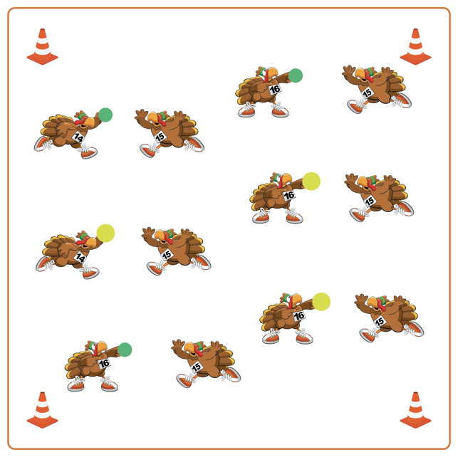
Equipment:
- 1 ball (or tossable) per 2 students
- Boundary cones/markers

Set-Up:
- Create a large activity area with cones around the perimeter.
- Students get a partner and 1 ball/tossable for the group.
- Each group will begin facing their partner, and spread out in general space inside the cones.
ACTIVITY PROCEDURES
- This activity is called Thankful Turkey Toss! The object is to overhand (for grades 3-5) or underhand (for grades K-2) toss with as many different partners as possible.
- When the music begins, the partner with the ball/tossable will begin with an overhand toss (or underhand for grades K-2) to their partner. Each pair will make 3 tosses, with the person tossing the ball stating something they are grateful for each time they toss. The partner who has the ball after 3 tosses will travel and find a new partner who does not have a ball.
- Continue to play until you hear the music stop.

DEBRIEF QUESTIONS
DOK 1: What are some things you are grateful for?
DOK 2: What are some ways you can show someone, with your words or actions, that you are grateful for them?

PRIORITY OUTCOMES
Manipulative Skills:
- Grades K-2: Demonstrates control while combining locomotor and manipulative skills in self-space and general space.
- Grades 3-5: Demonstrates manipulative skills using mature patterns for accuracy and control.

