TREASURE HUNT

STUDENT TARGETS
- Skill: I will demonstrate verbal communication skills and active listening throughout the activity.
- Cognitive: I will connect, listen, build trust, and reflect upon my experiences.
- Fitness: I will stay actively engaged throughout this activity.
- Personal & Social Responsibility: I will demonstrate respect for my classmates by following the rules of the activity and monitoring the safety of my blindfolded partner.

EQUIPMENT & SET-UP | 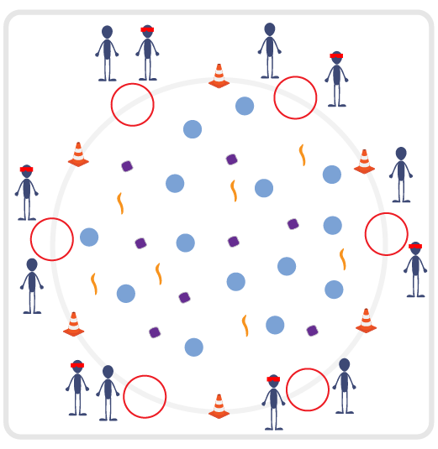
Equipment:
- Boundary cones
- Blindfolds or bandannas
- Variety of objects that can be safely spread out in activity area (bean bags, scarves, spot markers, Garden Heroes, etc.).
- 1 hula hoop per team
Set-Up:
- Arrange objects randomly inside activity space. Ensure there is adequate space for students to move between spot markers and objects safely. Please do not include objects such as a foam ball that could cause a blindfolded student to fall or roll an ankle.
- Create teams of 2 students and have them begin outside the perimeter of the activity space with a blindfold or bandanna, standing next to a hula hoop.

ACTIVITY PROCEDURES
- This activity is called Treasure Hunt! The object is to utilize communication and listening skills to safely move through the activity space and collect as many treasures as possible. One partner will start with a blindfold on, and the other partner will be the trust coach. Your team will begin next to your hula hoop outside of the boundary cones.
- On the start signal, the trust coach will begin to guide their partner using verbal communication only into the activity space. All blindfolded students will need to keep their arms extended in front of them at all times to create “bumpers” for safety. Trust coaches can move around anywhere outside of the boundary cones in order to ensure their partner can continue to hear their voice as they communicate how to travel from object to object.
- Your team gets one point for each object the blindfolded team member is able to collect and bring back to your hula hoop. You are only allowed to collect one piece of treasure per trip, and you must switch roles each time someone brings a treasure back to your hoop.
- On the stop signal, or when all treasure is collected, we will count up the points for each team.

TEACHING CUES
- Cue 1: Remember to always utilize your “bumpers” when you are blindfolded.
- Cue 2: Use clear and concise communication to articulate directions to your partner.
- Cue 3: Apply the 5 Adventure Learning Core Values throughout the activity.

TREASURE HUNT (continued…)

UNIVERSAL DESIGN ADAPTATIONS
- UDL 1: Allow students to work with additional partners to assist with communication if needed.
- UDL 2: Utilize visual demonstrations by students as needed.
- UDL 3: Provide modified movements or assistive technology as needed to ensure the activity is inclusive for all.

ACADEMIC LANGUAGE
Communication, Trust, Strategy

PRIORITY OUTCOMES
Values Physical Activity - Social Interaction:
- (Grade 6) Demonstrates respect for self and others in activities and games by following the rules, encouraging others, and playing within the spirit of the game or activity.
- (Grade 7) Demonstrates the importance of social interaction by helping and encouraging others, avoiding trash talk, and providing support to classmates.
- (Grade 8) Demonstrates respect for self by asking for help and helping others in various physical activities.
- (Grades 9-12) Identifies and evaluates the opportunity for social interaction and social support in self-selected physical activities.

DEBRIEF QUESTIONS
- DOK 1: Was there a strategy that your team used during this activity?
- DOK 2: Sometimes we use a strategy during a game or activity, and it doesn’t work well. Was there a communication strategy that you tried during this game that didn’t work very well? What did you do differently if you realized a communication strategy wasn’t working for your team?

