CIRCLE THE WAGONS

STUDENT TARGETS
- Skill: I will demonstrate verbal communication skills and active listening throughout this activity.
- Cognitive: I will identify the five core values of adventure learning.
- Fitness: I will stay actively engaged throughout this activity.
- Personal & Social Responsibility: I will be respectful of all classmates during this activity.
EQUIPMENT & SET-UP | 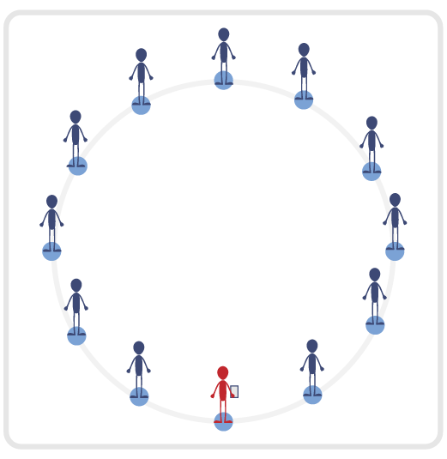
Equipment:
- Blindfold for each student
- Adventure Learning Core Values Card

Set-Up:
- Have the entire class begin by standing in a connection circle.
- Safety Tip: Ensure activity space is completely clear of all objects as students will be blindfolded.
- Review the 5 Adventure Learning Core Values before beginning this activity.
ACTIVITY PROCEDURES
- This activity is called Circle the Wagons! The object of the game is to reconnect our connection circle while everyone is blindfolded. You will use communication and listening skills to locate your partners.
- We will all begin in our connection circle. On the start signal, you will introduce yourself to the person on the right and the person on the left and give a “high five” or a handshake. These people will become your partners that you are trying to reconnect with, so make sure you learn and remember their names! If your partners have the same name as someone else in the group, use last name initials or a nickname to make sure you can reconnect with them.
- Each of you will now spread out in the activity space and place your blindfold over your eyes. Using verbal communication and listening skills, begin to call out the two names of your partners. While your “bumpers” are up (arms extended directly in front of you) begin to move slowly and safely in general space until you hear one of your partners. Once you are able to locate one of your partners, you will reconnect with an overhand wrist grip so that everyone can continue to use safety “bumpers”.
- Now that you have found one of your partners, continue the process until you find the other partner as well. Remember to be respectful and work together to move with your partner through the space (without pulling or moving too quickly). If you have reconnected with both of your partners, be a good teammate until they have found both of their partners too. Teachers: students who have found their partners no longer need to use verbal communication. This allows students who are still looking for their partners to have fewer distractions and find them faster.
- The activity will end when everyone has found both partners and our entire team is reconnected.
- Teachers: have students remove their blindfolds once the entire team is reconnected.
TEACHING CUES
- Cue 1: Keep your “bumpers” up at all times.
- Cue 2: Move carefully through the activity space (avoid pulling your partners, running, or fast movements).
- Cue 3: Apply the 5 Adventure Learning Core Values throughout the activity.

CIRCLE THE WAGONS (continued…)

UNIVERSAL DESIGN ADAPTATIONS
- UDL 1: Allow students to move through space as a group of 3 if needed.
- UDL 2: Utilize visual demonstrations by students as needed.
- UDL 3: Provide modified movements to ensure the activity is inclusive for all.

ACADEMIC LANGUAGE
Cooperation, Trust, Safety

PRIORITY OUTCOMES
Values Physical Activity - Social Interaction:
- (Grade 6) Demonstrates respect for self and others in activities and games by following the rules, encouraging others, and playing within the spirit of the game or activity.
- (Grade 7) Demonstrates the importance of social interaction by helping and encouraging others, avoiding trash talk, and providing support to classmates.
- (Grade 8) Demonstrates respect for self by asking for help and helping others in various physical activities.
- (Grades 9-12) Identifies and evaluates the opportunity for social interaction and social support in self-selected physical activities.

DEBRIEF QUESTIONS
- DOK 1: Provide an example of how you demonstrated one of the 5 Adventure Learning Core Values during the activity.
- DOK 2: Why was trust important during this activity?
- DOK 3: How does having trust with your partner impact your willingness to be open-minded and try new activities?

DUCKS AND DOGS

STUDENT TARGETS
- Skill: I will demonstrate verbal communication skills and active listening throughout this activity.
- Cognitive: I will identify the five core values of adventure learning.
- Fitness: I will stay actively engaged throughout this activity.
- Personal & Social Responsibility: I will be respectful of all classmates during this activity.
EQUIPMENT & SET-UP
Equipment:
- Blindfold for each student
- Adventure Learning Core Values Card

Set-Up:
- Have the entire class begin by standing in a connection circle. Split the circle in half with two equal teams.
- Safety Tip: Ensure activity space is completely clear of all objects as students will be blindfolded.
- Review the 5 Adventure Learning Core Values before beginning this activity.
ACTIVITY PROCEDURES
- This activity is called Ducks and Dogs! The object of the game is to reconnect each of your teams (one for Ducks and one for Dogs) while everyone is blindfolded. You will use communication and listening skills to reconnect with your entire team.
- We will begin in a connection circle with your team (one team for Ducks and one team for Dogs). Your team will have a conversation to determine how their assigned animal will sound. This sound is how you will find and reconnect with your team. The only verbal communication during this activity will be your animal sound.
- Each team will spread out evenly throughout the activity space. Once both teams are spread out, each person will place their blindfold over their eyes. On the start signal, place your “bumpers” up (arms extended directly in front of you). Teachers: you could have students spin in a circle three times once their blindfolds are on before beginning to move. Begin to move slowly and safely in general space until you hear one of your teammates. Once you are able to locate one of your teammates, you will reconnect with an overhand wrist grip so that everyone can continue to use safety “bumpers”.
- Now that you have found one of your teammates, continue the process until you are able to reconnect with the rest of your team. Remember to be respectful and work together to move with your teammates through the space (without pulling or moving too quickly).
- The activity will end when both teams have successfully reconnected. Winning team is the one who fully reconnects first. Teachers: have students remove their blindfolds once their team is reconnected.
TEACHING CUES
- Cue 1: Keep your “bumpers” up at all times.
- Cue 2: Move carefully through the activity space (avoid pulling your partners, running, or fast movements).
- Cue 3: Apply the 5 Adventure Learning Core Values throughout the activity.

DUCKS AND DOGS (continued…)

UNIVERSAL DESIGN ADAPTATIONS
- UDL 1: Allow students to have a peer partner as they move if needed.
- UDL 2: Utilize visual demonstrations by students as needed.
- UDL 3: Provide modified movements to ensure the activity is inclusive for all.

ACADEMIC LANGUAGE
Responsibility, Actively Engage, Challenge, Connection

PRIORITY OUTCOMES
Values Physical Activity - Social Interaction:
- (Grade 6) Demonstrates respect for self and others in activities and games by following the rules, encouraging others, and playing within the spirit of the game or activity.
- (Grade 7) Demonstrates the importance of social interaction by helping and encouraging others, avoiding trash talk, and providing support to classmates.
- (Grade 8) Demonstrates respect for self by asking for help and helping others in various physical activities.
- (Grades 9-12) Identifies and evaluates the opportunity for social interaction and social support in self-selected physical activities.

DEBRIEF QUESTIONS
- DOK 1: Provide an example of how you demonstrated one of the 5 Adventure Learning Core Values during the activity.
- DOK 2: Why was being open-minded important during this activity?
- DOK 3: How does being open-minded impact your willingness to try new activities and experience new challenges?

HEADS SHOULDERS KNEES TOES

STUDENT TARGETS
- Skill: I will demonstrate the five core values of adventure learning.
- Cognitive: I will work to anticipate the movements of my partner during this activity.
- Fitness: I will stay actively engaged throughout this activity.
- Personal & Social Responsibility: I will be respectful of all classmates during this activity.
EQUIPMENT & SET-UP | 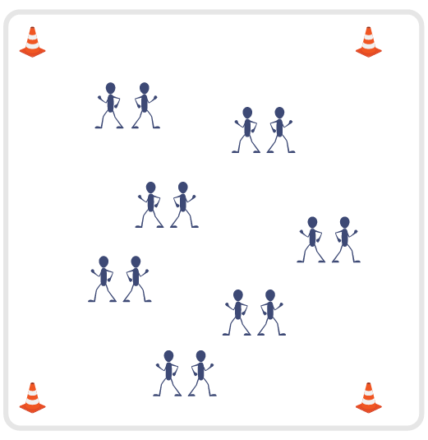
Equipment:
- Adventure Learning Core Values Card

Set-Up:
- Have the entire class begin by standing in a connection circle. Split the circle in half with two equal teams.
- Review the 5 Adventure Learning Core Values before beginning this activity.
- Students will pair up and stand back-to-back with their partner.
ACTIVITY PROCEDURES
- This activity is called Head Shoulders Knees and Toes. The object of the game is to match movements with your partner as quickly as possible to have the lowest score possible at the end of the activity, similar to golf.
- You will begin standing back-to-back with your partner. Each student will secretly select Head, Shoulders, Knees or Toes before they turn around and try to match movements with their partner. On the start signal, one partner will call out “1, 2, 3, Show!” and both partners will simultaneously turn around and face each other in an attempt to match Head, Shoulders, Knees or Toes. You want to match your partner’s movements in the fewest number of attempts, but remember we are not able to communicate or make a plan before we turn!
- Keep track of your score after each round. If it took you and your partner 3 attempts before you were able to match movements, then your score for that partner would be a 3.
- Once you and your partner have connected with a match, you will close with a high five and move through the activity space to find a new partner. You will add your score after matching with each new partner for your total score at the end.
- The activity will end when you hear the stop signal. Winning player is the one with the lowest total score.
- Teachers: You can choose to call out “1, 2, 3, Show!” for the first few attempts to ensure students understand the rules. Then students can take over leadership for the remaining time in the activity.
TEACHING CUES
- Cue 1: Keep some space between you and your partner when you begin back to back. This keeps everyone safe as you turn around.
- Cue 2: Try to match movements with as many different partners as possible during the activity.
- Cue 3: Apply the 5 Adventure Learning Core Values throughout the activity.

HEAD SHOULDERS KNEES TOES (continued…)

UNIVERSAL DESIGN ADAPTATIONS
- UDL 1: Allow students to have a peer partner as they move if needed.
- UDL 2: Utilize visual demonstrations by students as needed.
- UDL 3: Provide modified movements to ensure the activity is inclusive for all.

ACADEMIC LANGUAGE
Anticipate, Open-minded, Patience, Connection

PRIORITY OUTCOMES
Values Physical Activity - Social Interaction:
- (Grade 6) Demonstrates respect for self and others in activities and games by following the rules, encouraging others, and playing within the spirit of the game or activity.
- (Grade 7) Demonstrates the importance of social interaction by helping and encouraging others, avoiding trash talk, and providing support to classmates.
- (Grade 8) Demonstrates respect for self by asking for help and helping others in various physical activities.
- (Grades 9-12) Identifies and evaluates the opportunity for social interaction and social support in self-selected physical activities.

DEBRIEF QUESTIONS
- DOK 1: Provide an example of how you demonstrated one of the 5 Adventure Learning Core Values during the activity.
- DOK 2: Why was being respectful important during this activity?
- DOK 3: How does being respectful impact your success when you try new activities and experience new challenges?

LOOK UP

STUDENT TARGETS
- Skill: I will demonstrate the five core values of adventure learning.
- Cognitive: I will describe the benefits of being active with my friends.
- Fitness: I will stay actively engaged throughout this activity.
- Personal & Social Responsibility: I will be respectful of all classmates during this activity.
EQUIPMENT & SET-UP | 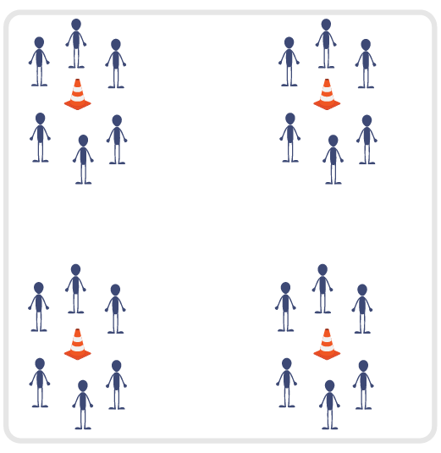
Equipment:
- 3-4 Large Cones (have 1 cone for every 10 students)
- Task tent for each cone
- Adventure Learning Core Values Card for each cone
Set-Up:
- Place the large cones approximately 30 feet apart in the activity space (e.g., 3 cones can create a triangle, 4 cones can create a square).
- Divide class into 3-4 even groups. Each group will begin at a cone in a small circle (facing their cone).
- Place Core Values Card in a task tent on each cone, and review the 5 Adventure Learning Core Values before beginning this activity.
ACTIVITY PROCEDURES
- This activity is called Look Up. The object of the game is to randomly connect with as many different classmates as possible to collect points.
- You will begin standing in a circle with your group facing the cone. Each of you will look down at the cone, and while looking down you will secretly choose a classmate that you will try to make eye contact with once you look up. I will say “Look Down; 1, 2, 3, Look Up!” and each of you will look directly at the person you secretly chose to make eye contact with. You want to earn a point by connecting with the person you chose (you would have both secretly chosen each other). But remember you are not able to verbally or nonverbally communicate or make a plan before you look up!
- If you and a classmate have both chosen each other and made eye contact, celebrate with an enthusiastic High-5 and then each of you will move to a different cone (you cannot choose to move to the same cone together). If you did not make a connection, you will stay at the same cone and try again. You get one point for each successful eye contact/connection that is made.
- Once you have successfully chosen a classmate and made a connection, try to choose a different classmate each time you look up. Note: Teachers can move cones further apart at various times during the activity (add approximately 10 feet each time you move them).
- The activity will end when you hear the stop signal. Winning player is the one who made the most successful connections and earned the most points!
- Teachers: You can call out “1, 2, 3, Look Up!” for the first few attempts to ensure students understand the rules. Then students can take over leadership at each cone for the remaining time in the activity.
TEACHING CUES
- Cue 1: Make sure to not communicate or make a plan with the person you choose before looking up.
- Cue 2: Try to make eye contact with as many different partners as possible during the activity.
- Cue 3: Apply the 5 Adventure Learning Core Values throughout the activity.

LOOK UP (continued…)

UNIVERSAL DESIGN ADAPTATIONS
- UDL 1: Allow students to have a peer partner as they move if needed.
- UDL 2: Utilize visual demonstrations by students as needed.
- UDL 3: Provide modified movements to ensure the activity is inclusive for all.

ACADEMIC LANGUAGE
Honesty, Enthusiasm, Connection

PRIORITY OUTCOMES
Values Physical Activity - Social Interaction:
- (Grade 6) Demonstrates respect for self and others in activities and games by following the rules, encouraging others, and playing within the spirit of the game or activity.
- (Grade 7) Demonstrates the importance of social interaction by helping and encouraging others, avoiding trash talk, and providing support to classmates.
- (Grade 8) Demonstrates respect for self by asking for help and helping others in various physical activities.
- (Grades 9-12) Identifies and evaluates the opportunity for social interaction and social support in self-selected physical activities.

DEBRIEF QUESTIONS
- DOK 1: Provide an example of how you demonstrated one of the 5 Adventure Learning Core Values during the activity.
- DOK 2: What are some of the benefits of being active with your friends?
- DOK 3: How does being active with your friends during PE class influence your willingness to be active and try new experiences with them outside of school?

WAH MASTER

STUDENT TARGETS
- Skill: I will demonstrate the five core values of adventure learning.
- Cognitive: I will describe the benefits of being active with my friends.
- Fitness: I will stay actively engaged throughout this activity.
- Personal & Social Responsibility: I will be respectful of all classmates during this activity.
EQUIPMENT & SET-UP
Equipment:
- 1 small cone per student
- Adventure Learning Core Values Card

Set-Up:
- Set up area with small cones in a large “Connection Circle.”
- Each student begins by a cone.
- Teacher begins by a cone as well, with a copy of the Adventure Learning Core Values Card.
ACTIVITY PROCEDURES
- This activity is called Wah Master. The object of the game is to take the mystical “Waaaah” from the Wah Master by anticipating what sign they will show. The teacher will begin as the Wah Master.
- As a Wah Master, I will lead you all in a game to see if you can take the mystical “Waaaah” from me. I will show one of three symbols: Fireball, Snake, or Grizzly Bear. Wah Masters have the ability to read the minds of the other players. Your challenge will be to show a symbol at the same time as me and try not to match what I show.
- There are three symbols we will represent with arm motions. Fireball is represented by arms crossed like an X in front of your chest. Snake is shown with one arm making a slithering motion. Bear is shown with both arms up with fingers in a claw position like a growling bear.
- I will begin by enthusiastically counting out loud and saying “1, 2, 3, Waaaah!” The leader will say, “1, 2, 3, Waaaah!” and show their symbol while the group will simultaneously show their own symbol. Participants are encouraged to say “Waaaah!” at each round.
- At the end of each round, those that match the Wah Master will take a knee and those that do not match will take one step forward and stay in the game. But remember, the person who holds the mystical “Waaaah” has two lives! The Wah Master would lose one life if everyone remaining in the game did not match their sign during that round.
- If you are the last one standing, you get to see if you can take the mystical “Waaaah” in a one-on-one show down!
- Teachers: The winner of the game should be able to hold the title of Wah Master for the rest of that day and should lead as the Wah Master the next time the game is played.

TEACHING CUES
- Cue 1: Bring your enthusiasm and energy to each round of the game.
- Cue 2: Remember to be honest with your sign for each round - changing your sign is not allowed.
- Cue 3: Apply the 5 Adventure Learning Core Values throughout the activity.

WAH MASTER (continued…)

UNIVERSAL DESIGN ADAPTATIONS
- UDL 1: Allow students to have a peer partner as they move if needed.
- UDL 2: Utilize visual demonstrations by students as needed.
- UDL 3: Provide modified movements to ensure the activity is inclusive for all.

ACADEMIC LANGUAGE
Honesty, Enthusiasm, Energy, Connection

PRIORITY OUTCOMES
Values Physical Activity - Social Interaction:
- (Grade 6) Demonstrates respect for self and others in activities and games by following the rules, encouraging others, and playing within the spirit of the game or activity.
- (Grade 7) Demonstrates the importance of social interaction by helping and encouraging others, avoiding trash talk, and providing support to classmates.
- (Grade 8) Demonstrates respect for self by asking for help and helping others in various physical activities.
- (Grades 9-12) Identifies and evaluates the opportunity for social interaction and social support in self-selected physical activities.

DEBRIEF QUESTIONS
- DOK 1: Provide an example of how you demonstrated one of the 5 Adventure Learning Core Values during the activity.
- DOK 2: What are some of the benefits of being active with your friends?
- DOK 3: How does being active with your friends during PE class influence your willingness to be active and try new experiences with them outside of school?

COOPERATIVE COUNT

STUDENT TARGETS
- Skill: I will demonstrate verbal communication skills and active listening throughout this activity.
- Cognitive: I will identify the five core values of adventure learning.
- Fitness: I will stay actively engaged throughout this activity.
- Personal & Social Responsibility: I will use supportive and encouraging language with my classmates during this activity.

EQUIPMENT & SET-UP | 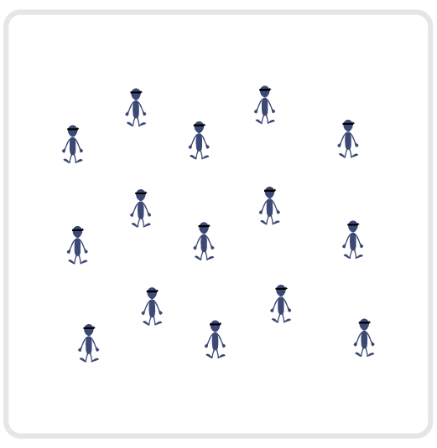
Equipment:
- Adventure Learning Core Values Card
- Blindfold for each student (optional)

Set-Up:
- Students begin spread out in activity space, either sitting or lying down with a blindfold on (or eyes closed).
- Review the 5 Adventure Learning Core Values before beginning this activity.

ACTIVITY PROCEDURES
- This activity is called Cooperative Count! The object of the game is to successfully count from 1-30 as a class, with only one student allowed to speak at a time. But we will all be blindfolded (or have our eyes closed) and unable to see each other to give any visual cues for who will speak next.
- Let’s begin by spreading out in the activity area. Find a comfortable place to sit or lay down that isn’t near any of your classmates. Once we are all spread out, we will place our blindfold over our eyes (or close our eyes).
- On the start signal, any student can call out the number 1 to begin the count. This continues with another student calling out the number 2, and until we can make it all the way to 30 with a different student calling out the number each time. But remember, only one student can speak at a time or we have to start over at the beginning with the number 1.
- We will see how many attempts it takes for us to make it all the way to 30 without a restart.
- Once we successfully count to 30, we will discuss the challenges and successes we experienced during the activity. Then, I will give you 2 minutes to organize and plan with your classmates before we try again.
TEACHING CUES
- Cue 1: Be patient with your classmates during each attempt to get to 30.
- Cue 2: Use encouraging language with your classmates.
- Cue 3: Apply the 5 Adventure Learning Core Values throughout the activity.

COOPERATIVE COUNT (continued…)

UNIVERSAL DESIGN FOR LEARNING
- UDL 1: Allow students to work with a partner if needed.
- UDL 2: Utilize visual and verbal demonstrations by students prior to activity.
- UDL 3: Allow the option to not wear a blindfold if it makes a student uncomfortable.

ACADEMIC LANGUAGE
Patience, Responsibility, Respect, Commitment

PRIORITY OUTCOMES
Values Physical Activity - Social Interaction:
- (Grade 6) Demonstrates respect for self and others in activities and games by following the rules, encouraging others, and playing within the spirit of the game or activity.
- (Grade 7) Demonstrates the importance of social interaction by helping and encouraging others, avoiding trash talk, and providing support to classmates.
- (Grade 8) Demonstrates respect for self by asking for help and helping others in various physical activities.
- (Grades 9-12) Identifies and evaluates the opportunity for social interaction and social support in self-selected physical activities.

DEBRIEF QUESTIONS
- DOK 1: Provide an example of how you demonstrated one of the 5 Adventure Learning Core Values during the activity.
- DOK 2: We were attempting a task that required a lot of patience. Is there a strategy that helped you remain patient during each of our attempts to count to 30?
- DOK 3: How did having the opportunity to plan with your classmates impact your ability to be successful at completing the task?

COOPERATIVE ABC’s

STUDENT TARGETS
- Skill: I will demonstrate verbal communication skills and active listening throughout this activity.
- Cognitive: I will identify the five core values of adventure learning.
- Fitness: I will stay actively engaged throughout this activity.
- Personal & Social Responsibility: I will use supportive and encouraging language with my classmates during this activity.

EQUIPMENT & SET-UP
Equipment:
- Adventure Learning Core Values Card
- Blindfold for each student (optional)

Set-Up:
- Students begin spread out in activity space, either sitting or lying down with a blindfold on (or eyes closed).
- Review the 5 Adventure Learning Core Values before beginning this activity.

ACTIVITY PROCEDURES
- This activity is called Cooperative ABC’s! The object of the game is to successfully say the entire alphabet as a class, with only one student allowed to speak at a time. But we will all be blindfolded (or have our eyes closed) and unable to see each other to give any visual cues for who will speak next.
- Let’s begin by spreading out in the activity area. Find a comfortable place to sit or lay down that isn’t near any of your classmates. Once we are all spread out, we will place our blindfold over our eyes (or close our eyes).
- On the start signal, any student can call out the letter A to begin. This continues with another student calling out the letter B, and until we can make it all the way to Z with a different student calling out the letter each time. But remember, only one student can speak at a time or we have to start over at the beginning with the letter A.
- We will see how many attempts it takes for us to make it all the way to Z without a restart.
- Once we successfully get through the entire alphabet, we will discuss the challenges and successes we experienced during the activity. Then, I will give you 2 minutes to organize and plan with your classmates before we try again.
TEACHING CUES
- Cue 1: Be patient with your classmates during each attempt to get from A to Z.
- Cue 2: Use encouraging language with your classmates.
- Cue 3: Apply the 5 Adventure Learning Core Values throughout the activity.

COOPERATIVE ABC’s (continued…)

UNIVERSAL DESIGN FOR LEARNING
- UDL 1: Allow students to work with a partner if needed.
- UDL 2: Utilize visual and verbal demonstrations by students prior to activity.
- UDL 3: Allow the option to not wear a blindfold if it makes a student uncomfortable.

ACADEMIC LANGUAGE
Patience, Responsibility, Respect, Commitment

PRIORITY OUTCOMES
Values Physical Activity - Social Interaction:
- (Grade 6) Demonstrates respect for self and others in activities and games by following the rules, encouraging others, and playing within the spirit of the game or activity.
- (Grade 7) Demonstrates the importance of social interaction by helping and encouraging others, avoiding trash talk, and providing support to classmates.
- (Grade 8) Demonstrates respect for self by asking for help and helping others in various physical activities.
- (Grades 9-12) Identifies and evaluates the opportunity for social interaction and social support in self-selected physical activities.

DEBRIEF QUESTIONS
- DOK 1: Provide an example of how you demonstrated one of the 5 Adventure Learning Core Values during the activity.
- DOK 2: We were attempting a task that required a lot of patience. Is there a strategy that helped you remain patient during each of our attempts to get through the entire alphabet?
- DOK 3: How did having the opportunity to plan with your classmates impact your ability to be successful at completing the task?

RIGHTY, LEFTY

STUDENT TARGETS
- Skill: I will demonstrate verbal communication skills and active listening throughout this activity.
- Cognitive: I will identify the five core values of adventure learning.
- Fitness: I will stay actively engaged throughout this activity.
- Personal & Social Responsibility: I will connect with as many classmates as possible.

EQUIPMENT & SET-UP | 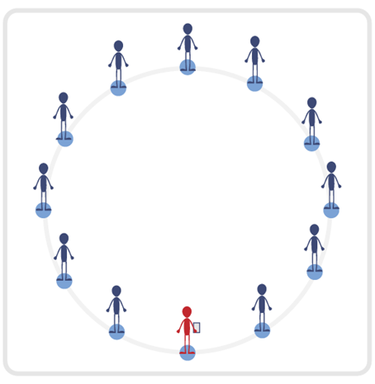
Equipment:
- 1 small cone per student
- Adventure Learning Core Values Card

Set-Up:
- Set up area with small cones in a large “Connection Circle.”
- Each student begins by a cone.
- Teacher begins by a cone as well, with a copy of the Adventure Learning Core Values Card.

ACTIVITY PROCEDURES
- This activity is called Righty, Lefty! The object of the game is to connect with as many classmates as possible while reinforcing the 5 Adventure Learning Core Values. The 5 core values are represented by the five fingers on each participant’s hand. The thumb represents being open minded; the index finger represents being responsible; the middle finger is a sign of disrespect – so we are going to flip that around as a reminder to be respectful; the ring finger represents being committed; and the pinky finger is a reminder to be physically and emotionally safe.
- On the start signal, you will put one hand behind your back and hold the other hand up ready to give a “high five”. You will move around the connection circle collecting high fives from your classmates, but you must make sure you find someone else with the same hand up as you! Your right hand can only “high five” someone else who also has their right hand up. After each high five, you will switch so you alternate between the right and left hand.
- On the stop signal, we will switch up the way we are moving inside the connection circle. During the second round, you are going to keep track of how many different connections you were able to make with your classmates.
TEACHING CUES
- Cue 1: Alternate hands after each “high five” connection.
- Cue 2: Connect with as many classmates as possible.
- Cue 3: Apply the 5 Adventure Learning Core Values throughout the activity.

RIGHTY, LEFTY (continued…)

UNIVERSAL DESIGN ADAPTATIONS
- UDL 1: Allow students to work with a partner if needed.
- UDL 2: Utilize visual demonstrations by students as needed.
- UDL 3: Provide modified movements or assistive technology as needed to ensure the activity is inclusive for all.

ACADEMIC LANGUAGE
Value, Open-minded, Responsibility, Respect, Commitment, Safety

PRIORITY OUTCOMES
Values Physical Activity - Social Interaction:
- (Grade 6) Demonstrates respect for self and others in activities and games by following the rules, encouraging others, and playing within the spirit of the game or activity.
- (Grade 7) Demonstrates the importance of social interaction by helping and encouraging others, avoiding trash talk, and providing support to classmates.
- (Grade 8) Demonstrates respect for self by asking for help and helping others in various physical activities.
- (Grades 9-12) Identifies and evaluates the opportunity for social interaction and social support in self-selected physical activities.

DEBRIEF QUESTIONS
- DOK 1: Provide an example of how you demonstrated one of the 5 Adventure Leaning Core Values during the activity.
- DOK 2: We were trying to make as many connections with classmates as possible during this activity. Why do you think it is important to make connections with your classmates?
- DOK 3: How can the connections you make during physical education have a positive impact on your school community as a whole?

ME, YOU, YOU, ME

STUDENT TARGETS
- Skill: I will demonstrate verbal communication skills and active listening throughout this activity.
- Cognitive: I will identify my classmates names while participating in this activity.
- Fitness: I will stay actively engaged during the activity.
- Personal & Social Responsibility: I will demonstrate respect for my classmates by following the rules of the activity.

EQUIPMENT & SET-UP
Equipment:
- 1 small cone per student
- Adventure Learning Core Values Card

Set-Up:
- Set up area with small cones in a large “Connection Circle.”
- Each student begins by a cone.
- Teacher begins by a cone as well, with a copy of the Adventure Learning Core Values Card.

ACTIVITY PROCEDURES
- This activity is called Me, You, You, Me! The object of the activity is to greet classmates to learn their names while reinforcing the 5 Adventure Learning Core Values.
- You do that by alternating between the right hand and left hand for a connection handshake with your classmates. The five fingers included in the connection handshake is a fun and interactive way to reinforce the core values of adventure learning.
- On the start signal, you will move around the activity space greeting classmates with an enthusiastic connection handshake. The proper sequence for the connection handshake is Me, You, You, Me: Partner 1 says their name, Partner 2 says their name, Partner 1 states Partner 2’s name, and Partner 2 states Partner 1’s name. During the connection handshake, you should be looking in your classmates eyes and release the handshake when the full Me, You, You, Me sequence is completed. As soon as you complete the sequence, find a different classmate to connect with.
- On the stop signal, you will look around to determine how many different classmates you have been able to connect with. We will then play one more round so you can try to connect with any remaining classmates.

TEACHING CUES
- Cue 1: Bring as much enthusiasm as possible to each connection handshake.
- Cue 2: Connect with as many classmates as possible.
- Cue 3: Apply the 5 Adventure Learning Core Values throughout the activity.

ME, YOU, YOU, ME (continued…)

UNIVERSAL DESIGN ADAPTATIONS
- UDL 1: Allow students to work with a partner if needed.
- UDL 2: Utilize visual demonstrations by students as needed.
- UDL 3: Provide modified movements or assistive technology as needed to ensure the activity is inclusive for all.

ACADEMIC LANGUAGE
Happiness, Connection, Alternate

PRIORITY OUTCOMES
Values Physical Activity - Social Interaction:
- (Grade 6) Demonstrates respect for self and others in activities and games by following the rules, encouraging others, and playing within the spirit of the game or activity.
- (Grade 7) Demonstrates the importance of social interaction by helping and encouraging others, avoiding trash talk, and providing support to classmates.
- (Grade 8) Demonstrates respect for self by asking for help and helping others in various physical activities.
- (Grades 9-12) Identifies and evaluates the opportunity for social interaction and social support in self-selected physical activities.

DEBRIEF QUESTIONS
- DOK 1: Who can share all 5 of the Adventure Learning Core Values?
- DOK 2: What do you think the benefits are for connecting with your classmates and learning their names?
- DOK 3: How could applying the 5 core values of adventure learning outside of physical education class have a positive impact on you both during and outside of school?

SUPER CHICKEN

STUDENT TARGETS
- Skill: I will demonstrate the ability to work with a variety of different partners during game play.
- Cognitive: I will participate in a class discussion about personal growth and development.
- Fitness: I will stay actively engaged throughout this activity.
- Personal & Social Responsibility: I will show respect for each of my opponents regardless of whether I win or lose.

EQUIPMENT & SET-UP | 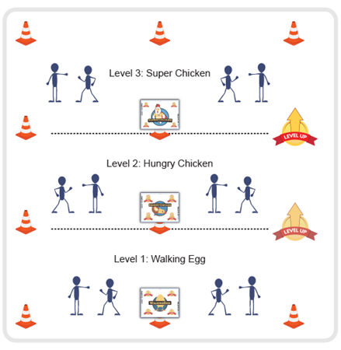
Equipment:
• 12 cones
• 3 Task Tents
• Super Chicken Believe In You Leadership Cards
• Music as a start/stop signal (optional)

Set-Up:
• Use cones to create 3 even zones.
• Place a Walking Egg card, a Hungry Chicken card, and a Super Chicken card into task tents.
• Hang the task tents on a cone in each zone to identify the 3 game zones.
• All students begin in the first Walking Egg zone.

ACTIVITY PROCEDURES
- This activity is called Super Chicken. The object of the activity is for you to evolve from a Walking Egg, into a Hungry Chicken, and then finally into a Super Chicken. You’re going to do that by winning Rock, Paper, Scissor (RPS) matches.
- Everyone begins this game as a Walking Egg. On the start signal, find any partner and play RPS. If you win, you evolve and move into the next zone – the Hungry Chicken Zone. If you don’t win, find another partner and try again.
- In each zone, find a partner and play RPS in an attempt to evolve.
- When you’ve won a match in the 3rd zone, you’ve become a Super Chicken. Do a 3 second Super Chicken Dance to celebrate and then safely and quickly move back to the Walking Egg zone to try again. How many times can you evolve into a Super Chicken before time runs out?

TEACHING CUES
- Cue 1: Bring as much enthusiasm as possible to each match of Rock, Paper, Scissor (R,P,S) – especially if you become a Super Chicken!
- Cue 2: Connect with as many classmates as possible.
- Cue 3: Apply the 5 Adventure Learning Core Values throughout the activity.

SUPER CHICKEN (continued…)

UNIVERSAL DESIGN ADAPTATIONS
- UDL 1: Allow students to work with a partner if needed.
- UDL 2: Utilize visual demonstrations by students as needed.
- UDL 3: Provide modified movements or assistive technology as needed to ensure the activity is inclusive for all.

ACADEMIC LANGUAGE
Awaken, Become, Transform

PRIORITY OUTCOMES
Values Physical Activity - Social Interaction:
- (Grade 6) Demonstrates respect for self and others in activities and games by following the rules, encouraging others, and playing within the spirit of the game or activity.
- (Grade 7) Demonstrates the importance of social interaction by helping and encouraging others, avoiding trash talk, and providing support to classmates.
- (Grade 8) Demonstrates respect for self by asking for help and helping others in various physical activities.
- (Grades 9-12) Identifies and evaluates the opportunity for social interaction and social support in self-selected physical activities.

DEBRIEF QUESTIONS
- DOK 1: The 3 Super Chicken words related to personal development are Awaken, Become, and Transform. In your own words, what do each of those words mean?
- DOK 2: How does your attitude about learning affect your ability to awaken, become, and transform?
- DOK 3: How does this game illustrate a person’s journey through life’s experiences?

THREE P’S

STUDENT TARGETS
- Skill: I will demonstrate the ability to work with a variety of different partners during this activity.
- Cognitive: I will connect, listen, and reflect upon the answers during the activity’s discussion.
- Fitness: I will stay actively engaged throughout this activity.
- Personal & Social Responsibility: I will demonstrate respect for my classmates during the activity.

EQUIPMENT & SET-UP
Equipment:
- 1 small cone per student
- 3 academic language cards

Set-Up:
- Set up area with small cones in a large “Connection Circle.”
- Each student begins by a cone.
- Teacher begins by a cone as well, with a copy of the academic language cards.

ACTIVITY PROCEDURES
- This activity is called The Three P’s! The object of the game is to increase our comfort level with each other as we connect by sharing interesting information that you choose to share about yourself.
- You do that by determining your “Three P’s” that you would like to share. The first P is for Personal. Choose something about you that is personal and specific to you. The second P is for Playful. Choose something about you that explains how you like to be playful and have fun. Playful can be described as anything you do outside of school that brings you enjoyment. The third P is for Peculiar. Using the “Challenge By Choice” principle, share something different about you that makes you unique or could be seen as peculiar.
- Teachers: Share your own Three P’s in the beginning as a way to increase comfort levels and help get conversations started amongst students.
- On the start signal, you will find a classmate and greet each other with a handshake, fist bump or High 5 to reinforce the 5 core values of adventure learning. Then, each of you will share your three P’s with one another. Once both classmates have shared and discussed, you will move through the connection circle and find a new classmate to share with.
- On the stop signal, we will give you an opportunity to share something interesting you learned about one of your classmates or a new connection you were able to make.

TEACHING CUES
- Cue 1: Be an active listener while your classmates are sharing with you.
- Cue 2: Connect with as many classmates as possible.
- Cue 3: Apply the 5 Adventure Learning Core Values throughout the activity.

THREE P’S (continued…)

UNIVERSAL DESIGN ADAPTATIONS
- UDL 1: Allow students to work with a partner if needed.
- UDL 2: Utilize visual demonstrations by students as needed.
- UDL 3: Provide modified movements or assistive technology as needed to ensure the activity is inclusive for all.

ACADEMIC LANGUAGE
Personal, Playful, Peculiar

PRIORITY OUTCOMES
Values Physical Activity - Social Interaction:
- (Grade 6) Demonstrates respect for self and others in activities and games by following the rules, encouraging others, and playing within the spirit of the game or activity.
- (Grade 7) Demonstrates the importance of social interaction by helping and encouraging others, avoiding trash talk, and providing support to classmates.
- (Grade 8) Demonstrates respect for self by asking for help and helping others in various physical activities.
- (Grades 9-12) Identifies and evaluates the opportunity for social interaction and social support in self-selected physical activities.

DEBRIEF QUESTIONS
- DOK 1: Did you learn something new about a classmate that surprised you today? Did you make a new connection with someone that enjoys some of the same things you do?
- DOK 2: Why do you think it is important to make connections with your classmates at school?

HERE YOU GO

STUDENT TARGETS
- Skill: I will utilize underhand throwing & catching skills throughout this activity while demonstrating verbal communication and listening skills.
- Cognitive: I will learn & memorize my classmates’ names throughout this activity.
- Fitness: I will stay actively engaged throughout this activity.
- Personal & Social Responsibility: I will demonstrate respect for my classmates by following the rules of the activity.

EQUIPMENT & SET-UP
Equipment:
- 1 small cone per student
- Tossables (e.g., yarn balls, bean bags, Garden Heroes bean bags, foam balls)

Set-Up:
- Set up area with small cones in a large “Connection Circle.”
- Each student begins by a cone.
- Teacher begins by a cone as well with tossable(s).

ACTIVITY PROCEDURES
- This activity is called Here You Go! The object of the game is to identify our classmates’ names while tossing and catching a variety of objects around the connection circle.
- We are going to continue working on building our physical education community by utilizing our classmates names while passing objects around our connection circle. Each time you have a tossable and are getting ready to pass it to a classmate, you will get their attention by saying “Here you go (and their name)” before you toss the object. Once they catch it, they will say, “Thank you (and your name)” before they repeat the process and find a new classmate to throw to. You may not throw an object back to the person who threw it to you, or the people that are directly next to you. Find a new classmate to throw to each time you catch an object.
- The activity begins when I demonstrate the first toss as an example. Our goal is for each of us to be tossed an object at least once during the activity.
- Once the activity gets going, I will toss in some additional objects so there are several being used at the same time. Keep focused since anyone can call your name at any time!

TEACHING CUES
- Cue 1: Connect with the person you are throwing to before making a throw.
- Cue 2: Connect with as many different classmates as possible.
- Cue 3: Apply the 5 Adventure Learning Core Values throughout the activity.

HERE YOU GO (continued…)

UNIVERSAL DESIGN ADAPTATIONS
- UDL 1: Allow students to work with a partner if needed.
- UDL 2: Utilize visual demonstrations by students as needed.
- UDL 3: Provide modified movements, equipment, or assistive technology as needed to ensure the activity is inclusive for all.

ACADEMIC LANGUAGE
Cooperation, Community, Challenge

PRIORITY OUTCOMES
Values Physical Activity - Social Interaction:
- (Grade 6) Demonstrates respect for self and others in activities and games by following the rules, encouraging others, and playing within the spirit of the game or activity.
- (Grade 7) Demonstrates the importance of social interaction by helping and encouraging others, avoiding trash talk, and providing support to classmates.
- (Grade 8) Demonstrates respect for self by asking for help and helping others in various physical activities.
- (Grades 9-12) Identifies and evaluates the opportunity for social interaction and social support in self-selected physical activities.

DEBRIEF QUESTIONS
- DOK 1: Why do you think it is important to learn other classmates’ names?
- DOK 2: How many names are you familiar with now after this activity? Is it more now than before we started this activity?
- DOK 3: Learning someone’s name shows respect for them. Have you ever been in a situation where you felt someone didn’t know your name and didn’t care enough to learn it? How did that make you feel?

MISTAKEN IDENTITY

STUDENT TARGETS
- Skill: I will demonstrate verbal communication skills and active listening throughout this activity.
- Cognitive: I will connect, listen, and reflect upon answers during discussions.
- Fitness: I will be actively engaged throughout the activity.
- Personal & Social Responsibility: I will demonstrate respect for my classmates’ responses and utilize the Challenge by Choice principle when selecting my responses.

EQUIPMENT & SET-UP
Equipment:
- 1 small cone per student
- Adventure Learning Core Values Card

Set-Up:
- Set up area with small cones in a large “Connection Circle.”
- Each student begins by a cone.
- Teacher begins by a cone as well, with a copy of the Adventure Learning Core Values Card.

ACTIVITY PROCEDURES
- This activity is called Mistaken Identity! The object of the activity is to connect with your classmates by learning information about them that becomes your new “identity” each time you work with a new partner.
- Each of you will share 3 pieces of personal information about yourself with your first partner. The first is something personal. Share something about yourself that is specific about you (and that you are willing to share). The second is a travel destination of your choice. Share anywhere in the world you would like to travel to. The third is a favorite food. Share what food you would want to eat while in your favorite travel destination. Teachers: Please share your 3 responses first as an example.
- On the start signal, you will travel around the connection circle and find a partner. You will greet each other with a handshake, fist bump, or high 5 to reinforce the core values of adventure learning. Your first connection is where you will share your personal information, but make sure you are being an active listener! Each time you make a new connection with a classmate you will share the identity information that was shared with you by your previous partner, not your own information! You will leave with a new identity to share after each connection with a classmate.
- On the stop signal, you will have an opportunity to share some of the information you learned about one of your classmates.
TEACHING CUES
- Cue 1: Be an active listener during conversations with your classmates.
- Cue 2: Connect with as many different classmates as possible.
- Cue 3: Apply the 5 Adventure Learning Core Values throughout the activity.

MISTAKEN IDENTITY (continued…)

UNIVERSAL DESIGN ADAPTATIONS
- UDL 1: Allow students to work with a partner if needed.
- UDL 2: Utilize visual demonstrations by students as needed.
- UDL 3: Provide modified movements or assistive technology as needed to ensure the activity is inclusive for all.

ACADEMIC LANGUAGE
Challenge By Choice, Active Listening

PRIORITY OUTCOMES
Values Physical Activity - Social Interaction:
- (Grade 6) Demonstrates respect for self and others in activities and games by following the rules, encouraging others, and playing within the spirit of the game or activity.
- (Grade 7) Demonstrates the importance of social interaction by helping and encouraging others, avoiding trash talk, and providing support to classmates.
- (Grade 8) Demonstrates respect for self by asking for help and helping others in various physical activities.
- (Grades 9-12) Identifies and evaluates the opportunity for social interaction and social support in self-selected physical activities.

DEBRIEF QUESTIONS
- DOK 1: Share something you learned about one of your classmates that you didn’t know before.
- DOK 2: This activity resembles the game of telephone, where people sometimes share information differently than how they heard it. Explain how miscommunication can sometimes lead to problems within a group or team.
- DOK 3: How can your identity at school impact your self-esteem and/or emotional health?

1, 2, 3, SHOW

STUDENT TARGETS
- Skill: I will demonstrate verbal communication skills and active listening throughout this activity.
- Cognitive: I will identify the five core values of adventure learning.
- Fitness: I will stay actively engaged throughout this activity.
- Personal & Social Responsibility: I will demonstrate respect for my classmates by following the rules of the activity.

EQUIPMENT & SET-UP | 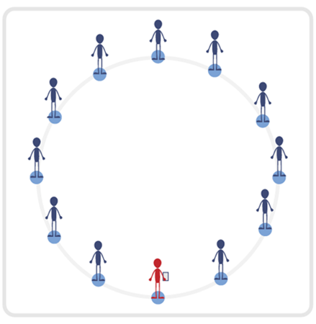
Equipment:
- 1 small cone per student
- Adventure Learning Core Values Card

Set-Up:
- Set up area with small cones in a large “Connection Circle.”
- Each student begins by a cone.
- Teacher begins by a cone as well, with a copy of the Adventure Learning Core Values Card.

ACTIVITY PROCEDURES
- This activity is called 1, 2, 3, Show! The object of the activity is to be the first partner to correctly solve a math problem while reinforcing our adventure learning core values.
- On the start signal, you will travel around the connection circle and find a partner. You will greet each other with a handshake, fist bump, or high 5 to reinforce the core values of adventure learning. You will then begin the first round of the game. Each partner will begin with a clinched fist and count out loud together 1, 2, 3, Show. On the word “show” you will both choose anywhere from 0-5 fingers to show at the same time. You will utilize some quick thinking to add together the total number of fingers being shown between both partners, and the first to call out the correct number wins! If there is a tie, play again until a winner is determined. Each partner will move through the connection circle and find a new classmate to play with after each round, but keep track of your number of wins.
- On the stop signal, we will determine who had the most number of wins. Teachers: you can also play another round using multiplication if your students are ready for that challenge. If you choose to use multiplication, no student can show a “0” as their number.

TEACHING CUES
- Cue 1: Begin each new connection with a handshake, fist bump, or high five.
- Cue 2: Connect with as many classmates as possible.
- Cue 3: Apply the 5 Adventure Learning Core Values throughout the activity.

1, 2, 3, SHOW (continued…)

UNIVERSAL DESIGN ADAPTATIONS
- UDL 1: Allow students to work with a partner if needed.
- UDL 2: Utilize visual demonstrations by students as needed.
- UDL 3: Provide modified movements or assistive technology as needed to ensure the activity is inclusive for all.

ACADEMIC LANGUAGE
Responsibility, Respect

PRIORITY OUTCOMES
Values Physical Activity - Social Interaction:
- (Grade 6) Demonstrates respect for self and others in activities and games by following the rules, encouraging others, and playing within the spirit of the game or activity.
- (Grade 7) Demonstrates the importance of social interaction by helping and encouraging others, avoiding trash talk, and providing support to classmates.
- (Grade 8) Demonstrates respect for self by asking for help and helping others in various physical activities.
- (Grades 9-12) Identifies and evaluates the opportunity for social interaction and social support in self-selected physical activities.

DEBRIEF QUESTIONS
- DOK 1: Provide an example of how you demonstrated one of the 5 Adventure Leaning Core Values during the activity.
- DOK 2: We were trying to make as many connections with classmates as possible during this activity. Why do you think it is important to make connections with your classmates?
- DOK 3: How can the connections you make during physical education have a positive impact on your school community as a whole?

ROBOTICS LAB

STUDENT TARGETS
- Skill: I will look for and then recognize open space in order to guide my robots safely into it.
- Cognitive: I will describe the benefits of being active with a group of friends.
- Fitness: I will stay actively engaged in physical education class in order to accumulate a maximum amount of physical activity minutes.
- Personal & Social Responsibility: I will work safely with my group members without teacher reminders.

EQUIPMENT & SET-UP | 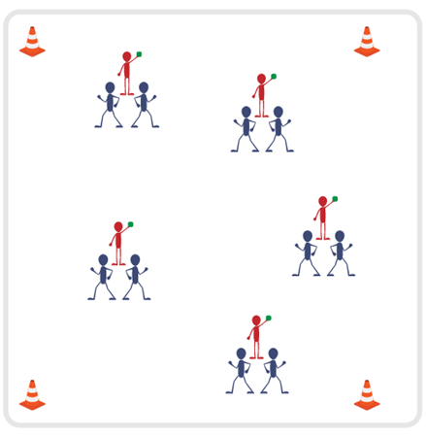
Equipment:
- 1 beanbag per 3 students
- 4 cones
- Music and music player

Set-Up:
- Create area boundaries with the 4 cones.
- Scatter groups of 3 students inside the activity area, each group with 1 beanbag.
- One student is the engineer and holds the beanbag (remote control). The other two are robots and stand back-to-back.

ACTIVITY PROCEDURES
- We’re about to turn physical education class into a robotics lab! The student in your group with the beanbag (the remote control) is the engineer. The other two students are the robots. It’s the engineer’s job to keep the robots under control by tapping them on the shoulder to turn them right or left.
- When the music starts, the robots will start to slowly march forward (each in opposite directions). Anytime a robot is blocked by a wall or another robot, she/he will march in place with her/his hands over her/his head. Robots must keep marching at all times (forward or in place).
- Engineers will work to safely steer their robots by tapping them on the shoulder of the direction they want them to turn. When tapped, robots will make a 90-degree turn. Engineers may not run; they will walk to their robots. Everyone freeze when the music stops.
TEACHING CUES
- Cue 1: Robots – march forward and avoid collisions by marching in place with hands up.
- Cue 2: Engineers – tap shoulders to turn robots and keep a walking pace.
- Cue 3: Apply the 5 Adventure Learning Core Values throughout the activity.

ROBOTICS LAB (continued…)

UNIVERSAL DESIGN ADAPTATIONS
- UDL 1: Allow students to work with a partner if needed.
- UDL 2: Utilize visual demonstrations by students as needed.
- UDL 3: Provide modified movements or assistive technology as needed to ensure the activity is inclusive for all.

ACADEMIC LANGUAGE
Social Interaction, Open Space, Safety

PRIORITY OUTCOMES
Values Physical Activity - Social Interaction:
- (Grade 6) Demonstrates respect for self and others in activities and games by following the rules, encouraging others, and playing within the spirit of the game or activity.
- (Grade 7) Demonstrates the importance of social interaction by helping and encouraging others, avoiding trash talk, and providing support to classmates.
- (Grade 8) Demonstrates respect for self by asking for help and helping others in various physical activities.
- (Grades 9-12) Identifies and evaluates the opportunity for social interaction and social support in self-selected physical activities.

DEBRIEF QUESTIONS
- DOK 1: How can you recognize safe behaviors?
- DOK 2: How would you compare and contrast safe behaviors with dangerous behaviors?
- DOK 3: Can you predict what would happen in our Robotics Lab activity if students acted in ways that were not safe?

LEANING TOWER

STUDENT TARGETS
- Skill: I will cooperate with my teammates to build a tower.
- Cognitive: I will discuss the importance of cooperation.
- Fitness: I will stay actively engaged during all activities.
- Personal & Social Responsibility: I will share equipment and space and work cooperatively.

EQUIPMENT & SET-UP | 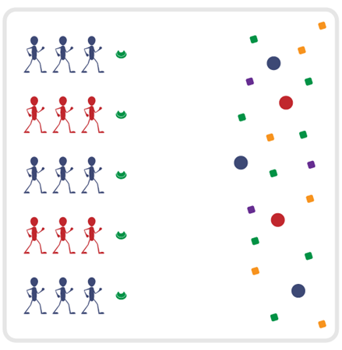
Equipment:
- 1 low-profile cone per group of 3–4 students
- 1 foam ball per group of 3–4 students
- 36+ bean bags

Set-Up:
- Space low-profile cones in a line along 1 side of the activity area.
- Scatter foam balls and bean bags on the opposite side of the play area.
- Create groups of 3–4 students; 1 group at each cone.

ACTIVITY PROCEDURES
- The name of this cooperative challenge is Leaning Tower. The object of the game is for each
team to create a tower on top of your cone using a foam ball and at least 3 bean bags.
- On the start signal, everyone on your team will move together to pick up a foam ball. Each
player must be touching the ball as you travel back to place the ball on the cone.
- In the same way, your team will then travel to pick up one bean bag, and then return to place the bean bag on top of the foam ball. Continue until your tower is built 3 or more bean bags high.
- If your tower falls at any time, you must return all materials back to the opposite sideline and
start over with a foam ball.
TEACHING CUES
- Cue 1: Move together as a team and use positive language.
- Cue 2: Listen to classmates while working together.
- Cue 3: Apply the 5 Adventure Learning Core Values throughout the activity.

LEANING TOWER (continued…)

UNIVERSAL DESIGN ADAPTATIONS
- UDL 1: Allow students to work with a partner if needed.
- UDL 2: Utilize visual demonstrations by students as needed.
- UDL 3: Provide modified movements or assistive technology as needed to ensure the activity is inclusive for all.

ACADEMIC LANGUAGE
Cooperation, Teamwork, Patience

PRIORITY OUTCOMES
Values Physical Activity - Social Interaction:
- (Grade 6) Demonstrates respect for self and others in activities and games by following the rules, encouraging others, and playing within the spirit of the game or activity.
- (Grade 7) Demonstrates the importance of social interaction by helping and encouraging others, avoiding trash talk, and providing support to classmates.
- (Grade 8) Demonstrates respect for self by asking for help and helping others in various physical activities.
- (Grades 9-12) Identifies and evaluates the opportunity for social interaction and social support in self-selected physical activities.

DEBRIEF QUESTIONS
- DOK 1: What does cooperation mean?
- DOK 2: What do you know about cooperation?
- DOK 3: How is cooperation related to success?

COUNT UP

STUDENT TARGETS
- Skill: I will demonstrate verbal communication skills and active listening throughout this activity.
- Cognitive: I will connect, listen, build trust, and reflect upon my experiences.
- Fitness: I will stay actively engaged throughout this activity.
- Personal & Social Responsibility: I will demonstrate respect for my classmates by following the rules of the activity and monitoring the safety of my blindfolded partner.

EQUIPMENT & SET-UP | 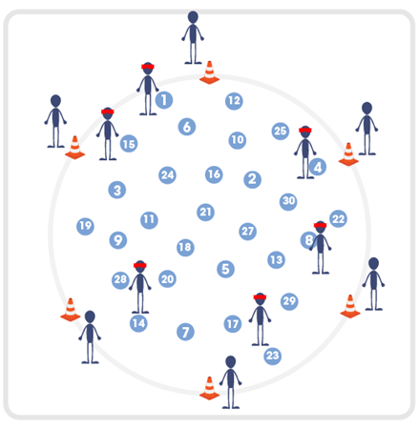
Equipment:
- Spot markers with numbers or cones with white boards to display numbers
- Blindfolds or bandannas
- Cones for perimeter boundary
Set-Up:
- Arrange the numbered spot markers or cones/white boards with numbers 1-30 randomly inside activity space. Ensure consecutive numbers are not next to each other and there is adequate space for students to move throughout area with numbers.
- Set up a circle of cones as a boundary around the outside of where the numbers are placed.
- Create teams of 2 students and have them begin at a boundary cone with a blindfold or bandanna.

ACTIVITY PROCEDURES
- This activity is called Count Up! The object is to utilize trust, communication, and listening skills to safely move through the activity space as a team. One partner will start with a blindfold on and standing beside any number, and the other partner will be the trust coach and will begin outside of the boundary cones as close to their partner as possible.
- On the start signal, the trust coach will begin to guide their partner using verbal communication only from one number to the next going in consecutive order. If you begin by the number 8, then your trust coach will use their best communication skills to guide you to the number 9. All blindfolded students will need to keep their arms extended in front of them at all times to create “bumpers” for safety. Trust coaches can move around anywhere outside of the boundary cones in order to ensure their partner can continue to hear their voice as they communicate how to travel to the next numbered cone.
- Your team gets one point for each successful numbered cone you reach safely. If you started by cone 8 and make it to cone 15 before the stop signal, your team would receive 7 points.
- On the stop signal, we will count up the points for your team and then you will switch roles for the second round.

TEACHING CUES
- Cue 1: Remember to always utilize your “bumpers” when you are blindfolded.
- Cue 2: Use clear and concise communication to articulate directions to your partner.
- Cue 3: Apply the 5 Adventure Learning Core Values throughout the activity.

COUNT UP (continued…)

UNIVERSAL DESIGN ADAPTATIONS
- UDL 1: Allow students to work with additional partners to assist with communication if needed.
- UDL 2: Utilize visual demonstrations by students as needed.
- UDL 3: Provide modified movements or assistive technology as needed to ensure the activity is inclusive for all.

ACADEMIC LANGUAGE
Trust, Strategy, Articulate

PRIORITY OUTCOMES
Values Physical Activity - Social Interaction:
- (Grade 6) Demonstrates respect for self and others in activities and games by following the rules, encouraging others, and playing within the spirit of the game or activity.
- (Grade 7) Demonstrates the importance of social interaction by helping and encouraging others, avoiding trash talk, and providing support to classmates.
- (Grade 8) Demonstrates respect for self by asking for help and helping others in various physical activities.
- (Grades 9-12) Identifies and evaluates the opportunity for social interaction and social support in self-selected physical activities.

DEBRIEF QUESTIONS
- DOK 1: What type of communication worked best for you during the Count Up activity?
- DOK 2: Explain how your trust coach moving around during the activity made you feel. Was there ever a moment you felt alone?
- DOK 3: This activity required a lot of trust with your partner. How does having patience during trust building activities change your experience and help you feel comfortable?

PARTNER PATHWAYS

STUDENT TARGETS
- Skill: I will demonstrate verbal communication skills and active listening throughout this activity.
- Cognitive: I will build trust with my classmates and reflect upon my experiences.
- Fitness: I will stay actively engaged throughout this activity.
- Personal & Social Responsibility: I will demonstrate respect for my classmates by following the rules of the activity and keeping them safe throughout the blindfolded trust building experience.

EQUIPMENT & SET-UP | 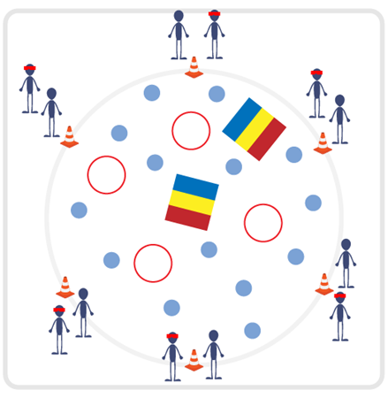
Equipment:
- Spot markers with numbers
- Blindfolds or bandannas
- Variety of objects that can be safely spread out in activity area (gymnastics mat, multi-goal, hula hoop, etc.).
Set-Up:
- Arrange numbered spot markers and objects randomly inside activity space. Ensure there is adequate space for students to move between numbered spot markers and objects safely.
- Create teams of 2 students and have them begin around the perimeter of the activity space with a blindfold or bandanna.

ACTIVITY PROCEDURES
- This activity is called Partner Pathways! The object is to utilize trust, communication, and listening skills to safely move through the activity space as a team. One partner will start with a blindfold on, and the other partner will be the trust coach and will begin about 3 feet away from their partner.
- On the start signal, the trust coach will begin to guide their partner, using verbal communication only from one object to the next. The trust coach determines what object they will guide their partner to next during the activity. All blindfolded students will need to keep their arms extended in front of them at all times to create “bumpers” for safety. If you have a team of 3 students, then two students will be blindfolded at the same time and will extend their outside arms as “bumpers” for safety. Trust coaches will move around about 3 feet from their partner so they can communicate how to travel to the next object.
- Your team gets one point for each object you reach safely. But be careful! If the blindfolded partner bumps into another student, then you subtract one point from your team.
- On the stop signal, we will count up the points for your team and then you will switch roles for the second round.

TEACHING CUES
- Cue 1: Remember to always utilize your “bumpers” when you are blindfolded.
- Cue 2: Use clear and concise communication to articulate directions to your partner.
- Cue 3: Apply the 5 Adventure Learning Core Values throughout the activity.

PARTNER PATHWAYS (continued…)

UNIVERSAL DESIGN ADAPTATIONS
- UDL 1: Allow students to work with additional partners to assist with communication if needed.
- UDL 2: Utilize visual demonstrations by students as needed.
- UDL 3: Provide modified movements or assistive technology as needed to ensure the activity is inclusive for all.

ACADEMIC LANGUAGE
Trust, Safety

PRIORITY OUTCOMES
Values Physical Activity - Social Interaction:
- (Grade 6) Demonstrates respect for self and others in activities and games by following the rules, encouraging others, and playing within the spirit of the game or activity.
- (Grade 7) Demonstrates the importance of social interaction by helping and encouraging others, avoiding trash talk, and providing support to classmates.
- (Grade 8) Demonstrates respect for self by asking for help and helping others in various physical activities.
- (Grades 9-12) Identifies and evaluates the opportunity for social interaction and social support in self-selected physical activities.

DEBRIEF QUESTIONS
- DOK 1: What does trust mean to you?
- DOK 2: Explain why building trust with your partner during this activity was so important.
- DOK 3: How can learning to build trust with your classmates help you outside of physical education?

TREASURE HUNT

STUDENT TARGETS
- Skill: I will demonstrate verbal communication skills and active listening throughout this activity.
- Cognitive: I will connect, listen, build trust, and reflect upon my experiences.
- Fitness: I will stay actively engaged throughout this activity.
- Personal & Social Responsibility: I will demonstrate respect for my classmates by following the rules of the activity and monitoring the safety of my blindfolded partner.

EQUIPMENT & SET-UP | 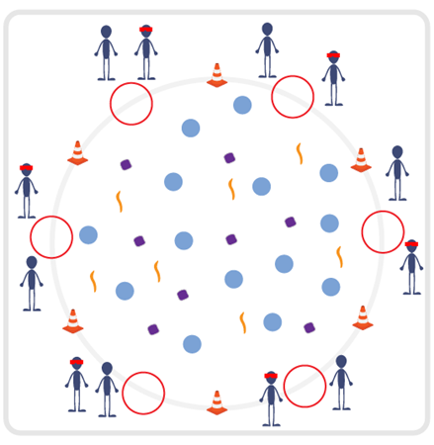
Equipment:
- Boundary cones
- Blindfolds or bandannas
- Variety of objects that can be safely spread out in activity area (bean bags, scarves, spot markers, Garden Heroes, etc.).
- 1 hula hoop per team
Set-Up:
- Arrange objects randomly inside activity space. Ensure there is adequate space for students to move between spot markers and objects safely. Please do not include objects such as a foam ball that could cause a blindfolded student to fall or roll an ankle.
- Create teams of 2 students and have them begin outside the perimeter of the activity space with a blindfold or bandanna, standing next to a hula hoop.

ACTIVITY PROCEDURES
- This activity is called Treasure Hunt! The object is to utilize communication and listening skills to safely move through the activity space and collect as many treasures as possible. One partner will start with a blindfold on, and the other partner will be the trust coach. Your team will begin next to your hula hoop outside of the boundary cones.
- On the start signal, the trust coach will begin to guide their partner using verbal communication only into the activity space. All blindfolded students will need to keep their arms extended in front of them at all times to create “bumpers” for safety. Trust coaches can move around anywhere outside of the boundary cones in order to ensure their partner can continue to hear their voice as they communicate how to travel from object to object.
- Your team gets one point for each object the blindfolded team member is able to collect and bring back to your hula hoop. You are only allowed to collect one piece of treasure per trip, and you must switch roles each time someone brings a treasure back to your hoop.
- On the stop signal, or when all treasure is collected, we will count up the points for each team.

TEACHING CUES
- Cue 1: Remember to always utilize your “bumpers” when you are blindfolded.
- Cue 2: Use clear and concise communication to articulate directions to your partner.
- Cue 3: Apply the 5 Adventure Learning Core Values throughout the activity.

TREASURE HUNT (continued…)

UNIVERSAL DESIGN ADAPTATIONS
- UDL 1: Allow students to work with additional partners to assist with communication if needed.
- UDL 2: Utilize visual demonstrations by students as needed.
- UDL 3: Provide modified movements or assistive technology as needed to ensure the activity is inclusive for all.

ACADEMIC LANGUAGE
Communication, Trust, Strategy

PRIORITY OUTCOMES
Values Physical Activity - Social Interaction:
- (Grade 6) Demonstrates respect for self and others in activities and games by following the rules, encouraging others, and playing within the spirit of the game or activity.
- (Grade 7) Demonstrates the importance of social interaction by helping and encouraging others, avoiding trash talk, and providing support to classmates.
- (Grade 8) Demonstrates respect for self by asking for help and helping others in various physical activities.
- (Grades 9-12) Identifies and evaluates the opportunity for social interaction and social support in self-selected physical activities.

DEBRIEF QUESTIONS
- DOK 1: Was there a strategy that your team used during this activity?
- DOK 2: Sometimes we use a strategy during a game or activity, and it doesn’t work well. Was there a communication strategy that you tried during this game that didn’t work very well? What did you do differently if you realized a communication strategy wasn’t working for your team?

