CIRCLE THE WAGONS

STUDENT TARGETS
- Skill: I will demonstrate verbal communication skills and active listening throughout this activity.
- Cognitive: I will identify the five core values of adventure learning.
- Fitness: I will stay actively engaged throughout this activity.
- Personal & Social Responsibility: I will be respectful of all classmates during this activity.
EQUIPMENT & SET-UP | 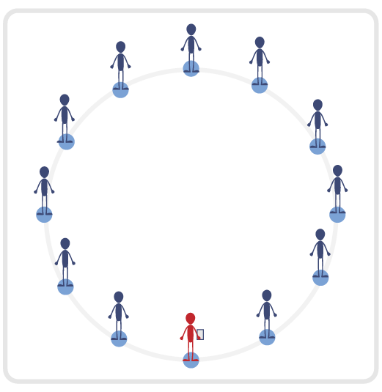
Equipment:
- Blindfold for each student
- Adventure Learning Core Values Card

Set-Up:
- Have the entire class begin by standing in a connection circle.
- Safety Tip: Ensure activity space is completely clear of all objects as students will be blindfolded.
- Review the 5 Adventure Learning Core Values before beginning this activity.
ACTIVITY PROCEDURES
- This activity is called Circle the Wagons! The object of the game is to reconnect our connection circle while everyone is blindfolded. You will use communication and listening skills to locate your partners.
- We will all begin in our connection circle. On the start signal, you will introduce yourself to the person on the right and the person on the left and give a “high five” or a handshake. These people will become your partners that you are trying to reconnect with, so make sure you learn and remember their names! If your partners have the same name as someone else in the group, use last name initials or a nickname to make sure you can reconnect with them.
- Each of you will now spread out in the activity space and place your blindfold over your eyes. Using verbal communication and listening skills, begin to call out the two names of your partners. While your “bumpers” are up (arms extended directly in front of you) begin to move slowly and safely in general space until you hear one of your partners. Once you are able to locate one of your partners, you will reconnect with an overhand wrist grip so that everyone can continue to use safety “bumpers”.
- Now that you have found one of your partners, continue the process until you find the other partner as well. Remember to be respectful and work together to move with your partner through the space (without pulling or moving too quickly). If you have reconnected with both of your partners, be a good teammate until they have found both of their partners too. Teachers: students who have found their partners no longer need to use verbal communication. This allows students who are still looking for their partners to have fewer distractions and find them faster.
- The activity will end when everyone has found both partners and our entire team is reconnected.
- Teachers: have students remove their blindfolds once the entire team is reconnected.
TEACHING CUES
- Cue 1: Keep your “bumpers” up at all times.
- Cue 2: Move carefully through the activity space (avoid pulling your partners, running, or fast movements).
- Cue 3: Apply the 5 Adventure Learning Core Values throughout the activity.

CIRCLE THE WAGONS (continued…)

UNIVERSAL DESIGN ADAPTATIONS
- UDL 1: Allow students to move through space as a group of 3 if needed.
- UDL 2: Utilize visual demonstrations by students as needed.
- UDL 3: Provide modified movements to ensure the activity is inclusive for all.

ACADEMIC LANGUAGE
Cooperation, Trust, Safety

PRIORITY OUTCOMES
Values Physical Activity - Social Interaction:
- (Grade 6) Demonstrates respect for self and others in activities and games by following the rules, encouraging others, and playing within the spirit of the game or activity.
- (Grade 7) Demonstrates the importance of social interaction by helping and encouraging others, avoiding trash talk, and providing support to classmates.
- (Grade 8) Demonstrates respect for self by asking for help and helping others in various physical activities.
- (Grades 9-12) Identifies and evaluates the opportunity for social interaction and social support in self-selected physical activities.

DEBRIEF QUESTIONS
- DOK 1: Provide an example of how you demonstrated one of the 5 Adventure Learning Core Values during the activity.
- DOK 2: Why was trust important during this activity?
- DOK 3: How does having trust with your partner impact your willingness to be open-minded and try new activities?

