DUCKS AND DOGS

STUDENT TARGETS
- Skill: I will demonstrate verbal communication skills and active listening throughout this activity.
- Cognitive: I will identify the five core values of adventure learning.
- Fitness: I will stay actively engaged throughout this activity.
- Personal & Social Responsibility: I will be respectful of all classmates during this activity.
EQUIPMENT & SET-UP | 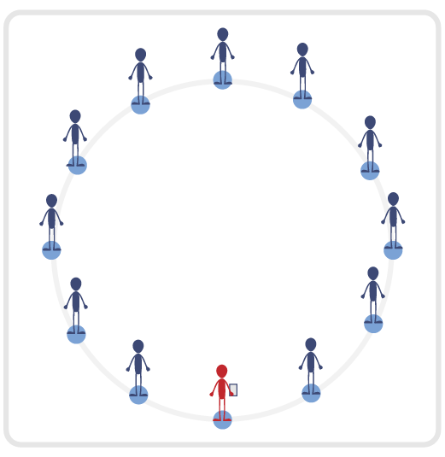
Equipment:
- Blindfold for each student
- Adventure Learning Core Values Card

Set-Up:
- Have the entire class begin by standing in a connection circle. Split the circle in half with two equal teams.
- Safety Tip: Ensure activity space is completely clear of all objects as students will be blindfolded.
- Review the 5 Adventure Learning Core Values before beginning this activity.
ACTIVITY PROCEDURES
- This activity is called Ducks and Dogs! The object of the game is to reconnect each of your teams (one for Ducks and one for Dogs) while everyone is blindfolded. You will use communication and listening skills to reconnect with your entire team.
- We will begin in a connection circle with your team (one team for Ducks and one team for Dogs). Your team will have a conversation to determine how their assigned animal will sound. This sound is how you will find and reconnect with your team. The only verbal communication during this activity will be your animal sound.
- Each team will spread out evenly throughout the activity space. Once both teams are spread out, each person will place their blindfold over their eyes. On the start signal, place your “bumpers” up (arms extended directly in front of you). Teachers: you could have students spin in a circle three times once their blindfolds are on before beginning to move. Begin to move slowly and safely in general space until you hear one of your teammates. Once you are able to locate one of your teammates, you will reconnect with an overhand wrist grip so that everyone can continue to use safety “bumpers”.
- Now that you have found one of your teammates, continue the process until you are able to reconnect with the rest of your team. Remember to be respectful and work together to move with your teammates through the space (without pulling or moving too quickly).
- The activity will end when both teams have successfully reconnected. Winning team is the one who fully reconnects first. Teachers: have students remove their blindfolds once their team is reconnected.
TEACHING CUES
- Cue 1: Keep your “bumpers” up at all times.
- Cue 2: Move carefully through the activity space (avoid pulling your partners, running, or fast movements).
- Cue 3: Apply the 5 Adventure Learning Core Values throughout the activity.

DUCKS AND DOGS (continued…)

UNIVERSAL DESIGN ADAPTATIONS
- UDL 1: Allow students to have a peer partner as they move if needed.
- UDL 2: Utilize visual demonstrations by students as needed.
- UDL 3: Provide modified movements to ensure the activity is inclusive for all.

ACADEMIC LANGUAGE
Responsibility, Actively Engage, Challenge, Connection

PRIORITY OUTCOMES
Values Physical Activity - Social Interaction:
- (Grade 6) Demonstrates respect for self and others in activities and games by following the rules, encouraging others, and playing within the spirit of the game or activity.
- (Grade 7) Demonstrates the importance of social interaction by helping and encouraging others, avoiding trash talk, and providing support to classmates.
- (Grade 8) Demonstrates respect for self by asking for help and helping others in various physical activities.
- (Grades 9-12) Identifies and evaluates the opportunity for social interaction and social support in self-selected physical activities.

DEBRIEF QUESTIONS
- DOK 1: Provide an example of how you demonstrated one of the 5 Adventure Learning Core Values during the activity.
- DOK 2: Why was being open-minded important during this activity?
- DOK 3: How does being open-minded impact your willingness to try new activities and experience new challenges?

