HEADS SHOULDERS KNEES TOES

STUDENT TARGETS
- Skill: I will demonstrate the five core values of adventure learning.
- Cognitive: I will work to anticipate the movements of my partner during this activity.
- Fitness: I will stay actively engaged throughout this activity.
- Personal & Social Responsibility: I will be respectful of all classmates during this activity.
EQUIPMENT & SET-UP | 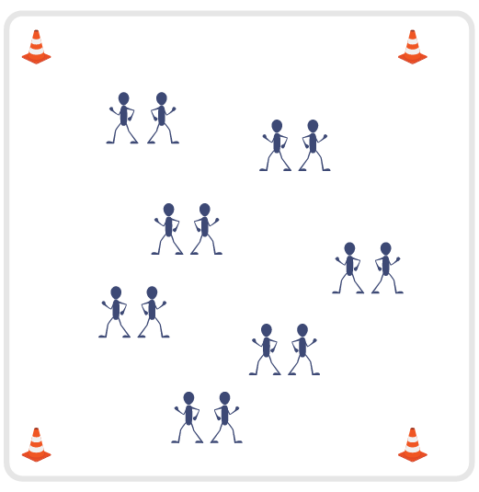
Equipment:
- Adventure Learning Core Values Card

Set-Up:
- Have the entire class begin by standing in a connection circle. Split the circle in half with two equal teams.
- Review the 5 Adventure Learning Core Values before beginning this activity.
- Students will pair up and stand back-to-back with their partner.
ACTIVITY PROCEDURES
- This activity is called Head Shoulders Knees and Toes. The object of the game is to match movements with your partner as quickly as possible to have the lowest score possible at the end of the activity, similar to golf.
- You will begin standing back-to-back with your partner. Each student will secretly select Head, Shoulders, Knees or Toes before they turn around and try to match movements with their partner. On the start signal, one partner will call out “1, 2, 3, Show!” and both partners will simultaneously turn around and face each other in an attempt to match Head, Shoulders, Knees or Toes. You want to match your partner’s movements in the fewest number of attempts, but remember we are not able to communicate or make a plan before we turn!
- Keep track of your score after each round. If it took you and your partner 3 attempts before you were able to match movements, then your score for that partner would be a 3.
- Once you and your partner have connected with a match, you will close with a high five and move through the activity space to find a new partner. You will add your score after matching with each new partner for your total score at the end.
- The activity will end when you hear the stop signal. Winning player is the one with the lowest total score.
- Teachers: You can choose to call out “1, 2, 3, Show!” for the first few attempts to ensure students understand the rules. Then students can take over leadership for the remaining time in the activity.
TEACHING CUES
- Cue 1: Keep some space between you and your partner when you begin back to back. This keeps everyone safe as you turn around.
- Cue 2: Try to match movements with as many different partners as possible during the activity.
- Cue 3: Apply the 5 Adventure Learning Core Values throughout the activity.

HEAD SHOULDERS KNEES TOES (continued…)

UNIVERSAL DESIGN ADAPTATIONS
- UDL 1: Allow students to have a peer partner as they move if needed.
- UDL 2: Utilize visual demonstrations by students as needed.
- UDL 3: Provide modified movements to ensure the activity is inclusive for all.

ACADEMIC LANGUAGE
Anticipate, Open-minded, Patience, Connection

PRIORITY OUTCOMES
Values Physical Activity - Social Interaction:
- (Grade 6) Demonstrates respect for self and others in activities and games by following the rules, encouraging others, and playing within the spirit of the game or activity.
- (Grade 7) Demonstrates the importance of social interaction by helping and encouraging others, avoiding trash talk, and providing support to classmates.
- (Grade 8) Demonstrates respect for self by asking for help and helping others in various physical activities.
- (Grades 9-12) Identifies and evaluates the opportunity for social interaction and social support in self-selected physical activities.

DEBRIEF QUESTIONS
- DOK 1: Provide an example of how you demonstrated one of the 5 Adventure Learning Core Values during the activity.
- DOK 2: Why was being respectful important during this activity?
- DOK 3: How does being respectful impact your success when you try new activities and experience new challenges?

