LOOK UP

STUDENT TARGETS
- Skill: I will demonstrate the five core values of adventure learning.
- Cognitive: I will describe the benefits of being active with my friends.
- Fitness: I will stay actively engaged throughout this activity.
- Personal & Social Responsibility: I will be respectful of all classmates during this activity.
EQUIPMENT & SET-UP | 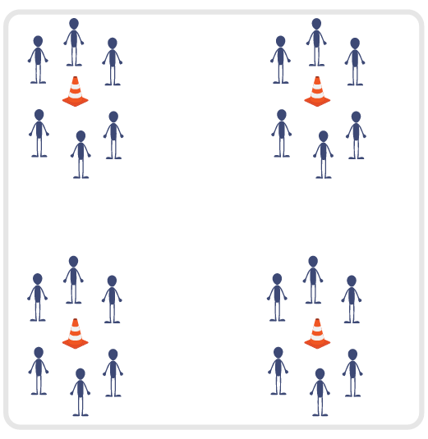
Equipment:
- 3-4 Large Cones (have 1 cone for every 10 students)
- Task tent for each cone
- Adventure Learning Core Values Card for each cone
Set-Up:
- Place the large cones approximately 30 feet apart in the activity space (e.g., 3 cones can create a triangle, 4 cones can create a square).
- Divide class into 3-4 even groups. Each group will begin at a cone in a small circle (facing their cone).
- Place Core Values Card in a task tent on each cone, and review the 5 Adventure Learning Core Values before beginning this activity.
ACTIVITY PROCEDURES
- This activity is called Look Up. The object of the game is to randomly connect with as many different classmates as possible to collect points.
- You will begin standing in a circle with your group facing the cone. Each of you will look down at the cone, and while looking down you will secretly choose a classmate that you will try to make eye contact with once you look up. I will say “Look Down; 1, 2, 3, Look Up!” and each of you will look directly at the person you secretly chose to make eye contact with. You want to earn a point by connecting with the person you chose (you would have both secretly chosen each other). But remember you are not able to verbally or nonverbally communicate or make a plan before you look up!
- If you and a classmate have both chosen each other and made eye contact, celebrate with an enthusiastic High-5 and then each of you will move to a different cone (you cannot choose to move to the same cone together). If you did not make a connection, you will stay at the same cone and try again. You get one point for each successful eye contact/connection that is made.
- Once you have successfully chosen a classmate and made a connection, try to choose a different classmate each time you look up. Note: Teachers can move cones further apart at various times during the activity (add approximately 10 feet each time you move them).
- The activity will end when you hear the stop signal. Winning player is the one who made the most successful connections and earned the most points!
- Teachers: You can call out “1, 2, 3, Look Up!” for the first few attempts to ensure students understand the rules. Then students can take over leadership at each cone for the remaining time in the activity.
TEACHING CUES
- Cue 1: Make sure to not communicate or make a plan with the person you choose before looking up.
- Cue 2: Try to make eye contact with as many different partners as possible during the activity.
- Cue 3: Apply the 5 Adventure Learning Core Values throughout the activity.

LOOK UP (continued…)

UNIVERSAL DESIGN ADAPTATIONS
- UDL 1: Allow students to have a peer partner as they move if needed.
- UDL 2: Utilize visual demonstrations by students as needed.
- UDL 3: Provide modified movements to ensure the activity is inclusive for all.

ACADEMIC LANGUAGE
Honesty, Enthusiasm, Connection

PRIORITY OUTCOMES
Values Physical Activity - Social Interaction:
- (Grade 6) Demonstrates respect for self and others in activities and games by following the rules, encouraging others, and playing within the spirit of the game or activity.
- (Grade 7) Demonstrates the importance of social interaction by helping and encouraging others, avoiding trash talk, and providing support to classmates.
- (Grade 8) Demonstrates respect for self by asking for help and helping others in various physical activities.
- (Grades 9-12) Identifies and evaluates the opportunity for social interaction and social support in self-selected physical activities.

DEBRIEF QUESTIONS
- DOK 1: Provide an example of how you demonstrated one of the 5 Adventure Learning Core Values during the activity.
- DOK 2: What are some of the benefits of being active with your friends?
- DOK 3: How does being active with your friends during PE class influence your willingness to be active and try new experiences with them outside of school?

