WAH MASTER

STUDENT TARGETS
- Skill: I will demonstrate the five core values of adventure learning.
- Cognitive: I will describe the benefits of being active with my friends.
- Fitness: I will stay actively engaged throughout this activity.
- Personal & Social Responsibility: I will be respectful of all classmates during this activity.
EQUIPMENT & SET-UP | 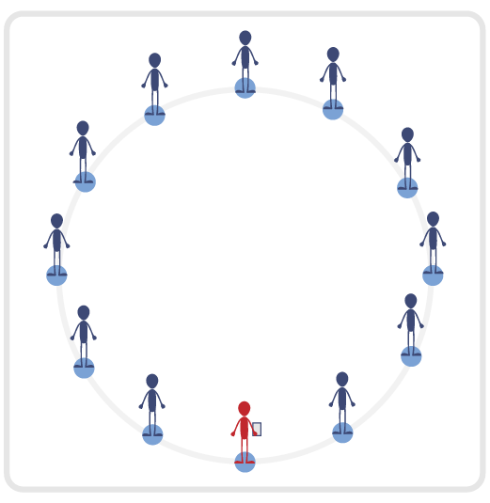
Equipment:
- 1 small cone per student
- Adventure Learning Core Values Card

Set-Up:
- Set up area with small cones in a large “Connection Circle.”
- Each student begins by a cone.
- Teacher begins by a cone as well, with a copy of the Adventure Learning Core Values Card.
ACTIVITY PROCEDURES
- This activity is called Wah Master. The object of the game is to take the mystical “Waaaah” from the Wah Master by anticipating what sign they will show. The teacher will begin as the Wah Master.
- As a Wah Master, I will lead you all in a game to see if you can take the mystical “Waaaah” from me. I will show one of three symbols: Fireball, Snake, or Grizzly Bear. Wah Masters have the ability to read the minds of the other players. Your challenge will be to show a symbol at the same time as me and try not to match what I show.
- There are three symbols we will represent with arm motions. Fireball is represented by arms crossed like an X in front of your chest. Snake is shown with one arm making a slithering motion. Bear is shown with both arms up with fingers in a claw position like a growling bear.
- I will begin by enthusiastically counting out loud and saying “1, 2, 3, Waaaah!” The leader will say, “1, 2, 3, Waaaah!” and show their symbol while the group will simultaneously show their own symbol. Participants are encouraged to say “Waaaah!” at each round.
- At the end of each round, those that match the Wah Master will take a knee and those that do not match will take one step forward and stay in the game. But remember, the person who holds the mystical “Waaaah” has two lives! The Wah Master would lose one life if everyone remaining in the game did not match their sign during that round.
- If you are the last one standing, you get to see if you can take the mystical “Waaaah” in a one-on-one show down!
- Teachers: The winner of the game should be able to hold the title of Wah Master for the rest of that day and should lead as the Wah Master the next time the game is played.

TEACHING CUES
- Cue 1: Bring your enthusiasm and energy to each round of the game.
- Cue 2: Remember to be honest with your sign for each round - changing your sign is not allowed.
- Cue 3: Apply the 5 Adventure Learning Core Values throughout the activity.

WAH MASTER (continued…)

UNIVERSAL DESIGN ADAPTATIONS
- UDL 1: Allow students to have a peer partner as they move if needed.
- UDL 2: Utilize visual demonstrations by students as needed.
- UDL 3: Provide modified movements to ensure the activity is inclusive for all.

ACADEMIC LANGUAGE
Honesty, Enthusiasm, Energy, Connection

PRIORITY OUTCOMES
Values Physical Activity - Social Interaction:
- (Grade 6) Demonstrates respect for self and others in activities and games by following the rules, encouraging others, and playing within the spirit of the game or activity.
- (Grade 7) Demonstrates the importance of social interaction by helping and encouraging others, avoiding trash talk, and providing support to classmates.
- (Grade 8) Demonstrates respect for self by asking for help and helping others in various physical activities.
- (Grades 9-12) Identifies and evaluates the opportunity for social interaction and social support in self-selected physical activities.

DEBRIEF QUESTIONS
- DOK 1: Provide an example of how you demonstrated one of the 5 Adventure Learning Core Values during the activity.
- DOK 2: What are some of the benefits of being active with your friends?
- DOK 3: How does being active with your friends during PE class influence your willingness to be active and try new experiences with them outside of school?

