PASS AND SET CIRCLES

STUDENT TARGETS
- Skill: I will accurately pass the ball back to a partner.
- Cognitive: I will describe how hand position and force impacts the level of control.
- Fitness: I will actively engage and work to improve my striking and volleying skills.
- Personal & Social Responsibility: I will work cooperatively with my classmates.

EQUIPMENT & SET-UP | 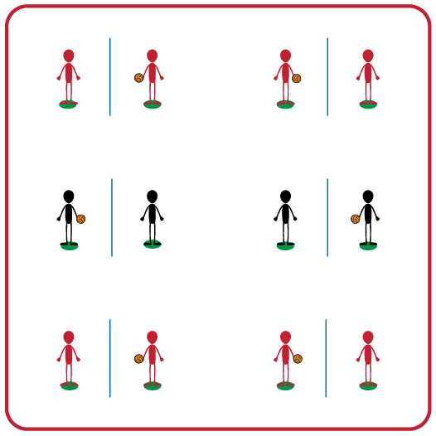
Equipment:
- Foam ball for each pair of 2 students
- Jump rope (optional) for each pair of 2 students
- Spot marker for each student

Set-Up:
- Place spot markers 3-5 feet apart.
- Place a jump rope on the ground between each set of spot markers.
- Pair students in groups of 2. Each pair of 2 students will begin with a foam ball and will stand on a spot marker facing their partner (with the jump rope on the ground between them).

ACTIVITY PROCEDURES
- This activity is called Pass and Set Circles. The object of the game is to successfully toss and return a foam ball with a partner. You do that by tossing the ball to a partner who will either forearm pass (bump) or overhead pass (set) back to the tosser.
- On the start signal the tosser will complete 5 tosses to their partner, who will return each toss back to them using a bump (e.g., toss, bump, catch). Then the partners will switch roles after each set of 5 attempts.
- On the stop signal the partner with the ball will place the ball between their shoes while the partner without the ball will find a new partner. You will then switch to a set instead of a bump.
- Teachers: Remind students that a good toss will help set their partner up for an accurate bump or set back to them.

GRADE LEVEL PROGRESSION
- Grade 3: Play as described above.
- Grade 4: Toss and bump/set continuously with a partner.
- Grade 5: Have partners join another group to toss and bump/set continuously with a group of 4.

TEACHING CUES
- Cue 1: Body in ready position (knees bent, head up, feet shoulders width apart, hands ready, facing partner).
- Cue 2: Toss “rainbows” and not “lightning bolts” to your partner.
- Cue 3: Power comes from the legs not the arms.

PASS AND SET CIRCLES (continued…)

UNIVERSAL DESIGN ADAPTATIONS
- UDL 1: Increase/decrease the size of the activity space.
- UDL 2: Use modified equipment as needed (e.g., beeper ball, balloon, beach ball).
- UDL 3: Use verbal cues and visual aids along with demonstrations.
- UDL 4: Use peer partners as appropriate.

ACADEMIC LANGUAGE
Volley, Toss, Bump, Set, Pass, Rally

PRIORITY OUTCOMES
Working With Others:
- (3) Works cooperatively with others.
- (4) Accepts “players” of all skill levels into the physical activity.
- (5) Accepts, recognizes, and actively involves others with both higher and lower skill abilities into physical activities and group projects.

DEBRIEF QUESTIONS
- DOK 1: What does it look like when partners work together? Sound like? Feel like?
- DOK 2: How does working with a partner compare to working with a group?
- DOK 3: In what way does force and hand position affect the pathway of the ball?

