VOLLEY HOOPS

STUDENT TARGETS
- Skill: I will underhand serve with accuracy.
- Cognitive: I will describe the cues for a proper serve.
- Fitness: I will actively engage and work to improve my underhand serving.
- Personal & Social Responsibility: I will describe characteristics of an appropriate response when giving or receiving feedback.

EQUIPMENT & SET-UP | 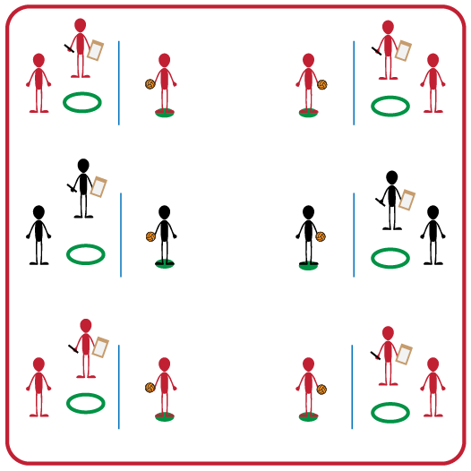
Equipment:
- Foam Ball (1 per group of 3)
- Jump Rope (1 per group of 3)
- Hula Hoop (1 per group of 3)
- Spot Marker (1 per group of 3)
- Clipboard (1 per group of 3)
- Pencil (1 per group of 3)
- Peer Feedback Form (1 per group of 3)
Set-Up:
- Divide students into groups of 3.
- Each group will place their jump rope on the ground, with a spot maker 3-5 feet from the jump rope on one side and a hula hoop 3-5 feet from the jump rope on the opposite side.
- Each group will have a clipboard with a Peer Feedback Form and pencil.

ACTIVITY PROCEDURES
- This activity is called Volley Hoops. The object of the activity is to give specific and appropriate feedback to our classmates. You do that by observing their underhand serve to a stationary hula hoop and then providing feedback to help them improve.
- Each person in your group will have one of three positions: server, rebounder, or observer.
- On the start signal, servers will underhand strike the foam ball and try to make it land inside the hula hoop. Rebounders will collect the foam ball and return it to the server. Observers will fill out the Peer Feedback Form. Each student will perform 5 serve attempts and then you will rotate positions until everyone in your group has been observed.
- On the stop signal you will place the feedback form and ball into the hula hoop so we can discuss our successes and challenges before we play again.
- During the second round, we will see if your scores can improve by using the feedback you were given.
GRADE LEVEL PROGRESSION
- Grade 3: Participate without using the peer feedback form.
- Grade 4: Play as described above.
- Grade 5: Convert rebounder into a serve receiver/passer.
TEACHING CUES
- Cue 1: Use positive language with your classmates when giving feedback.
- Cue 2: Hold ball in non-dominant hand and have non-dominant foot in front.
- Cue 3: Pull arm back and swing to strike low with palm.

VOLLEY HOOPS (continued…)

UNIVERSAL DESIGN ADAPTATIONS
- UDL 1: Increase/decrease the distance from hoop to spot marker as needed.
- UDL 2: Use modified equipment as needed (e.g., beeper ball, balloon, beach ball).
- UDL 3: Use verbal cues and visual aids along with demonstrations.
- UDL 4: Use peer partners as appropriate.
- UDL 5: Modify Peer Feedback Form to meet needs of all students, including use of assistive technology.

ACADEMIC LANGUAGE
Feedback, Serve, Underhand, Target, Rebound

PRIORITY OUTCOMES
Accepting Feedback:
- (3) Accepts and implements specific corrective teacher feedback.
- (4) Listens respectfully to corrective feedback from others (adults and peers).
- (5) Gives corrective feedback respectfully to peers.

DEBRIEF QUESTIONS
- DOK 1: How can you recognize corrective feedback?
- DOK 2: How is positive language related to corrective feedback?
- DOK 3: How would you compare and contrast corrective feedback and negative criticism?
- DOK 3: Let’s create a list of ground rules for providing and receiving corrective feedback.

