I GOT IT! I GOT IT!

STUDENT TARGETS
- Skill: I will track a serve to anticipate where it will land.
- Cognitive: I will list the cues for an underhand serve.
- Fitness: I will actively engage and work to improve my serving and tracking skills.
- Personal & Social Responsibility: I will use positive language and challenge my partner(s) to improve.

EQUIPMENT & SET-UP | 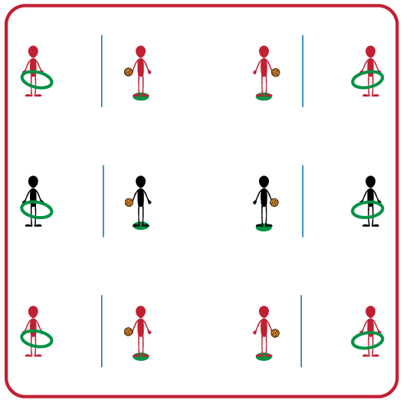
Equipment:
- 1 Jump Rope per group
- 1 Foam Ball per group
- 1 Hula Hoop per group
- 1 Spot marker per group

Set-Up:
- Divide students into groups of 2.
- Divide each group’s activity space in half using a jump rope.
- Place a spot marker 3-5 feet away from the jump rope and place a hula hoop on the opposite side of the rope.
- One partner will stand on the spot marker with the foam ball, and other partner will be on opposite side of jump rope holding the hula hoop.

ACTIVITY PROCEDURES
- This activity is called I Got It! I Got It! The object of the game is to track the serve and anticipate where it will land. You do that by moving a held hula hoop in the path of the serve.
- On the start signal the player on the spot marker will serve the ball high over the rope. The partner with the hula hoop will track the path of the ball to anticipate where they think it will land. If the partner receiving the serve can hold the hoop so that the serve goes through it before hitting the ground, they score a point. You and your partner will switch roles after every 5 serve attempts.
- On the stop signal players will return equipment to the starting positions.
- Once the equipment is back to the starting position, the partner on the side of the rope with the hula hoop will go and find a new partner to play again. The partner with the foam ball will stay on the spot marker until a new partner has joined their team.

GRADE LEVEL PROGRESSION
- Grade 3: Play as described above.
- Grade 4: Players must put the hula hoop on the ground where they anticipate it will land instead of letting the foam ball pass through the hoop in the air.
- Grade 5: Players attempt to catch the foam ball after it bounces inside the hoop.

TEACHING CUES
- Cue 1: Hold ball in non-dominant hand and have non-dominant foot in front.
- Cue 2: Pull arm back and swing to strike low with palm.
- Cue 3: Move to get under the ball when receiving/tracking the serve.
I GOT IT! I GOT IT! (continued…)

UNIVERSAL DESIGN ADAPTATIONS
- UDL 1: Increase/decrease the size of target/activity space.
- UDL 2: Use modified equipment as needed (e.g., beeper ball, balloon, beach ball).
- UDL 3: Use verbal cues and visual aids along with demonstrations.
- UDL 4: Use peer partners as appropriate.

ACADEMIC LANGUAGE
Accuracy, Estimate, Anticipate, Tracking

PRIORITY OUTCOMES
Manipulative Skills:
- (3) Demonstrates manipulative skills using mature patterns for accuracy and control.
- (4) Combines locomotor and manipulative skills using mature patterns for accuracy and control in static and dynamic environments.
- (5) Executes a variety of manipulative skills with control and accuracy in small-sided games.

DEBRIEF QUESTIONS
- DOK 1: Can you list the cues for an underhand serve?
- DOK 2: What was a strategy you used to help track the ball after it was served to anticipate where it would land?

