VOLLEY BATTLESHIP

STUDENT TARGETS
- Skill: I will accurately underhand serve the ball into a designated space.
- Cognitive: I will discuss the challenge that comes from learning new physical activities.
- Fitness: I will stay actively engaged throughout this activity.
- Personal & Social Responsibility: I will use good sportsmanship by shaking hands or giving a high five to the other team after each game.

EQUIPMENT & SET-UP | 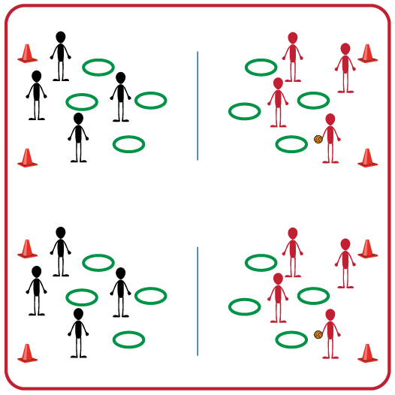
Equipment:
- Jump Rope for each set of 2 teams
- 1 Hoop per student
- 4 boundary cones for each set of 2 teams
- 1 foam ball for each set of 2 teams

Set-Up:
- Divide students into equal teams (e.g., 3v3 or 4v4).
- Two equal teams will play against one another. Divide the space for each set of two teams into equal areas with the jump rope in the middle and 4 cones to set the boundaries.
- Each student will begin with a hula hoop. Teams face each other on opposite sides of the jump rope in their activity space.

ACTIVITY PROCEDURES
- This activity is called Volley Battleship. The object of the game is to eliminate your opponents' hula hoops first by serving the foam ball into one of the other team’s hoops.
- On the start signal, each student will choose a spot within the boundary cones to place their hula hoop on the ground (on their side of the activity space). Teams will take turns trying to serve the ball into one of their opponents’ hoops. If a serve lands in one of your team's hoops you will remove that hoop from your side.
- The game ends when one team loses all of their hoops or if you hear the stop signal.
- If you are still playing when you hear the stop signal, each team will count any remaining hoops on their side. The team with the most hoops left will be the winner! Winning teams will stay in their activity space, while their opponents must move to a new space to challenge a different team.

GRADE LEVEL PROGRESSION
- Grade 3: Play as described above.
- Grade 4: Players can defend their hoops using a bump or a set before the ball hits the ground.
- Grade 5: Use more than one foam ball so that teams have to both serve and defend their hoops at the same time.

TEACHING CUES
- Cue 1: Hold ball in non-dominant hand and have non-dominant foot in front to serve.
- Cue 2: Pull arm back and swing to strike low with palm.
- Cue 3: Use good sportsmanship after each game by shaking hands or giving a high five to the other team.
VOLLEY BATTLESHIP (continued…)

UNIVERSAL DESIGN ADAPTATIONS
- UDL 1: Increase/decrease the size of the activity space as needed.
- UDL 2: Use modified equipment as needed (e.g., beeper ball, balloon, beach ball).
- UDL 3: Use verbal cues and visual aids along with demonstrations.
- UDL 4: Use peer partners as appropriate.

ACADEMIC LANGUAGE
Defend, Serve, Bump, Set, Target

PRIORITY OUTCOMES
Personal Challenge:
- (3) Discusses the challenge that comes from learning new physical activities.
- (4) Rates the enjoyment of participating in challenging and mastered physical activities.
- (5) Expresses the enjoyment and challenge of participating in a favorite physical activity.

DEBRIEF QUESTIONS
Personal and Social Responsibility Question Set:
- DOK 1: Is there something about volleyball that you have found challenging?
- DOK 2: Did you do something to overcome that challenge? What strategies did you use?
- DOK 3: Would you be willing to continue playing volleyball even if you find it challenging? What could be a benefit of continuing to play during any challenges you were having?

Skill-based Question Set:
- DOK 1: Were you able to consistently serve the ball into your opponents’ hoops?
- DOK 2: What was one thing you did differently if your serve didn’t land in a hoop?
- DOK 3: How did the amount of force you used impact whether your serve landed in the hoop or not? If your serve hit the ground in front of the hoop you were aiming at, what could you do differently on your next attempt?

