SCOOTER VOLLEYBALL

STUDENT TARGETS
- Skill: I will work with teammates to volley a balloon ball back and forth over a net.
- Cognitive: I will identify strategies to track and anticipate where the ball will land.
- Fitness: I will stay actively engaged throughout this activity.
- Personal & Social Responsibility: I will act responsibly and use positive and encouraging language with my teammates.
EQUIPMENT & SET-UP | 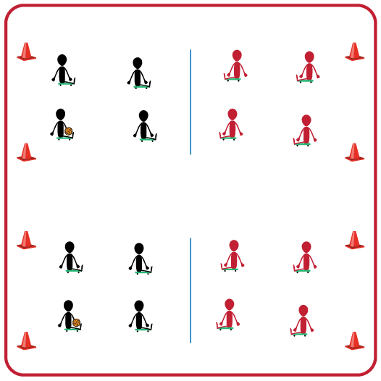
Equipment:
- 1 Scooter per student
- 1 Balloon Ball or Beach Ball per group
- 1 Volleyball Net or Elevated Line (e.g., jump rope between cones)
- 4 boundary cones for each set of 2 teams
Set-Up:
- Divide students into equal teams (e.g., 3v3 or 4v4). Two equal teams will play against one another.
- Divide the space for each set of two teams into equal areas using a volleyball net and 4 boundary cones. Have students get a scooter and take it with them to their group’s area.
- If you do not have one scooter per student, identify a rotation where one student per team serves as a line judge and then rotates into the game every few minutes.
ACTIVITY PROCEDURES
- This activity is called Scooter Volleyball. The object of the game is to make the balloon ball hit the ground on your opponent's side of the net. You do that by keeping the balloon from hitting the ground on your side and hitting the balloon ball onto your opponent's side of the net.
- On the start signal each student will sit on their scooter on their side of the net. All players must be on their scooter inside the boundary cones at all times. One representative from each team will face off in Rock, Paper, Scissors to determine which team will serve first.
- The serving team will hit the balloon ball over the net and play begins. If the ball lands on the ground on your opponent's side your team gets a point. If your team hits the ball out of bounds the opponent gets the point.
- On the stop signal players will stand up and flip their scooter over so the wheels are up.
- Teams will rotate clockwise every 5 minutes to give teams a variety of opponents.
GRADE LEVEL PROGRESSION
- Grade 3: Play as described above.
- Grade 4: Limit the maximum number of hits to 3 before the ball goes over the net.
- Grade 5: Use king/queen of the court rules where the team with highest score moves up one court, and team with the lower score moves down one court.
TEACHING CUES
- Bottom must stay on scooter at all times while participating in a scooter volleyball game.
- Move your scooter to get under the balloon ball when it comes on your side of the net.
- Use good communication skills with your teammates so that you can all work together.

SCOOTER VOLLEYBALL (continued…)

UNIVERSAL DESIGN ADAPTATIONS
- UDL 1: Increase/decrease the size of the activity space and/or height of the net.
- UDL 2: Use modified equipment as needed (e.g., beeper ball, balloon, beach ball).
- UDL 3: Use verbal cues and visual aids along with demonstrations.
- UDL 4: Use peer partners as appropriate.

ACADEMIC LANGUAGE
Net, Scooter, Boundary, Teamwork, Cooperative, Rotation

PRIORITY OUTCOMES
Personal Responsibility & Safety:
- (3) Works independently and safely in physical activity settings.
- (4) Exhibits responsible behavior in independent group situations.
- (5) Engages in physical activity with responsible interpersonal behavior (e.g., peer to peer, student to teacher).

DEBRIEF QUESTIONS
- DOK 1: What does it look like when teammates work together?
- DOK 2: How does working with a team compare to working with a partner or by yourself?
- DOK 3: How does it make you feel if you see a teammate not acting responsibly towards you or another classmate? What is something that you could say or do to encourage them to use more responsible behaviors in the future?

