HELPFUL NET

STUDENT TARGETS
- Skill: I will work with my teammates to volley back and forth as long as possible.
- Cognitive: I will identify strategies and tactics needed to volley continuously with my teammates.
- Fitness: I will remain actively engaged throughout the lesson.
- Personal & Social Responsibility: I will work together with my teammates for maximum possible success during this activity.

EQUIPMENT & SET-UP | 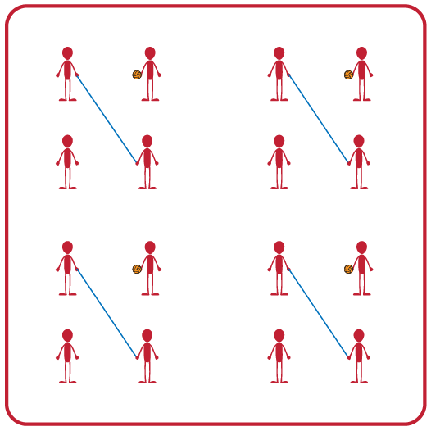
Equipment:
- 1 balloon or foam ball per group of 4
- 1 jump rope per group of 4

Set-Up:
- Divide students into teams of 4.
- Two players begin by holding the jump rope to make a net for their team.
- Other two players begin on opposite sides of the net facing each other, with one student holding the foam ball and ready to serve after hearing the start signal.

ACTIVITY PROCEDURES
- This activity is called Helpful Net. The object of the game is to work with your teammates to rally the ball (or balloon) as long as you can. You do that by working together to hit the ball back and forth over the net (which is a jump rope held by two players).
- On the start signal, the two volleying players will hit the ball back and forth as many times as they can. The two players holding the net can help the two volleying players be successful by moving their feet or altering the height of the net. The net holders and the volleying players will work together to achieve the highest possible team score! Any time the ball hits the ground, the players will each rotate clockwise one spot. You will use the team score from your longest rally as a new goal each time players rotate positions.
- On the stop signal players will place the jump rope and the ball down on the ground. The two players who were holding the jump rope when you heard the stop signal will move to a new group before we play again.
GRADE LEVEL PROGRESSION
- Grade 3: Play as described above.
- Grade 4: Net Holders can raise or lower the net to help their team but cannot move their feet.
- Grade 5: Have two teams of 4 join together to make a group of 8. The 2 jump ropes will be held so that a grid of 4 activity spaces is made with the helpful nets (similar to 4-square).
TEACHING CUES
- Cue 1: Body in Position (knees bent, head up, feet shoulders width apart, hands ready, facing partner).
- Cue 2: Move feet to get under the ball so you can get the ball back to your partner for a longer rally.
- Cue 3: Net holders need to stay attentive & work together so they can move where needed during the rally.
HELPFUL NET (continued…)

UNIVERSAL DESIGN ADAPTATIONS
- UDL 1: Increase/decrease the activity space.
- UDL 2: Use modified equipment as needed (e.g., beeper ball, balloon, beach ball).
- UDL 3: Use verbal cues and visual aids along with demonstrations.
- UDL 4: Use peer partners as appropriate.

ACADEMIC LANGUAGE
Cooperation, Supportive, Encouraging, Goal, Achieve

PRIORITY OUTCOMES
Working With Others:
- (3) Works cooperatively with others.
- (4) Accepts “players” of all skill levels into the physical activity.
- (5) Accepts, recognizes, and actively involves others with both higher and lower skill abilities into physical activities and group projects.

DEBRIEF QUESTIONS
- DOK 1: Was there a communication strategy that your team used during this activity?
- DOK 2: Sometimes we use a strategy during a game or activity, and it doesn’t work well. Was there a communication strategy that you tried during this game that didn’t work very well? What did you do differently if you realized a communication strategy wasn’t working for your team?

