DOUBLES TROUBLE

STUDENT TARGETS
- Skill: I will work with my partner to score points for our team during this activity.
- Cognitive: I will identify ways integrity can impact physical activities and competitions.
- Fitness: I will stay actively engaged for the duration of this activity.
- Personal & Social Responsibility: I will work cooperatively with my teammate during this activity.

EQUIPMENT & SET-UP | 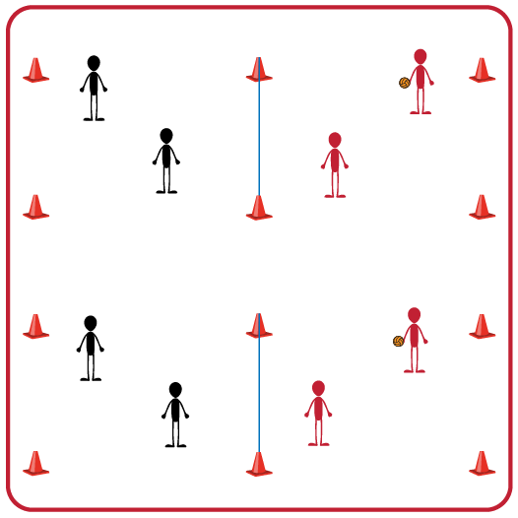
Equipment:
- 1 foam ball for each group of 2 teams
- 1 volleyball net or elevated line for each group of 2 teams
- 4 boundary cones for each group of 2 teams

Set-Up:
- Divide students into teams of 2.
- Pair each team of 2 with another team (for a group of 4).
- Divide the space for each group into equal areas using a volleyball net or elevated line. Use 4 boundary cones for each group’s activity area.

ACTIVITY PROCEDURES
- This activity is called Doubles Trouble. The object of the game is to work together with your teammate to score points on the opposing team. You do that by keeping the ball from hitting the ground on your side of the net and hitting the ball onto your opponent's side of the net.
- On the start signal the serving team will hit the ball over the net and play begins. Your team will work together to hit the ball over the net to the other team before it hits the ground on your side. You and your teammate can hit the ball a maximum of 5 times on your side before it must go over the net.
- If the ball hits the ground on your opponent's side your team gets a point. If a team hits the ball out of bounds the opponent gets the point.
- On the stop signal, place the ball on the ground. We will rotate the teams every 5 minutes to give everyone a variety of opponents. The team who has the ball when you hear the stop signal will stay, and the other team will rotate clockwise to the next court.

GRADE LEVEL PROGRESSION
- Grade 3: Allow for a throw to begin the game instead of a serve if needed.
- Grade 4: Limit the maximum number of hits for a team to 3 before the ball goes over the net.
- Grade 5: Use king/queen of the court rules where the team with highest score moves up one court, and team with the lower score moves down one court.

TEACHING CUES
- Cue 1: Body in Position (knees bent, head up, feet shoulders width apart, hands ready, facing partner).
- Cue 2: Move feet to get under the ball so you can prevent it from hitting the ground on your side of the net.
- Cue 3: Stay attentive, communicate, and work together with your teammate(s).
DOUBLES TROUBLE (continued…)

UNIVERSAL DESIGN ADAPTATIONS
- UDL 1: Increase/decrease the activity space and/or height of the net.
- UDL 2: Use modified equipment as needed (e.g., beeper ball, balloon, beach ball).
- UDL 3: Use verbal cues and visual aids along with demonstrations.
- UDL 4: Use peer partners as appropriate.

ACADEMIC LANGUAGE
Compete, Integrity, Alternate, Rotate, Partner

PRIORITY OUTCOMES
Working With Others:
- (3) Works cooperatively with others.
- (4) Accepts “players” of all skill levels into the physical activity.
- (5) Accepts, recognizes, and actively involves others with both higher and lower skill abilities into physical activities and group projects.

DEBRIEF QUESTIONS
- DOK 1: What is integrity?
- DOK 2: Why is integrity important in physical activity or competitive settings?
- DOK 3: How is integrity related to the enjoyment of everyone playing a game of Volleyball?

