Pi DAY RACES

STUDENT TARGETS
- Skill: I will focus on the first 8 numbers of Pi to help my team collect the correct cards.
- Cognitive: I will describe the social benefits gained from participation in physical activity.
- Fitness: I will be actively engaged in this Pi Day challenge.
- Personal & Social Responsibility: I will use positive and encouraging communication with my teammates.

EQUIPMENT & SET-UP | 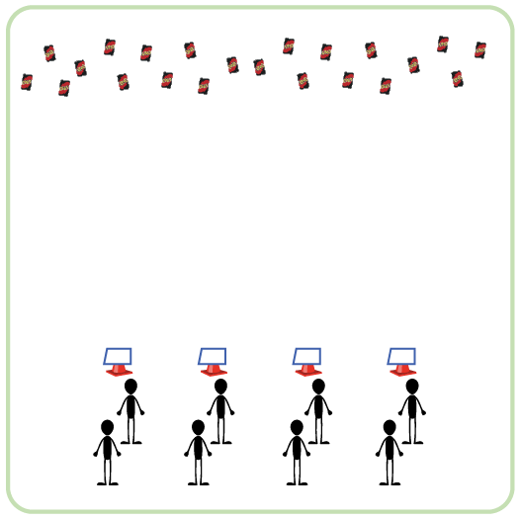
Equipment:
- 2-3 decks of UNO cards
- 1 cone per team
- 1 Pi Day Station Card & task tent per team

Set-Up:
- Create teams of 3 players.
- Each team begins at a starting cone. Each cone has a task tent with the Pi Day Station Card.
- UNO Cards are spread out on the ground on opposite side of activity space from the starting cones.
ACTIVITY PROCEDURES
- This activity is called Pi Day Races. The object of this game is for your team to build out the first 8 numbers of Pi. The first team to get the first 8 numbers in the correct order will win!
- Get ready by reviewing the first 8 numbers of Pi on your station card. You want to make sure that you collect cards that will help you build out the numbers of Pi, so it is important that you are familiar with which numbered cards your team needs to collect. You will then determine your order and line up behind your cone.
- On the start signal, the first teammate will go and collect one card to bring back. Your team will make sure it is a number from Pi, then place it on the ground by your cone. Your team will continue this process until you have built out the first 8 numbers of Pi in the correct order.
- Teachers: You can list out more than the first 8 numbers of Pi for secondary students.

ACADEMIC LANGUAGE
- Cooperation, Teamwork, Encourage, Challenge

PRIORITY OUTCOMES
Social Interaction:
- (K-2) Discusses the enjoyment of playing with family and friends.
- (3-5) Describes the social benefits gained from participation in physical activity.
- (6-8) Demonstrates the importance of social interaction by helping and encouraging others, avoiding trash talk, and providing support to classmates.

Pi TOSS

STUDENT TARGETS
- Skill: I will use correct form for an underhand toss.
- Cognitive: I will discuss the enjoyment of being physically active with friends.
- Fitness: I will be actively engaged in this Pi Day challenge.
- Personal & Social Responsibility: I will use positive and encouraging communication with my teammates.

EQUIPMENT & SET-UP | 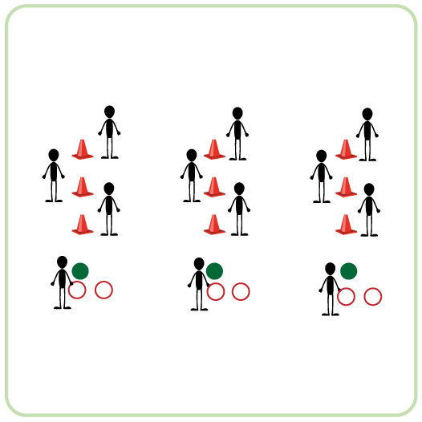
Equipment:
- 3 cones per team of 4
- 1 spot marker per team of 4
- 2 sling rings per team of 4
- 2 hula hoops per team of 4
Set-Up:
- Create teams of 4 players.
- Each team has space with 3 cones spaced 3-5 feet apart and a spot marker as the starting position for the tosser. The cones and spot marker are all in a straight line.
- One teammate is the tosser and stands on the spot marker. Remaining teammates are positioned by one of the cones, ready to retrieve the rings/hoops after they are tossed.
ACTIVITY PROCEDURES
- This activity is called Pi Toss. The object of this game is to toss objects so they land around the cones. Each team will get to choose between rings and hula hoops to toss around the cones, since they are both shaped like a pie!
- Get ready by having three of your teammates standing by a cone, and the remaining teammate standing on the spot marker. The teammate on the spot marker is the tosser.
- On the start signal, the tosser gets two attempts to get either a ring or a hula hoop around a cone. The teammates by the cones will grab the rings and quickly get them to the next tosser.
- Since the first three numbers of Pi are 3.14, your team will get one point for the first cone, three points for the second cone, and 4 points for the third cone that is the furthest away. Keep track of how many points your team can collect!
- This rotation continues with your team alternating turns until you hear the stop signal.
ACADEMIC LANGUAGE
- Pi, Challenge, Cooperation, Teamwork

PRIORITY OUTCOMES
Social Interaction:
- (K-2) Discusses the enjoyment of playing with family and friends.
- (3-5) Describes the social benefits gained from participation in physical activity.
- (6-8) Demonstrates the importance of social interaction by helping and encouraging others, avoiding trash talk, and providing support to classmates.

Pi DAY DICE RELAY

STUDENT TARGETS
- Skill: I will work collaboratively with my team during this challenge.
- Cognitive: I will focus my attention on the challenge in an effort to improve my team’s score.
- Fitness: I will be actively engaged in this Pi Day challenge.
- Personal & Social Responsibility: I will use positive language with my teammates.
EQUIPMENT & SET-UP | 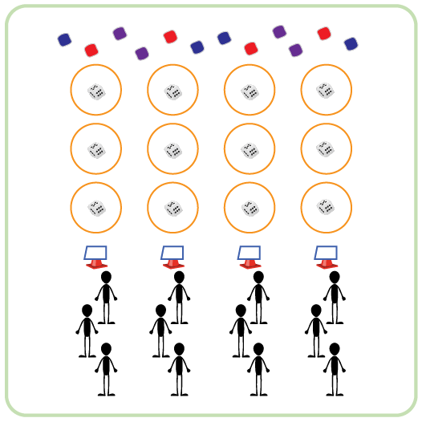
Equipment:
- 1 cone per team
- 3 hula hoops per team
- 3 dice per team
- 50-60 beanbags
- 1 Pi Day Station Card & task tent per team
Set-Up:
- Create teams of 3 players.
- Each team has space with 3 hoops spaced 5-10 feet apart and a cone as the starting position. Each hoop has a die inside. The hoops and starting cone are all in a straight line.
- Place Pi Day Station Card in a task tent at starting cone. Teams begin at starting cone.
- Evenly spread out beanbags on the ground past the last hoop for each team.
ACTIVITY PROCEDURES
- This activity is called Pi Day Dice Relay. The object of this game is to collect as many bean bags as possible for your team. However, you must attempt the challenge in all three hoops before you can collect a bean bag and return to your teammates.
- Get ready by reviewing the Pi Day Station Card at your starting cone. You want to make sure that you know what numbers to roll in each hoop, so it is important that you are familiar with the first 3 numbers of Pi. You want to roll a 3 in the first hoop, a 1 in the second hoop, and a 4 in the third hoop.
- On the start signal, the first person moves to the first hoop. You roll the die until you get a 3, or until you have attempted 5 times. Once you roll a 3 or attempt 5 times, you move to the next hoop. You continue this process until you have completed the challenge in all 3 hoops. After the third hoop, you can collect one bean bag and return to your teammates. Give a “high five” to the next person in line so they can begin.
- This rotation continues with your team alternating turns until you hear the stop signal.
ACADEMIC LANGUAGE
- Growth Mindset, Cooperation, Teamwork, Determination, Challenge

PRIORITY OUTCOMES
Social Interaction:
- (K-2) Discusses the enjoyment of playing with family and friends.
- (3-5) Describes the social benefits gained from participation in physical activity.
- (6-8) Demonstrates the importance of social interaction by helping and encouraging others, avoiding trash talk, and providing support to classmates.

CAKE OR Pi?

STUDENT TARGETS
- Skill: I will pace activity to stay in my Target Heart Rate Zone.
- Cognitive: I will calculate my target heart rate and identify my target heart rate zone.
- Fitness: I will be actively engaged in this Pi Day challenge.
- Personal & Social Responsibility: I will use positive and encouraging communication with my teammates.
EQUIPMENT & SET-UP | 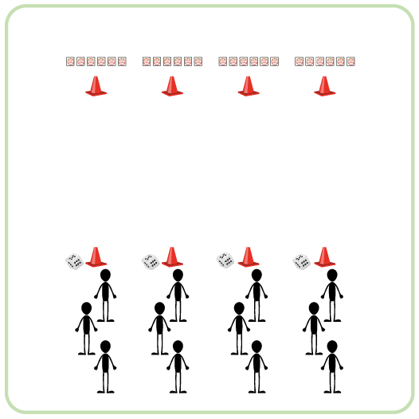
Equipment:
- 2 cones per team
- 6 double-sided Cake vs Pi Cards per team
- 1 six-sided die per team

Set-Up:
- Create teams of 3-4 players.
- Use cones to create start and finish lines for each team that are 20 meters apart.
- Place a die at each starting cone and 6 Cake vs Pi cards at each finish cone. Cards should all be in a straight line and showing Cake to begin.
- Each team will begin at a starting cone.
ACTIVITY PROCEDURES
- This activity is called Cake or Pi? The object of this game is to get your team’s cards to all show Pi at the same time. However, remember that it will depend on each roll of the die!
- This activity will also allow us to work on our 20-meter pacer running. At the end of the activity, we will check our pulse to see if we were able to work within our target heart rate zone.
- On the start signal, the first person in line rolls the die and then runs down to flip the card that corresponds to the number rolled.
- As soon as that player returns to the line, the next player rolls the die and runs down to flip the appropriate card. If the same number gets rolled again, the corresponding card is flipped back over.
- This rotation continues until one team gets all cards with Pi facing up, or you hear the stop signal.
- Teachers: discuss how to calculate a student’s Target Heart Rate Zone and check their pulse at the end of the activity. Another option is to use Heart Rate Monitor Technology.
ACADEMIC LANGUAGE
- Target Heart Rate, Teamwork, Challenge

PRIORITY OUTCOMES
Social Interaction:
- (K-2) Discusses the enjoyment of playing with family and friends.
- (3-5) Describes the social benefits gained from participation in physical activity.
- (6-8) Demonstrates the importance of social interaction by helping and encouraging others, avoiding trash talk, and providing support to classmates.

WHO WANTS Pi?

STUDENT TARGETS
- Skill: I will work cooperatively with my teammates to create our Pi.
- Cognitive: I will identify the rules and etiquette for creating a Pi during this activity.
- Fitness: I will be actively engaged in this Pi Day challenge.
- Personal & Social Responsibility: I will use encouraging language with my teammates.
EQUIPMENT & SET-UP | 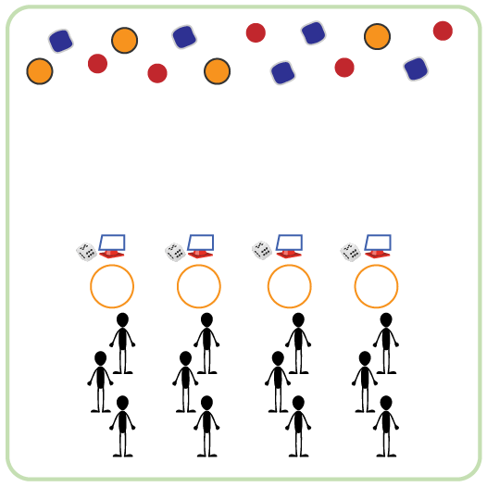
Equipment:
- Cones for boundaries
- 1 cone & die per team
- 1 task tent & activity card per team
- 1 hula hoop per team
- Equipment to create/decorate each Pi (e.g., Garden Heroes, bean bags, yarn balls, scarves)
Set-Up:
- Create equal teams of 3-4 students. Each team at a cone.
- Place a cone, task tent with activity card, hula hoop, and die for each team to create a circle around the perimeter.
- Place a variety of equipment in the center of the teaching area for teams to choose the items they want to use to create and decorate their Pi.
ACTIVITY PROCEDURES
- It’s time to create a unique and delicious Pi (pie)! Each team will do that by rolling the die and completing the corresponding exercise on the activity card. Each roll earns your team one ingredient.
- On the start signal, one person from your team will roll the die and your entire team will complete the exercise from the activity card. The person who rolled the die will then go to the middle and collect one ingredient to create your Pi.
- Once you’ve collected and placed your ingredient in the Pi shell (hoop by your cone) the next team member will roll the die. But remember, you can only collect 1 ingredient at a time. Roll the die and complete the activity to “earn” the next one. Rotate who gets to roll the die and choose the ingredient added to the Pi.
- We will continue until all of the ingredients have been collected.

ACADEMIC LANGUAGE
- Ingredient, Teamwork, Cooperation

PRIORITY OUTCOMES
Social Interaction:
- (K-2) Discusses the enjoyment of playing with family and friends.
- (3-5) Describes the social benefits gained from participation in physical activity.
- (6-8) Demonstrates the importance of social interaction by helping and encouraging others, avoiding trash talk, and providing support to classmates.

