Pi DAY RACES

STUDENT TARGETS
- Skill: I will focus on the first 8 numbers of Pi to help my team collect the correct cards.
- Cognitive: I will describe the social benefits gained from participation in physical activity.
- Fitness: I will be actively engaged in this Pi Day challenge.
- Personal & Social Responsibility: I will use positive and encouraging communication with my teammates.

EQUIPMENT & SET-UP | 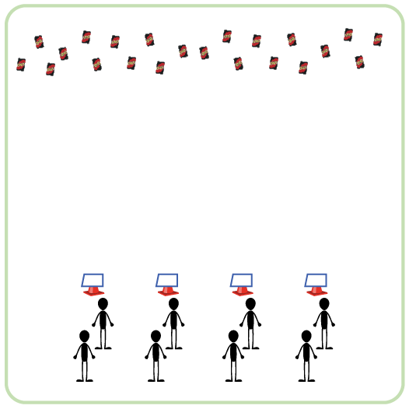
Equipment:
- 2-3 decks of UNO cards
- 1 cone per team
- 1 Pi Day Station Card & task tent per team

Set-Up:
- Create teams of 3 players.
- Each team begins at a starting cone. Each cone has a task tent with the Pi Day Station Card.
- UNO Cards are spread out on the ground on opposite side of activity space from the starting cones.
ACTIVITY PROCEDURES
- This activity is called Pi Day Races. The object of this game is for your team to build out the first 8 numbers of Pi. The first team to get the first 8 numbers in the correct order will win!
- Get ready by reviewing the first 8 numbers of Pi on your station card. You want to make sure that you collect cards that will help you build out the numbers of Pi, so it is important that you are familiar with which numbered cards your team needs to collect. You will then determine your order and line up behind your cone.
- On the start signal, the first teammate will go and collect one card to bring back. Your team will make sure it is a number from Pi, then place it on the ground by your cone. Your team will continue this process until you have built out the first 8 numbers of Pi in the correct order.
- Teachers: You can list out more than the first 8 numbers of Pi for secondary students.

ACADEMIC LANGUAGE
- Cooperation, Teamwork, Encourage, Challenge

PRIORITY OUTCOMES
Social Interaction:
- (K-2) Discusses the enjoyment of playing with family and friends.
- (3-5) Describes the social benefits gained from participation in physical activity.
- (6-8) Demonstrates the importance of social interaction by helping and encouraging others, avoiding trash talk, and providing support to classmates.

