Pi TOSS

STUDENT TARGETS
- Skill: I will use correct form for an underhand toss.
- Cognitive: I will discuss the enjoyment of being physically active with friends.
- Fitness: I will be actively engaged in this Pi Day challenge.
- Personal & Social Responsibility: I will use positive and encouraging communication with my teammates.

EQUIPMENT & SET-UP | 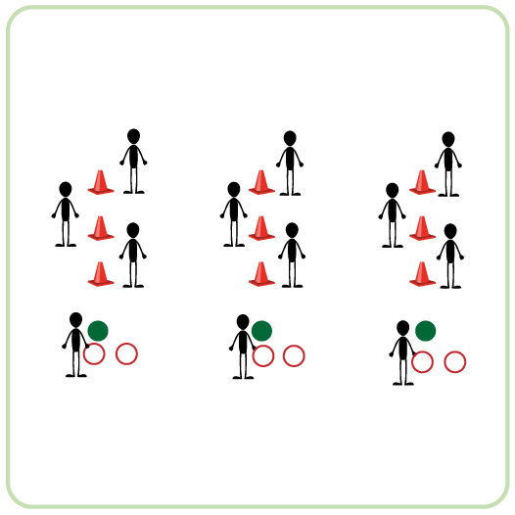
Equipment:
- 3 cones per team of 4
- 1 spot marker per team of 4
- 2 sling rings per team of 4
- 2 hula hoops per team of 4
Set-Up:
- Create teams of 4 players.
- Each team has space with 3 cones spaced 3-5 feet apart and a spot marker as the starting position for the tosser. The cones and spot marker are all in a straight line.
- One teammate is the tosser and stands on the spot marker. Remaining teammates are positioned by one of the cones, ready to retrieve the rings/hoops after they are tossed.
ACTIVITY PROCEDURES
- This activity is called Pi Toss. The object of this game is to toss objects so they land around the cones. Each team will get to choose between rings and hula hoops to toss around the cones, since they are both shaped like a pie!
- Get ready by having three of your teammates standing by a cone, and the remaining teammate standing on the spot marker. The teammate on the spot marker is the tosser.
- On the start signal, the tosser gets two attempts to get either a ring or a hula hoop around a cone. The teammates by the cones will grab the rings and quickly get them to the next tosser.
- Since the first three numbers of Pi are 3.14, your team will get one point for the first cone, three points for the second cone, and 4 points for the third cone that is the furthest away. Keep track of how many points your team can collect!
- This rotation continues with your team alternating turns until you hear the stop signal.
ACADEMIC LANGUAGE
- Pi, Challenge, Cooperation, Teamwork

PRIORITY OUTCOMES
Social Interaction:
- (K-2) Discusses the enjoyment of playing with family and friends.
- (3-5) Describes the social benefits gained from participation in physical activity.
- (6-8) Demonstrates the importance of social interaction by helping and encouraging others, avoiding trash talk, and providing support to classmates.

