Pi DAY DICE RELAY

STUDENT TARGETS
- Skill: I will work collaboratively with my team during this challenge.
- Cognitive: I will focus my attention on the challenge in an effort to improve my team’s score.
- Fitness: I will be actively engaged in this Pi Day challenge.
- Personal & Social Responsibility: I will use positive language with my teammates.
EQUIPMENT & SET-UP | 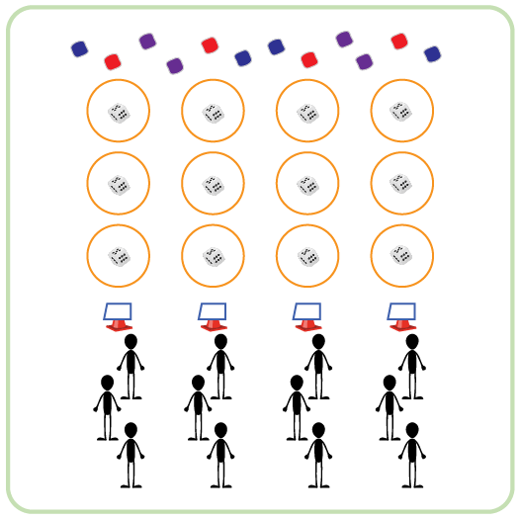
Equipment:
- 1 cone per team
- 3 hula hoops per team
- 3 dice per team
- 50-60 beanbags
- 1 Pi Day Station Card & task tent per team
Set-Up:
- Create teams of 3 players.
- Each team has space with 3 hoops spaced 5-10 feet apart and a cone as the starting position. Each hoop has a die inside. The hoops and starting cone are all in a straight line.
- Place Pi Day Station Card in a task tent at starting cone. Teams begin at starting cone.
- Evenly spread out beanbags on the ground past the last hoop for each team.
ACTIVITY PROCEDURES
- This activity is called Pi Day Dice Relay. The object of this game is to collect as many bean bags as possible for your team. However, you must attempt the challenge in all three hoops before you can collect a bean bag and return to your teammates.
- Get ready by reviewing the Pi Day Station Card at your starting cone. You want to make sure that you know what numbers to roll in each hoop, so it is important that you are familiar with the first 3 numbers of Pi. You want to roll a 3 in the first hoop, a 1 in the second hoop, and a 4 in the third hoop.
- On the start signal, the first person moves to the first hoop. You roll the die until you get a 3, or until you have attempted 5 times. Once you roll a 3 or attempt 5 times, you move to the next hoop. You continue this process until you have completed the challenge in all 3 hoops. After the third hoop, you can collect one bean bag and return to your teammates. Give a “high five” to the next person in line so they can begin.
- This rotation continues with your team alternating turns until you hear the stop signal.
ACADEMIC LANGUAGE
- Growth Mindset, Cooperation, Teamwork, Determination, Challenge

PRIORITY OUTCOMES
Social Interaction:
- (K-2) Discusses the enjoyment of playing with family and friends.
- (3-5) Describes the social benefits gained from participation in physical activity.
- (6-8) Demonstrates the importance of social interaction by helping and encouraging others, avoiding trash talk, and providing support to classmates.

