CAKE OR Pi?

STUDENT TARGETS
- Skill: I will pace activity to stay in my Target Heart Rate Zone.
- Cognitive: I will calculate my target heart rate and identify my target heart rate zone.
- Fitness: I will be actively engaged in this Pi Day challenge.
- Personal & Social Responsibility: I will use positive and encouraging communication with my teammates.
EQUIPMENT & SET-UP | 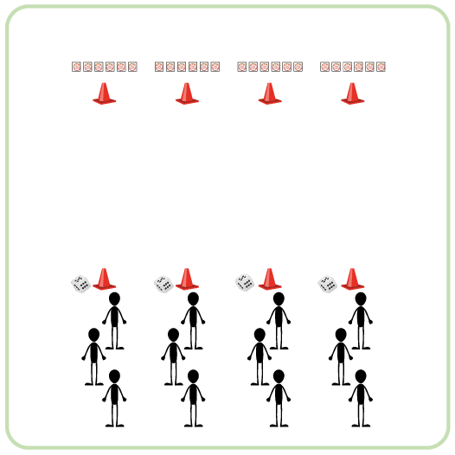
Equipment:
- 2 cones per team
- 6 double-sided Cake vs Pi Cards per team
- 1 six-sided die per team

Set-Up:
- Create teams of 3-4 players.
- Use cones to create start and finish lines for each team that are 20 meters apart.
- Place a die at each starting cone and 6 Cake vs Pi cards at each finish cone. Cards should all be in a straight line and showing Cake to begin.
- Each team will begin at a starting cone.
ACTIVITY PROCEDURES
- This activity is called Cake or Pi? The object of this game is to get your team’s cards to all show Pi at the same time. However, remember that it will depend on each roll of the die!
- This activity will also allow us to work on our 20-meter pacer running. At the end of the activity, we will check our pulse to see if we were able to work within our target heart rate zone.
- On the start signal, the first person in line rolls the die and then runs down to flip the card that corresponds to the number rolled.
- As soon as that player returns to the line, the next player rolls the die and runs down to flip the appropriate card. If the same number gets rolled again, the corresponding card is flipped back over.
- This rotation continues until one team gets all cards with Pi facing up, or you hear the stop signal.
- Teachers: discuss how to calculate a student’s Target Heart Rate Zone and check their pulse at the end of the activity. Another option is to use Heart Rate Monitor Technology.
ACADEMIC LANGUAGE
- Target Heart Rate, Teamwork, Challenge

PRIORITY OUTCOMES
Social Interaction:
- (K-2) Discusses the enjoyment of playing with family and friends.
- (3-5) Describes the social benefits gained from participation in physical activity.
- (6-8) Demonstrates the importance of social interaction by helping and encouraging others, avoiding trash talk, and providing support to classmates.

