WHO WANTS Pi?

STUDENT TARGETS
- Skill: I will work cooperatively with my teammates to create our Pi.
- Cognitive: I will identify the rules and etiquette for creating a Pi during this activity.
- Fitness: I will be actively engaged in this Pi Day challenge.
- Personal & Social Responsibility: I will use encouraging language with my teammates.
EQUIPMENT & SET-UP | 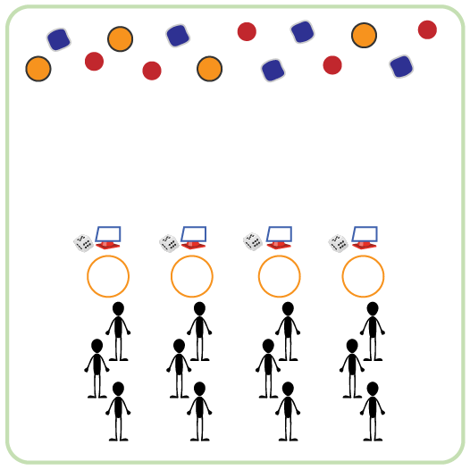
Equipment:
- Cones for boundaries
- 1 cone & die per team
- 1 task tent & activity card per team
- 1 hula hoop per team
- Equipment to create/decorate each Pi (e.g., Garden Heroes, bean bags, yarn balls, scarves)
Set-Up:
- Create equal teams of 3-4 students. Each team at a cone.
- Place a cone, task tent with activity card, hula hoop, and die for each team to create a circle around the perimeter.
- Place a variety of equipment in the center of the teaching area for teams to choose the items they want to use to create and decorate their Pi.
ACTIVITY PROCEDURES
- It’s time to create a unique and delicious Pi (pie)! Each team will do that by rolling the die and completing the corresponding exercise on the activity card. Each roll earns your team one ingredient.
- On the start signal, one person from your team will roll the die and your entire team will complete the exercise from the activity card. The person who rolled the die will then go to the middle and collect one ingredient to create your Pi.
- Once you’ve collected and placed your ingredient in the Pi shell (hoop by your cone) the next team member will roll the die. But remember, you can only collect 1 ingredient at a time. Roll the die and complete the activity to “earn” the next one. Rotate who gets to roll the die and choose the ingredient added to the Pi.
- We will continue until all of the ingredients have been collected.

ACADEMIC LANGUAGE
- Ingredient, Teamwork, Cooperation

PRIORITY OUTCOMES
Social Interaction:
- (K-2) Discusses the enjoyment of playing with family and friends.
- (3-5) Describes the social benefits gained from participation in physical activity.
- (6-8) Demonstrates the importance of social interaction by helping and encouraging others, avoiding trash talk, and providing support to classmates.

