PILLARS OF HEALTH

STUDENT TARGETS
- Skill: I will demonstrate leadership while acting as a movement captain.
- Cognitive: I will identify the four pillars of health and their impact on my health and wellness.
- Fitness: I will discuss different physical activities and how each can positively impact my overall health.
- Personal & Social Responsibility: I will show respect for myself and others by using positive and supportive language.

EQUIPMENT & SET-UP | 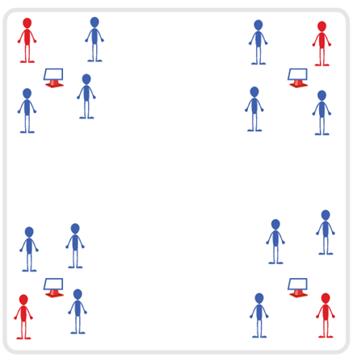
Equipment:
- 4 Cones
- Pillars of Health Activity Cards
- Task Tents
- Music and Music Player
Set-Up:
- Create 4 quadrants in the activity area, with a cone in the center of each quadrant.
- Create 4 equal groups of students, 1 group per cone.
- Designate 1 student per group to be the Movement Captain.
ACTIVITY PROCEDURES
- Today we’ll work on improving our health and wellness with an activity called Pillars of Health! The object is for you to follow the movements of each cone’s Movement Captain. When you hear the music stop, everyone except the Movement Captains will rotate clockwise.
- Movement Captains, you are in charge of creating a safe and high-energy movement (or sequence) with the goal of incorporating movements related to the 4 Pillars of Health while they are active at your cone. Each cone will have a focus on one of the 4 pillars of health (nutrition, movement, relaxation/stress management, sleep). Captains are responsible for leading each group that rotates to their cone and can choose the same movement each time or a new one for each group.
- Once groups rotate all the way around the area and make it back to their original cones, the Movement Captain will select a new captain for the next round.
- This activity can also be done with exercises specific to a fitness component. For example, the Movement Captain can become the Muscular Fitness Captain, or the Yoga Captain, etc.
GRADE LEVEL PROGRESSION
- Grade 6: Play the activity as described above.
- Grades 7-8: Challenge the students to create a health-related fitness question for each Movement Captain to ask groups as they rotate to each cone.
TEACHING CUES
- Cue 1: Keep it fun.
- Cue 2: Use positive and supportive language during the activity.
- Cue 3: Keep moving!

PILLARS OF HEALTH (continued…)

UNIVERSAL DESIGN ADAPTATIONS
- UDL 1: Modify the boundaries to make the activity area smaller to meet the needs of all students.
- UDL 2: Provide sample activities for Movement Captains to help facilitate activity and minimize decision-making.
- UDL 3: Assign peer partners as needed for any student who needs additional support.

ACADEMIC LANGUAGE
Nutrition, Movement, Relaxation, Stress Management, Sleep, Leadership

PRIORITY OUTCOMES
Social Interaction:
- (6) Demonstrates respect for self and others in activities and games by following the rules, encouraging others, and playing within the spirit of the game or activity.
- (7) Demonstrates the importance of social interaction by helping and encouraging others, avoiding trash talk, and providing support to classmates.
- (8) Demonstrates respect for self by asking for help and helping others in various physical activities.

DEBRIEF QUESTIONS
Cognitive Question Set:
- DOK 1: What would you include on a list about leadership?
- DOK 2: How did the Movement Captains show leadership during the activity today?

Social & Emotional Question Set:
- DOK 1: How does physical activity affect your overall health and wellness?
- DOK 2: Explain how each of the 4 pillars of health have an impact on your physical and/or emotional health.
- DOK 3: What experiences or activities would you choose to support your physical and/or emotional health and wellness? Elaborate on why you chose them.

FOOD IS FUEL

STUDENT TARGETS
- Skill: I will successfully complete the food label scavenger hunt.
- Cognitive: I will correctly identify food labels for each item on the scavenger hunt card.
- Fitness: I will perform health-related fitness activities in personal and general space.
- Personal & Social Responsibility: I will use positive communication and encouraging language with my teammates.

EQUIPMENT & SET-UP | 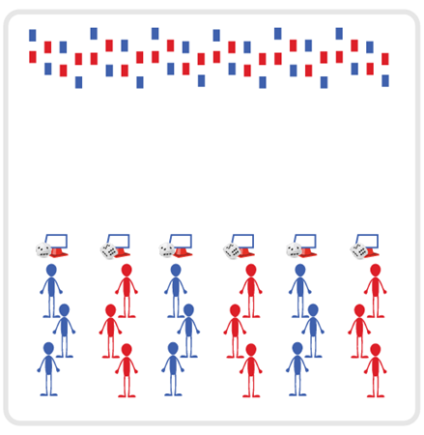
Equipment:
- Scavenger Hunt Cards
- 6 cones and 6 task tents
- Food Models from National Dairy Council
- Food Label Dice Card
- 1 foam die per team

Set-Up:
- Print and cut out food model cards. Scatter food models on one side of activity space.
- Place 6 cones at opposite end of space from food models.
- Place a foam die, task tent, Food Label Dice Card, and Scavenger Hunt Card at each cone.
- Create even groups of students at each cone.
ACTIVITY PROCEDURES
- This activity is called Food is Fuel! It is important for us to recognize how to fuel our bodies with healthy foods and beverages. Reviewing food labels on things we eat and drink help us do that.
- The object of the activity is for your group to successfully complete your scavenger hunt card. You do that by having one person at a time from your team go and find a food label on a food model card that matches each item on the scavenger hunt card. You will need a different food label for each item on the scavenger hunt card.
- On the start signal, the first person will go and find the first item, the second person will find the second item, etc. You will continue to take turns relay race style until your team has matched a food label to each item on the scavenger hunt card. After bringing the food label back to your group, you will roll the foam die and perform the corresponding exercise shown on the chart.
- Once each team has completed their scavenger card, or when you hear the stop signal, each group will rotate one cone to their right and review the food labels selected by that team to confirm the items selected match the scavenger hunt card.

GRADE LEVEL PROGRESSION
- Grade 6: Play the activity as described above.
- Grades 7-8: Challenge students to also create a balanced My Plate meal with the food models they select to complete their scavenger hunt card.

TEACHING CUES
- Cue 1: Keep it fun.
- Cue 2: Use positive and supportive language during the activity.
- Cue 3: Keep moving!

FOOD IS FUEL (continued…)

UNIVERSAL DESIGN ADAPTATIONS
- UDL 1: Modify the boundaries to make the activity area smaller to meet the needs of all students.
- UDL 2: Provide demonstrations as visuals to enhance understanding of directions for activity.
- UDL 3: Assign peer partners as needed for any student who needs additional support.

ACADEMIC LANGUAGE
Food label, Healthy, Body Composition, Nutrient, Cooperation

PRIORITY OUTCOMES
Nutrition:
- (6) Identifies foods from each food group that can be combined to build balanced meals.
- (7) Compares and contrasts the health benefits of whole foods verses processed foods.
- (8) Seeks out and makes requests for nutritious whole-food choices.

DEBRIEF QUESTIONS
Cognitive Question Set:
- DOK 1: What were some healthy food options that you found during the scavenger hunt?
- DOK 2: What are the reasons you felt these food options were healthy?
- DOK 3: What are some things you can look for on a food label to help you determine if it is a healthy food or drink option?

Social & Emotional Question Set:
- DOK 1: How would you describe cooperation?
- DOK 2: What is an example of a way either you or a classmate showed cooperation today?
- DOK 3: Does being cooperative impact a group or teams ability to be successful in completing a task or a challenge?

ON THE RUN

STUDENT TARGETS
- Skill: I will demonstrate verbal communication skills and active listening throughout this activity.
- Cognitive: I will identify strategies for communicating clearly with my partner.
- Fitness: I will stay actively engaged throughout this activity.
- Personal & Social Responsibility: I will use positive and supportive language with my classmates.

EQUIPMENT & SET-UP | 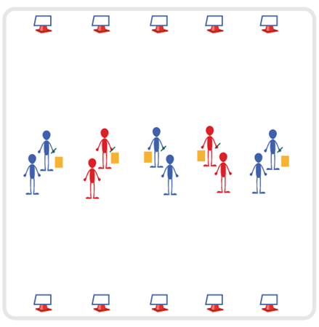
Equipment:
- Copy of On the Run Paragraphs 1 & 2 for each group
- Cone and Task Tent for each group
- Clipboard, 2 sheets of blank paper, and a pencil for each group
Set-Up:
- Print both of the On the Run paragraphs. On one side of activity area, place a cone/task tent with paragraph 1 on one side and paragraph 2 on the other.
- Directly across from each task tent (10-15 feet apart) place a clipboard with two sheets of blank paper and a pencil.
- Create groups of 2 students. One partner begins by a task tent and the other partner will begin directly across from them by a clipboard.

ACTIVITY PROCEDURES
- This activity is called On the Run! The object is to read, memorize, and verbally communicate some text to a partner who will be writing down what is dictated to them. This is done by one partner memorizing the text while “on the run” and the other partner writing down exactly what is shared with them. The goal is to complete an error free paper before time runs out.
- On the start signal, the partner by the task tent (runner) will begin to read and memorize as much of paragraph 1 as they can. Then they will walk or run to their partner (writer) and verbally dictate what they read, while their partner writes it down verbatim on a sheet of paper. The runner will continue to move back and forth from the text and the writer until they have dictated the entire paragraph or until the time runs out.
- On the stop signal, students will switch roles and repeat the activity using paragraph 2.

GRADE LEVEL PROGRESSION
- Grade 6: Play the activity as described above.
- Grade 7: Have the runners hold a plank position by the task tent while they are memorizing the text.
- Grade 8: Have the runner dribble an object with hands or feet as they move to and from the writer (e.g., basketball, soccer, hockey).

TEACHING CUES
- Cue 1: Keep it fun.
- Cue 2: Use positive and supportive language during the activity.
- Cue 3: Keep moving!

ON THE RUN (continued…)

UNIVERSAL DESIGN ADAPTATIONS
- UDL 1: Modify the distance to/from the text to make the activity area smaller if needed.
- UDL 2: Provide texts at different levels of complexity and in different size fonts as needed.
- UDL 3: Assign peer partners as needed for any student who needs additional support.
- UDL 4: Ensure any assistive technology needed by a student is available on the day of this activity.

ACADEMIC LANGUAGE
Dictation, Paragraph, Locomotor

PRIORITY OUTCOMES
Values Physical Activity - Social Interaction:
- (Grade 6) Demonstrates respect for self and others in activities and games by following the rules, encouraging others, and playing within the spirit of the game or activity.
- (Grade 7) Demonstrates the importance of social interaction by helping and encouraging others, avoiding trash talk, and providing support to classmates.
- (Grade 8) Demonstrates respect for self by asking for help and helping others in various physical activities.

DEBRIEF QUESTIONS
- DOK 1: Was there a strategy that your team used during this activity?
- DOK 2: Sometimes we use a strategy during a game or activity, and it doesn’t work well. Was there a communication strategy that you tried during this game that didn’t work very well? What did you do differently if you realized a communication strategy wasn’t working for your team?

FOOD RELATIONSHIPS

STUDENT TARGETS
- Skill: I will help and encourage others during the gallery walk.
- Cognitive: I will identify things that influence my relationship with food.
- Fitness: I will discuss ways that food and beverage intake are linked to my overall health and wellness.
- Personal & Social Responsibility: I will show respect for myself and others by using positive and supportive language.
EQUIPMENT & SET-UP | 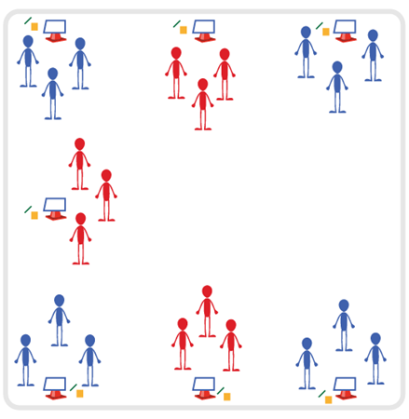
Equipment:
- Food Relationship Cards
- Cones with Task Tents (or tape to stick posters to the wall)
- Several Sticky Notes per student
- Pens or pencils
- Music and Music Player
Set-Up:
- Place Food Relationship Cards on cones using Task Tents, or tape them on the walls around the activity area.
- Place a pad of sticky notes and pencils next to each Food Relationship Card.
- Group students and send each group to a Food Relationship Card.
ACTIVITY PROCEDURES
- A healthy relationship with food includes valuing the pleasure that food gives us, respecting the body’s need for food and nutrition, and having mostly positive thoughts and feelings about food.
- Today we’re going to complete a gallery walk in order to explore more about food relationships and some things that can influence a person’s relationship with food.
- When the music starts, your group will walk to the nearest food relationship poster. Look at the title of the topic and then read the first question.
- Take a few seconds to think about your response to this question, then write a short answer on a sticky note. Post that sticky note on the wall next to the poster (or by cone with task tent), then walk clockwise to the next poster and repeat the process when the music stops.
- Once we’ve completed a loop around the gallery and responded to question 1, we’ll take some time to discuss a few of the answers on the sticky notes for each poster.
- Teachers: if time permits, repeat the entire gallery walk with students responding to question 2.
GRADE LEVEL PROGRESSION
- Grade 6: Focus on question 1 and allow time for detailed discussion during the debrief of the first gallery walk.
- Grades 7-8: If students demonstrate mastery of the concepts discussed for question 1, continue on to question 2 during a second gallery walk.
TEACHING CUES
- Cue 1: Think before you write.
- Cue 2: Use positive and supportive language during class discussion.

FOOD RELATIONSHIPS (continued…)

UNIVERSAL DESIGN ADAPTATIONS
- UDL 1: Allow students to work with a partner if needed.
- UDL 2: Provide multiple forms of prompts and cues - kinesthetic, visual, and auditory.
- UDL 3: Utilize questions at a variety of reading levels if needed.
- UDL 4: Allow students to dictate responses to Gallery Walk questions versus writing on a sticky note. Could dictate to a partner or to the teacher.

ACADEMIC LANGUAGE
Cultural Tradition, Dietary Restriction, Experience, Food Relationship, Influence, Nutrition, Preference, Relationship

PRIORITY OUTCOMES
Social Interaction:
(6) Demonstrates respect for self and others in activities by following the rules and encouraging others.
(7) Demonstrates the importance of social interaction by helping and encouraging others, avoiding trash talk, and providing support to classmates.
(8) Demonstrates respect for self by asking for help and helping others in various physical activities.

DEBRIEF QUESTIONS
Cognitive Question Set:
- DOK 1: What was something that you learned or heard for the first time today about food relationships?
- DOK 2: How will what we discussed today influence your relationship with food?
- DOK 3: What are some lifestyle changes related to food and beverage intake that could improve your overall health and wellness?

Social & Emotional Question Set:
- DOK 1: How would you describe respect?
- DOK 2: Did you experience an example today of someone showing respect? Explain why you feel your example was being respectful.
- DOK 3: How could someone earn your respect? What is something you could do to earn the respect of someone else?

SPELL IT OUT

STUDENT TARGETS
- Skill: I will demonstrate fitness activities with proper form and attention to safety.
- Cognitive: I will identify the types of heat-related illness and the necessary safety precautions.
- Fitness: I will stay actively engaged throughout this activity.
- Personal & Social Responsibility: I will stay focused on safe and appropriate participation while working cooperatively with my classmates.

EQUIPMENT & SET-UP | 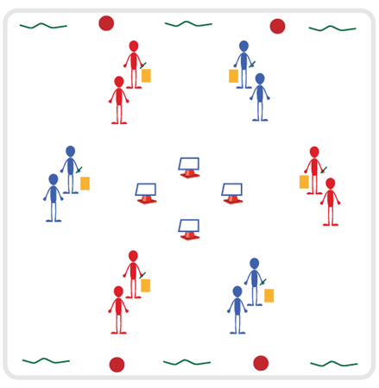
Equipment:
- Clipboard, Spell It Out Worksheet, and pencil for each group
- Spell it Out Movement Key on display in activity space
- Variety of equipment needed to complete tasks on Movement Key
Set-Up:
- Divide students into groups of 2-3
- Place equipment needed to complete tasks on Movement Key around perimeter of space
- Place copies of Movement Key in several places in activity space, or be prepared to display with a projector
- Groups begin spread out in activity space with a clipboard and pencil to complete the Spell It Out Worksheet

ACTIVITY PROCEDURES
- This activity is called Spell It Out! The object is to complete the worksheet with your group and the corresponding movements associated with each of your answers.
- On the start signal, each group will answer all of the questions on the Spell It Out Worksheet. Once it is completely filled out, your entire group will begin to complete the exercises/activities from the Spell It Out Movement Key that correspond with your answers. For example, if the answer given is running your team will do 10 lunges on each leg for the letter “R”, identify three aerobic exercises for the letter “U” and so on. The entire group should complete each challenge before moving on to the next answer given by your group on the Worksheet.
- Teachers: You will need to teach/review the terminology and topics on the Spell It Out worksheet prior to this activity.

GRADE LEVEL PROGRESSION
- Grade 6: Play the activity as described above.
- Grade 7-8: Have each group of students partner up with another group and complete a peer assessment of each other’s Spell It Out Worksheet.

TEACHING CUES
- Cue 1: Keep it safe during each of the exercises and movements.
- Cue 2: Use positive and supportive language with your classmates.
- Cue 3: Have fun!

SPELL IT OUT (continued…)

UNIVERSAL DESIGN ADAPTATIONS
- UDL 1: Allow students to work with a partner if needed.
- UDL 2: Provide multiple forms of prompts and cues - kinesthetic, visual, and auditory.
- UDL 3: Utilize questions at a variety of reading levels if needed.
- UDL 4: Allow students to dictate responses to questions versus writing on the worksheet. Could dictate to a partner or to the teacher.

ACADEMIC LANGUAGE
Heat-related Illness, Cardiorespiratory Endurance, FITT Principle

PRIORITY OUTCOMES
Personal Challenge:
- (6) Recognizes individual challenges and copes in a positive way, such as extending effort, asking for help/feedback, and/or modifying the tasks.
- (7) Generates positive strategies such as offering suggestions/assistance, leading/following others, and/or providing possible solutions when faced with a group challenge.
- (8) Develops a plan of action and makes appropriate decisions based on that plan when faced with a challenge.

DEBRIEF QUESTIONS
- DOK 1: How can you recognize an activity or exercise that works to improve cardiorespiratory endurance?
- DOK 2: Why do you think it is important to include cardiorespiratory endurance in your exercise and fitness plans?

THE A TO ZZZ’S OF SLEEP

STUDENT TARGETS
- Skill: I will work cooperatively with my teammates to complete the Public Service Announcement planning worksheet.
- Cognitive: I will identify why sleep is important for my mental and physical health.
- Fitness: I will stay actively engaged throughout this activity.
- Personal & Social Responsibility: I will use positive communication and encouraging language with my teammates.

EQUIPMENT & SET-UP
Equipment:
- Public Service Announcement Planning Worksheet for each group
- Clipboard/Pencils for each group
- Technology for research (laptops, iPads, etc.)

Set-Up:
- Divide students into groups of 3-4.
- Have technology available for research by groups.
- Have each group spread out within the activity space with their clipboard, planning worksheet, and pencils.

ACTIVITY PROCEDURES
- We are going to work together to create a Public Service Announcement (PSA) on the importance of sleep. Sleeping is a basic human need, just like breathing or eating, and is vital for our mental and physical health.
- Your group is going to work together to plan out a PSA related to sleep. There will be four steps: 1) choose your topic; 2) determine how you will “hook” your audience; 3) research and choose your facts/statistics; and 4) script out a clear message.
- On the start signal, each group will use the PSA planning worksheet to complete each of the 4 steps. It will be important for all group members to have input and feel heard during the planning process. There is technology available to assist with your research during the planning process as well. Note: teachers will need to ensure all available technology allows student research from allowable sites for your school district.
GRADE LEVEL PROGRESSION
- Grade 6: Play the activity as described above.
- Grade 7: Have students present the PSA’s developed to the class.
- Grade 8: Have students record their PSA’s and reach out to local media to try and share their message with the community.
TEACHING CUES
- Cue 1: Think before you write.
- Cue 2: Be creative!
- Cue 3: Use positive and supportive language during class discussion.

THE A TO ZZZ’S OF SLEEP (continued…)

UNIVERSAL DESIGN ADAPTATIONS
- UDL 1: Allow students to work with a partner if needed.
- UDL 2: Provide multiple forms of prompts and cues - kinesthetic, visual, and auditory.
- UDL 3: Ensure any assistive technology needed by a student is available on the day of this activity.
- UDL 4: Allow students to dictate responses on planning worksheet versus writing them down. Could dictate to a partner or to the teacher.

ACADEMIC LANGUAGE
Sleep, Public Service Announcement, Teamwork

PRIORITY OUTCOMES
Working with Others:
- (6) Accepts differences among classmates in physical development, maturation, and
varying skill levels by providing encouragement and positive feedback.
- (7) Demonstrates cooperation skills by establishing rules and guidelines for resolving conflicts.
- (8) Responds appropriately to participants’ ethical and unethical behavior during physical activity by using rules and guidelines for resolving conflicts.

DEBRIEF QUESTIONS
Cognitive Question Set:
- DOK 1: How much sleep do you think someone your age needs?
- DOK 2: How do you feel the next day if you haven’t gotten enough sleep the night before?
- DOK 3: What is an example of something that would be unsafe for someone to do if they haven’t gotten enough sleep? Why would that task/activity be unsafe?

Social & Emotional Question Set:
- DOK 1: What does cooperation mean?
- DOK 2: What is an example of how your group used cooperation to complete the PSA Planning Worksheet?
- DOK 3: How is cooperation related to the success of your group?

MY FITNESS PLAN

STUDENT TARGETS
- Skill: I will design a fitness and nutrition plan based on personal fitness goals, emotional and mental health needs, and activity preferences.
- Cognitive: I will identify barriers to maintaining a physically active lifestyle and seek solutions for eliminating those barriers.
- Fitness: I will participate in a variety of fitness activities using available technology.
- Personal & Social Responsibility: I will seek out opportunities to be active with friends and/or family in my local community.
EQUIPMENT & SET-UP
Equipment:
- Believe In You Great Goals 5-day Journal
- Task Tents with Pillars of Health Activity Cards
- Variety of equipment needed for activities

Set-Up:
- Divide students into groups of 3-4.
- Place task tents in center of activity space with the Pillars of Health Activity Cards.
- Place variety of equipment around perimeter of activity space.
- Groups begin spread out evenly at each of the task tents.
ACTIVITY PROCEDURES
- This activity is called My Fitness Plan. We are going to begin by reviewing the 4 Pillars of Health, and then work on setting some GREAT goals related to the 4 Pillars. The object is for each of you to develop goals that will improve or maintain your physical and emotional health.
- On the start signal, each group will begin at a task tent. You will review the Pillar of Health displayed. Next, you will discuss strategies or activities that can assist with that Pillar. For example, if you are at the “Movement” task tent you could have a potential goal to increase the amount of time you are physically active. Your group could discuss community opportunities for individual or team sports you may be interested in.
- Each time you hear the stop signal, you will rotate clockwise to the next task tent until you have reviewed and discussed all 4 Pillars. There is also a variety of activity equipment around the perimeter of the space if your group would like to try out any potential activities/sports that are discussed within your group.
- Once all 4 Pillars have been reviewed and discussed by each group, you will each complete Day 1 of the GREAT Goals 5-day Journal. You will identify at least 2 of the 4 Pillars of Health to create a goal for. You will complete one page of the journal for each goal until all 5 days are complete.
- Teachers: Provide opportunities for assistance and feedback with completion of the journals throughout the week. Journals can be completed at home or during the beginning/end of each class.
GRADE LEVEL PROGRESSION
- Grade 6: Complete the activity as described above.
- Grade 7: Have students develop both short-term and long-term goals for each of the 4 Pillars.
- Grade 8: Have students track their progress towards each of their goals and identify adjustments they could make for any goals that were not successfully achieved.

MY FITNESS PLAN (continued…)

TEACHING CUES
- Cue 1: Be thoughtful about setting goals that are important to you and will bring you joy.
- Cue 2: Use positive and supportive language with classmates during the activity.
- Cue 3: When setting goals, include activities that you enjoy and are interested in.

UNIVERSAL DESIGN ADAPTATIONS
- UDL 1: Allow students to work with a partner if needed.
- UDL 2: Provide multiple forms of prompts and cues - kinesthetic, visual, and auditory.
- UDL 3: Ensure any assistive technology needed by a student is available on the day of this activity.
- UDL 4: Allow students to dictate their goals versus writing them down. Could dictate to a partner or to the teacher.

ACADEMIC LANGUAGE
Health-related Fitness, Skill-related Fitness, Technology, Goal

PRIORITY OUTCOMES
Physical Activity Knowledge:
- (6) Identifies a variety of physical activity options available in the local community.
- (7) Identifies barriers to maintaining a physically active lifestyle and seeks solutions for eliminating barriers.
- (8) Explains the connection between regular physical activity and overall physical, emotional, and mental health.

Fitness Programming:
- (6) Maintains a physical activity log and reflects on activity levels documented in the log.
- (7) Designs a fitness and nutrition plan based on personal fitness goals, emotional and mental health needs, and activity preferences.
- (8) Seeks out and identifies fitness opportunities in the local community.

DEBRIEF QUESTIONS
Cognitive Question Set:
- DOK 1: How does being physically active lead to a healthy body?
- DOK 2: Goal setting is an important part of being healthy and active for a lifetime. What are some strategies you could use when developing your GREAT Goals?
- DOK 3: Sometimes we experience barriers when trying to reach our goals. What are some strategies you could use to identify potential barriers and seek solutions to eliminate them?

Social & Emotional Question Set:
- DOK 1: What is emotional health?
- DOK 2: How does physical activity affect emotional health?

