PILLARS OF HEALTH

STUDENT TARGETS
- Skill: I will demonstrate leadership while acting as a movement captain.
- Cognitive: I will identify the four pillars of health and their impact on my health and wellness.
- Fitness: I will discuss different physical activities and how each can positively impact my overall health.
- Personal & Social Responsibility: I will show respect for myself and others by using positive and supportive language.

EQUIPMENT & SET-UP | 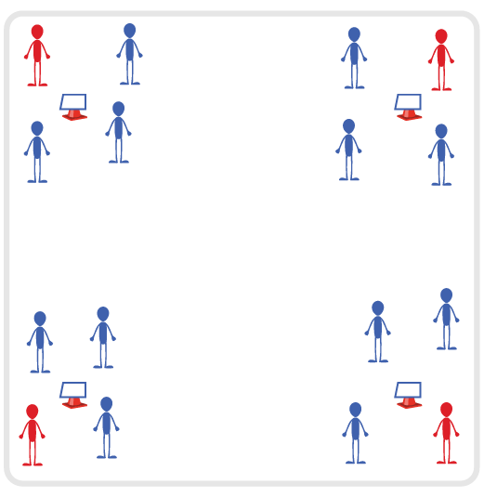
Equipment:
- 4 Cones
- Pillars of Health Activity Cards
- Task Tents
- Music and Music Player
Set-Up:
- Create 4 quadrants in the activity area, with a cone in the center of each quadrant.
- Create 4 equal groups of students, 1 group per cone.
- Designate 1 student per group to be the Movement Captain.
ACTIVITY PROCEDURES
- Today we’ll work on improving our health and wellness with an activity called Pillars of Health. The object is for you to follow the movements of each cone’s Movement Captain. When you hear the music stop, everyone except the Movement Captains will rotate clockwise.
- Movement Captains, you are in charge of creating a safe and high-energy movement (or sequence) with the goal of incorporating movements related to the 4 Pillars of Health while they are active at your cone. Each cone will have a focus on one of the 4 pillars of health (nutrition, movement, relaxation/stress management, sleep). Captains are responsible for leading each group that rotates to their cone and can choose the same movement each time or a new one for each group.
- Once groups rotate all the way around the area and make it back to their original cones, the Movement Captain will select a new captain for the next round.
- This activity can also be done with exercises specific to a fitness component. For example, the Movement Captain can become the Muscular Fitness Captain, or the Yoga Captain, etc.
GRADE LEVEL PROGRESSION
- Grade 6: Play the activity as described above.
- Grades 7-8: Challenge the students to create a health-related fitness question for each Movement Captain to ask groups as they rotate to each cone.
TEACHING CUES
- Cue 1: Keep it fun.
- Cue 2: Use positive and supportive language during the activity.
- Cue 3: Keep moving!

PILLARS OF HEALTH (continued…)

UNIVERSAL DESIGN ADAPTATIONS
- UDL 1: Modify the boundaries to make the activity area smaller to meet the needs of all students.
- UDL 2: Provide sample activities for Movement Captains to help facilitate activity and minimize decision-making.
- UDL 3: Assign peer partners as needed for any student who needs additional support.

ACADEMIC LANGUAGE
Nutrition, Movement, Relaxation, Stress Management, Sleep, Leadership

PRIORITY OUTCOMES
Social Interaction:
- (6) Demonstrates respect for self and others in activities and games by following the rules, encouraging others, and playing within the spirit of the game or activity.
- (7) Demonstrates the importance of social interaction by helping and encouraging others, avoiding trash talk, and providing support to classmates.
- (8) Demonstrates respect for self by asking for help and helping others in various physical activities.

DEBRIEF QUESTIONS
Cognitive Question Set:
- DOK 1: What would you include on a list about leadership?
- DOK 2: How did the Movement Captains show leadership during the activity today?

Social & Emotional Question Set:
- DOK 1: How does physical activity affect your overall health and wellness?
- DOK 2: Explain how each of the 4 pillars of health have an impact on your physical and/or emotional health.
- DOK 3: What experiences or activities would you choose to support your physical and/or emotional health and wellness? Elaborate on why you chose them.

