FOOD IS FUEL

STUDENT TARGETS
- Skill: I will successfully complete the food label scavenger hunt.
- Cognitive: I will correctly identify food labels for each item on the scavenger hunt card.
- Fitness: I will perform health-related fitness activities in personal and general space.
- Personal & Social Responsibility: I will use positive communication and encouraging language with my teammates.

EQUIPMENT & SET-UP | 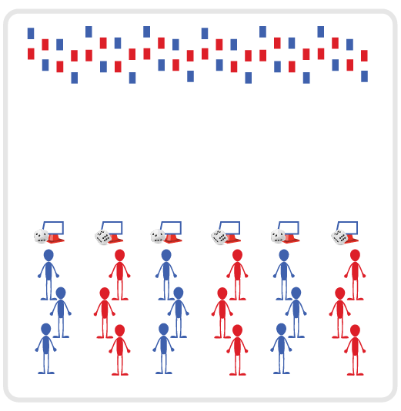
Equipment:
- Scavenger Hunt Cards
- 6 cones and 6 task tents
- Food Models from National Dairy Council
- Food Is Fuel Dice Card
- 1 foam die per team

Set-Up:
- Print and cut out food model cards. Scatter food models on one side of activity space.
- Place 6 cones at opposite end of space from food models.
- Place a foam die, task tent, Food Is Fuel Dice Card, and Scavenger Hunt Card at each cone.
- Create even groups of students at each cone.
ACTIVITY PROCEDURES
- This activity is called Food is Fuel! It is important for us to recognize how to fuel our bodies with healthy foods and beverages. Reviewing food labels on things we eat and drink help us do that.
- The object of the activity is for your group to successfully complete your scavenger hunt card. You do that by having one person at a time from your team go and find a food label on a food model card that matches each item on the scavenger hunt card. You will need a different food label for each item on the scavenger hunt card.
- On the start signal, the first person will go and find the first item, the second person will find the second item, etc. You will continue to take turns relay race style until your team has matched a food label to each item on the scavenger hunt card. After bringing the food label back to your group, you will roll the foam die and perform the corresponding exercise shown on the chart.
- Once each team has completed their scavenger card, or when you hear the stop signal, each group will rotate one cone to their right and review the food labels selected by that team to confirm the items selected match the scavenger hunt card.

GRADE LEVEL PROGRESSION
- Grade 6: Play the activity as described above.
Grades 7-8: Challenge students to also create a balanced My Plate meal with the food models they select to complete their scavenger hunt card.
TEACHING CUES
- Cue 1: Keep it fun.
- Cue 2: Use positive and supportive language during the activity.
- Cue 3: Keep moving!

FOOD IS FUEL (continued…)

UNIVERSAL DESIGN ADAPTATIONS
- UDL 1: Modify the boundaries to make the activity area smaller to meet the needs of all students.
- UDL 2: Provide demonstrations as visuals to enhance understanding of directions for activity.
- UDL 3: Assign peer partners as needed for any student who needs additional support.

ACADEMIC LANGUAGE
Food label, Healthy, Body Composition, Nutrient, Cooperation

PRIORITY OUTCOMES
Nutrition:
- (6) Identifies foods from each food group that can be combined to build balanced meals.
- (7) Compares and contrasts the health benefits of whole foods verses processed foods.
- (8) Seeks out and makes requests for nutritious whole-food choices.

DEBRIEF QUESTIONS
Cognitive Question Set:
- DOK 1: What were some healthy food options that you found during the scavenger hunt?
- DOK 2: What are the reasons you felt these food options were healthy?
- DOK 3: What are some things you can look for on a food label to help you determine if it is a healthy food or drink option?

Social & Emotional Question Set:
- DOK 1: How would you describe cooperation?
- DOK 2: What is an example of a way either you or a classmate showed cooperation today?
- DOK 3: Does being cooperative impact a group or team’s ability to be successful in completing a task or a challenge?

