FOOD RELATIONSHIPS

STUDENT TARGETS
- Skill: I will help and encourage others during the gallery walk.
- Cognitive: I will identify things that influence my relationship with food.
- Fitness: I will discuss ways that food and beverage intake are linked to my overall health and wellness.
- Personal & Social Responsibility: I will show respect for myself and others by using positive and supportive language.
EQUIPMENT & SET-UP | 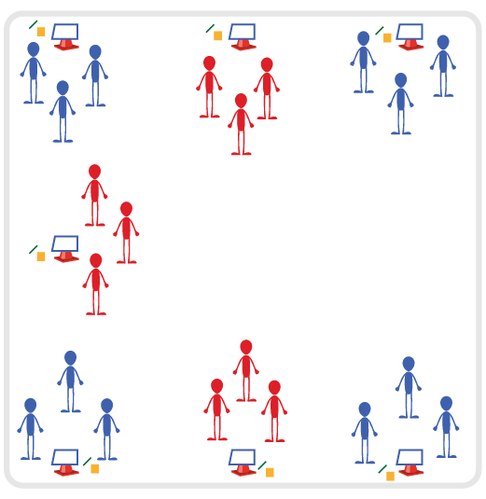
Equipment:
- Food Relationship Cards
- Cones with Task Tents (or tape to stick posters to the wall)
- Several Sticky Notes per student
- Pens or pencils
- Music and Music Player
Set-Up:
- Place Food Relationship Cards on cones using Task Tents, or tape them on the walls around the activity area.
- Place a pad of sticky notes and pencils next to each Food Relationship Card.
- Group students and send each group to a Food Relationship Card.
ACTIVITY PROCEDURES
- A healthy relationship with food includes valuing the pleasure that food gives us, respecting the body’s need for food and nutrition, and having mostly positive thoughts and feelings about food.
- Today we’re going to complete a gallery walk in order to explore more about food relationships and some things that can influence a person’s relationship with food.
- When the music starts, your group will walk to the nearest food relationship poster. Look at the title of the topic and then read the first question.
- Take a few seconds to think about your response to this question, then write a short answer on a sticky note. Post that sticky note on the wall next to the poster (or by cone with task tent), then walk clockwise to the next poster and repeat the process when the music stops.
- Once we’ve completed a loop around the gallery and responded to question 1, we’ll take some time to discuss a few of the answers on the sticky notes for each poster.
- Teachers: if time permits, repeat the entire gallery walk with students responding to question 2.
GRADE LEVEL PROGRESSION
- Grade 6: Focus on question 1 and allow time for detailed discussion during the debrief of the first gallery walk.
- Grades 7-8: If students demonstrate mastery of the concepts discussed for question 1, continue on to question 2 during a second gallery walk.
TEACHING CUES
- Cue 1: Think before you write.
- Cue 2: Use positive and supportive language during class discussion.

FOOD RELATIONSHIPS (continued…)

UNIVERSAL DESIGN ADAPTATIONS
- UDL 1: Allow students to work with a partner if needed.
- UDL 2: Provide multiple forms of prompts and cues - kinesthetic, visual, and auditory.
- UDL 3: Utilize questions at a variety of reading levels if needed.
- UDL 4: Allow students to dictate responses to Gallery Walk questions versus writing on a sticky note. Could dictate to a partner or to the teacher.

ACADEMIC LANGUAGE
Cultural Tradition, Dietary Restriction, Experience, Food Relationship, Influence, Nutrition, Preference, Relationship, Respect

PRIORITY OUTCOMES
Social Interaction:
(6) Demonstrates respect for self and others in activities by following the rules and encouraging others.
(7) Demonstrates the importance of social interaction by helping and encouraging others, avoiding trash talk, and providing support to classmates.
(8) Demonstrates respect for self by asking for help and helping others in various physical activities.

DEBRIEF QUESTIONS
Cognitive Question Set:
DOK 1: What was something that you learned or heard for the first time today about food relationships?
DOK 2: How will what we discussed today influence your relationship with food?
DOK 3: What are some lifestyle changes related to food and beverage intake that could improve your overall health and wellness?

Social & Emotional Question Set:
- DOK 1: How would you describe respect?
- DOK 2: Did you experience an example today of someone showing respect? Explain why you feel your example was being respectful.
- DOK 3: How could someone earn your respect? What is something you could do to earn the respect of someone else?

