MY FITNESS PLAN

STUDENT TARGETS
- Skill: I will design a fitness and nutrition plan based on personal fitness goals, emotional and mental health needs, and activity preferences.
- Cognitive: I will identify barriers to maintaining a physically active lifestyle and seek solutions for eliminating those barriers.
- Fitness: I will participate in a variety of fitness activities using available technology.
- Personal & Social Responsibility: I will seek out opportunities to be active with friends and/or family in my local community.
EQUIPMENT & SET-UP | 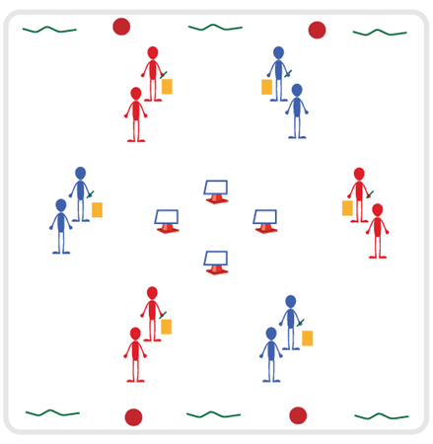
Equipment:
- Believe In You Great Goals 5-day Journal
- Task Tents with Pillars of Health Activity Cards
- Variety of equipment needed for activities

Set-Up:
- Divide students into groups of 3-4.
- Place task tents in center of activity space with the Pillars of Health Activity Cards.
- Place variety of equipment around perimeter of activity space.
- Groups begin spread out evenly at each of the task tents.
ACTIVITY PROCEDURES
- This activity is called My Fitness Plan. We are going to begin by reviewing the 4 Pillars of Health, and then work on setting some GREAT goals related to the 4 Pillars. The object is for each of you to develop goals that will improve or maintain your physical and emotional health.
- On the start signal, each group will begin at a task tent. You will review the Pillar of Health displayed. Next, you will discuss strategies or activities that can assist with that Pillar. For example, if you are at the “Movement” task tent you could have a potential goal to increase the amount of time you are physically active. Your group could discuss community opportunities for individual or team sports you may be interested in.
- Each time you hear the stop signal, you will rotate clockwise to the next task tent until you have reviewed and discussed all 4 Pillars. There is also a variety of activity equipment around the perimeter of the space if your group would like to try out any potential activities/sports that are discussed within your group.
- Once all 4 Pillars have been reviewed and discussed by each group, you will each complete Day 1 of the GREAT Goals 5-day Journal. You will identify at least 2 of the 4 Pillars of Health to create a goal for. You will complete one page of the journal for each goal until all 5 days are complete.
- Teachers: Provide opportunities for assistance and feedback with completion of the journals throughout the week. Journals can be completed at home or during the beginning/end of each class.
GRADE LEVEL PROGRESSION
- Grade 6: Complete the activity as described above.
- Grade 7: Have students develop both short-term and long-term goals for each of the 4 Pillars.
- Grade 8: Have students track their progress towards each of their goals and identify adjustments they could make for any goals that were not successfully achieved.

MY FITNESS PLAN (continued…)

TEACHING CUES
- Cue 1: Be thoughtful about setting goals that are important to you and will bring you joy.
- Cue 2: Use positive and supportive language with classmates during the activity.
- Cue 3: When setting goals, include activities that you enjoy and are interested in.

UNIVERSAL DESIGN ADAPTATIONS
- UDL 1: Allow students to work with a partner if needed.
- UDL 2: Provide multiple forms of prompts and cues - kinesthetic, visual, and auditory.
- UDL 3: Ensure any assistive technology needed by a student is available on the day of this activity.
- UDL 4: Allow students to dictate their goals versus writing them down. Could dictate to a partner or to the teacher.

ACADEMIC LANGUAGE
Health-related Fitness, Skill-related Fitness, Technology, Goal

PRIORITY OUTCOMES
Physical Activity Knowledge:
- (6) Identifies a variety of physical activity options available in the local community.
- (7) Identifies barriers to maintaining a physically active lifestyle and seeks solutions for eliminating barriers.
- (8) Explains the connection between regular physical activity and overall physical, emotional, and mental health.

Fitness Programming:
- (6) Maintains a physical activity log and reflects on activity levels documented in the log.
- (7) Designs a fitness and nutrition plan based on personal fitness goals, emotional and mental health needs, and activity preferences.
- (8) Seeks out and identifies fitness opportunities in the local community.

DEBRIEF QUESTIONS
Cognitive Question Set:
- DOK 1: How does being physically active lead to a healthy body?
- DOK 2: Goal setting is an important part of being healthy and active for a lifetime. What are some strategies you could use when developing your GREAT Goals?
- DOK 3: Sometimes we experience barriers when trying to reach our goals. What are some strategies you could use to identify potential barriers and seek solutions to eliminate them?

Social & Emotional Question Set:
- DOK 1: What is emotional health?
- DOK 2: How does physical activity affect emotional health?

