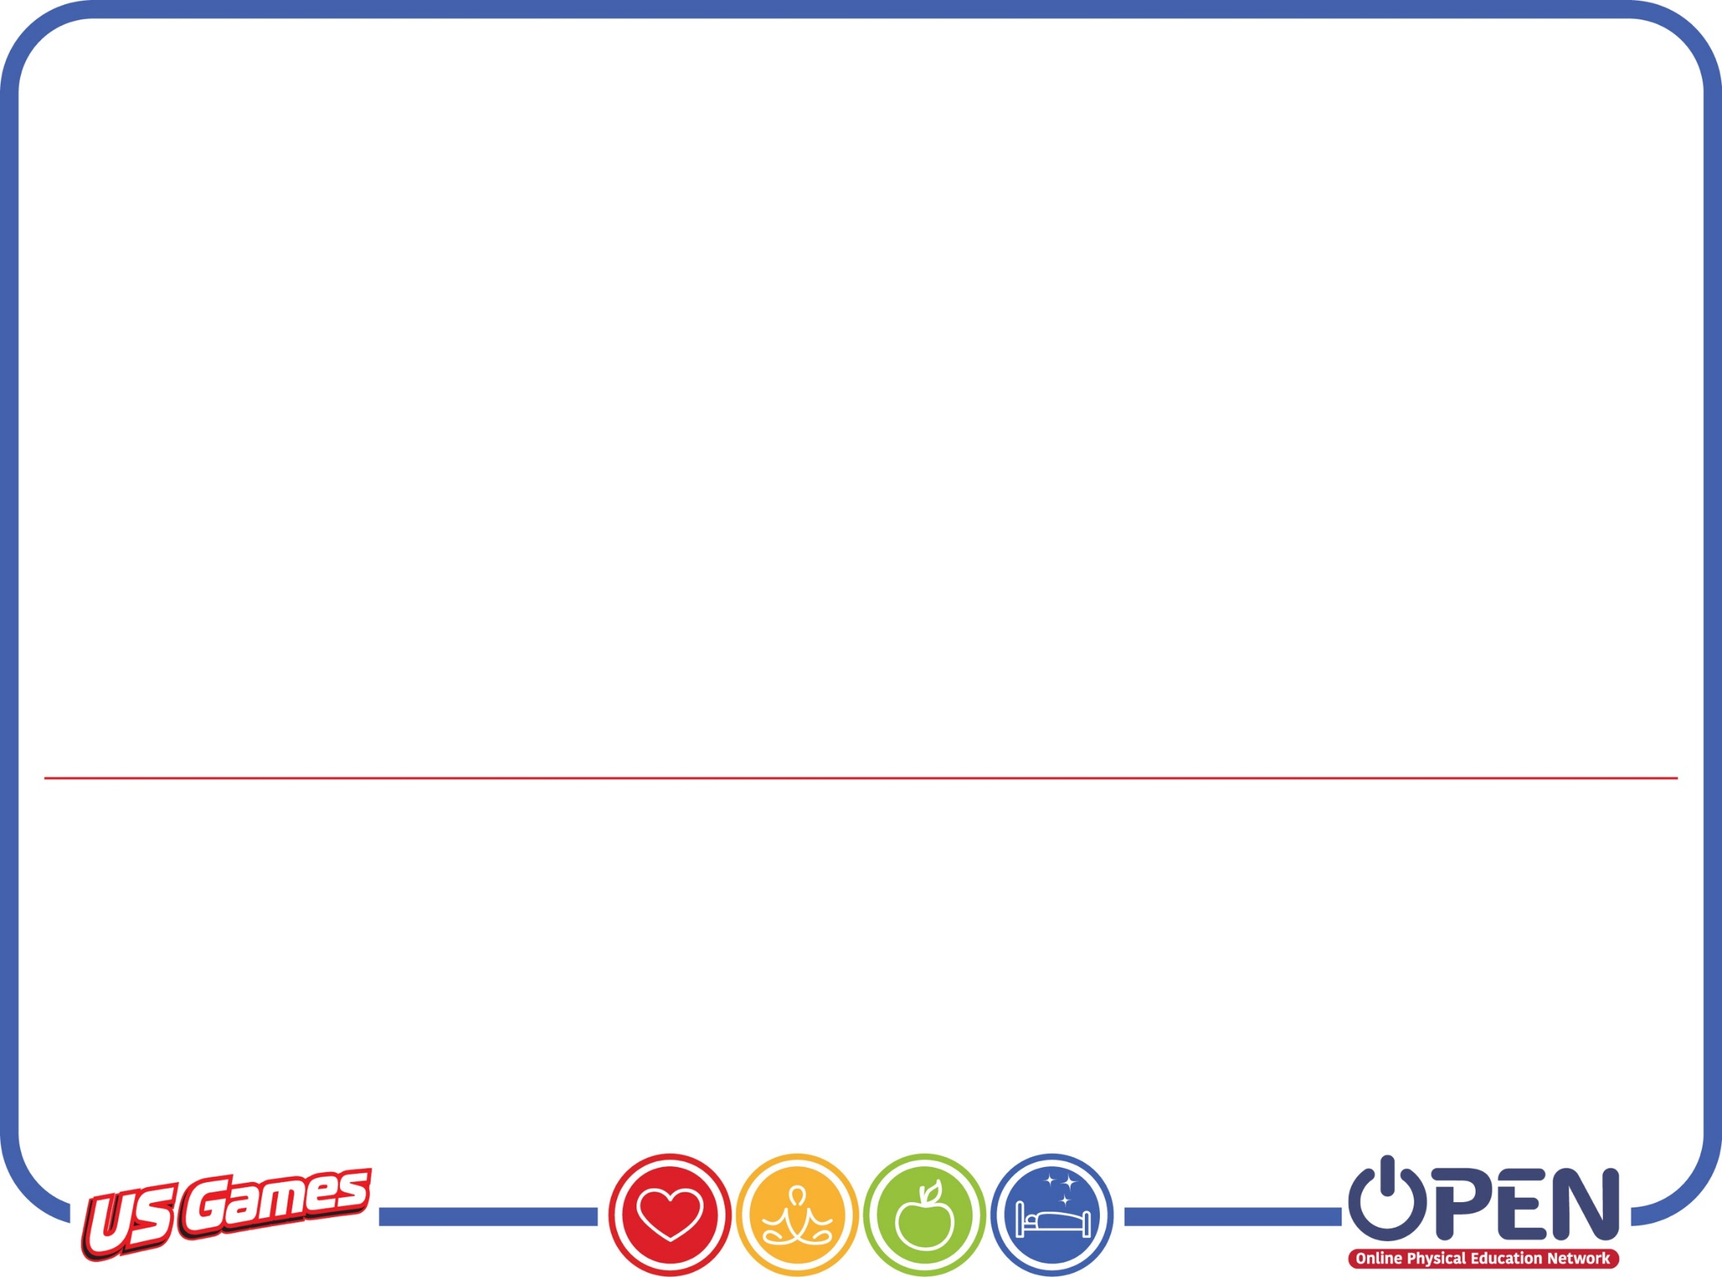

**On The Run**

**Paragraph 2**

Think of food as energy to charge up your battery for the day. Throughout the day, you use energy from the battery to think and move, so you need to eat and drink to stay powered up. Balancing the energy you take in through food and beverages with the energy you use for growth, activity, and daily living is called "energy balance."