­­

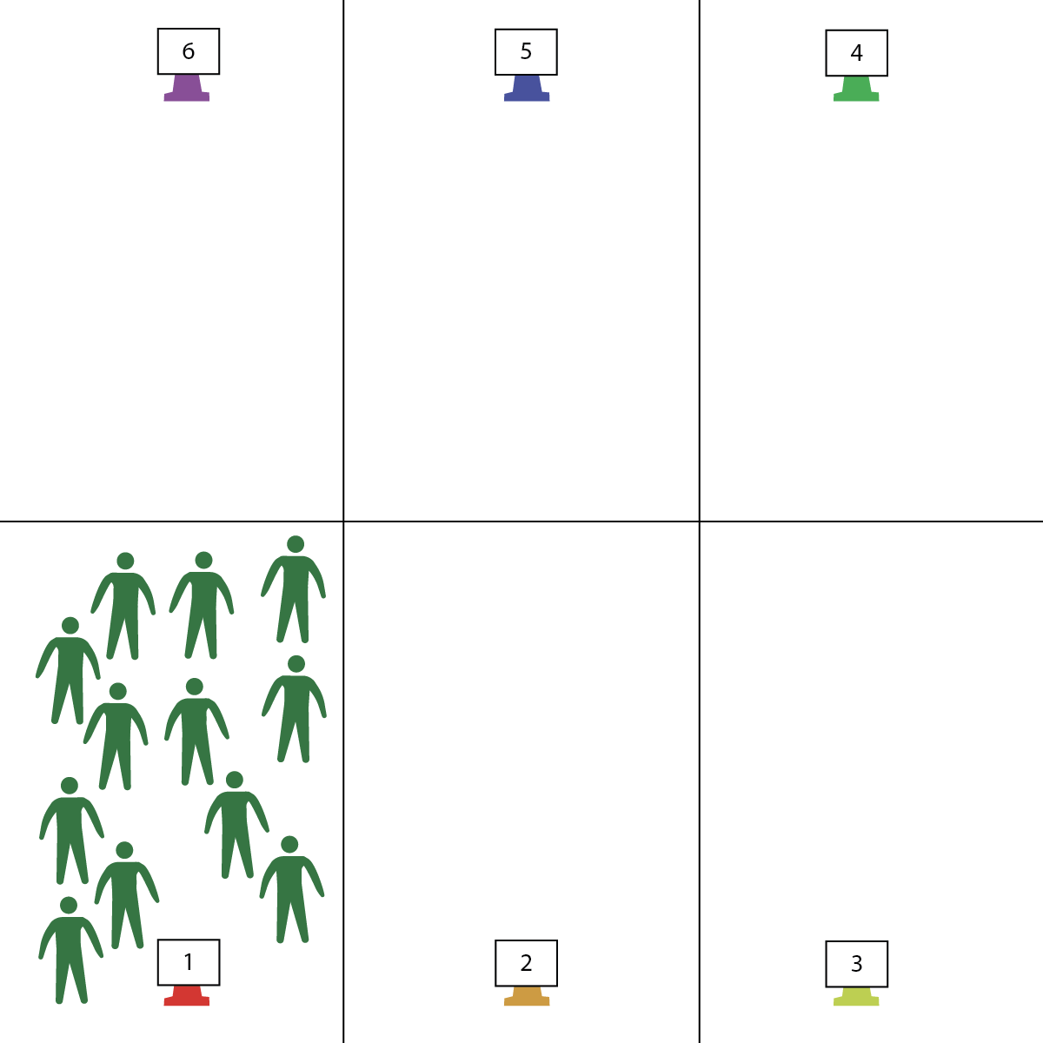

* High Plank with Hands Under Shoulders
* Back and Body Straight with Core Engaged
* Bend Elbows Naturally Down to 90 Degrees
* Push Back Up and Exhale
* **Skill:** I will perform push-ups with perfect form.
* **Cognitive:** I will discuss the concept of leveling up with respect to personal improvement and development.
* **Fitness:** I will identify exercises that promote muscular fitness.
* **Personal & Social Responsibility:** I will participate with a variety of classmates – even those that I don’t already know on a personal level.

**Activity Procedures:**

1. This is RPS Level Up – Push-ups Edition. This activity will help us develop our Muscular Fitness.
2. The object is to win as many games of Rock, Paper, Scissors as possible. After each win, you will Level Up to the next level by completing the routine on the Level Up Card. If you do not win, move down 1 level and find a new person to challenge.
3. To Play: You will perform 3 push-ups while saying, “Rock, Paper, Scissors” and then “Show!”

* To show ROCK – bring both feet up to the chest (like starting of burpee)
* To show PAPER – spread feet and legs into a wide V
* To show SCISSORS –perform an X-Plank (stretch 1 arm up and out and opposite leg up and out)

MODIFIED on knees: Perform 3 shoulder taps, “Rock, Paper, Scissors” and then “Show!”

* + To show ROCK – bring arms and chest down (child’s pose)
  + To show PAPER – bring arms straight up, keeping good alignment (thunderbolt pose)
  + To show SCISSORS – perform bird dog pose (stretch one arm out with opposite leg out)

**Grade Level Progression:**

**Level-Up!** Provide blank Level Up Cards to groups of students and prompt them to create new cards by choosing their favorite exercises.

**Equipment:**

* 6 cones for boundaries
* Level Up Cards
* 6 Task Tents

**Set-Up:**

1. Place Level Up Cards in Task Tents and place on cones in order from Level 1 to Level 6.
2. Place the 6 cones either around the perimeter or in sequential order across the playing space.
3. Students start in pairs with everyone at Level 1.

**RPS LEVEL UP (PUSH-UPS)**

**RPS LEVEL UP (PUSH-UP)**



* **DOK 1:** Can you list 3 exercises that help you develop your muscular fitness?
* **DOK 2:** How would you modify these exercises to make them easier? How would you make them more challenging?
* **DOK 3:** Why is it important to understand how to modify exercises as you work to improve your overall fitness?
* **DOK 4:** Choose a muscular fitness exercise. Create 3 modifications that could be used to build a fitness plan that starts with an easy version and becomes increasingly more challenging. Take time to practice each modification.



Muscular Fitness, Push-up, Modify



* **Values Physical Activity [Personal Challenge]:** (HS) Chooses an appropriate level of challenge to experience success and a desire to participate in self-selected physical activity while working toward personal fitness goals.
* **Fitness Knowledge [Fitness Programming]:** (HS) Creates and implements a life-style plan that includes fitness, nutrition, emotional and mental health, and career/productivity goals.
* **Responsible Behaviors [Etiquette]** (HS) Exhibits proper etiquette, respect for others, and teamwork while engaging in physical activity and/or social dance.



* Replace push-ups with high planks and students simply saying, “Rock, Paper, Scissors, SHOW!”.
* Allow students to participate in modified plank positions (hands and knees).
* Play the game with wall push-ups or wall planks and students positioned side-by-side against a safe and sturdy wall.

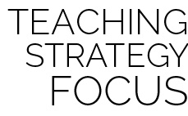

**Help students practice skills, strategies, and processes:** Throughout a person’s physical fitness journey, they will be required to adapt and adjust the intensity of their physical activity based on their goals and limitations (such as an injury). To have the required confidence, students must be given the opportunity and instructional support needed to do this correctly. Take this time to work through the debrief questions above and make the time and space students need to create their own exercise modifications.