­­

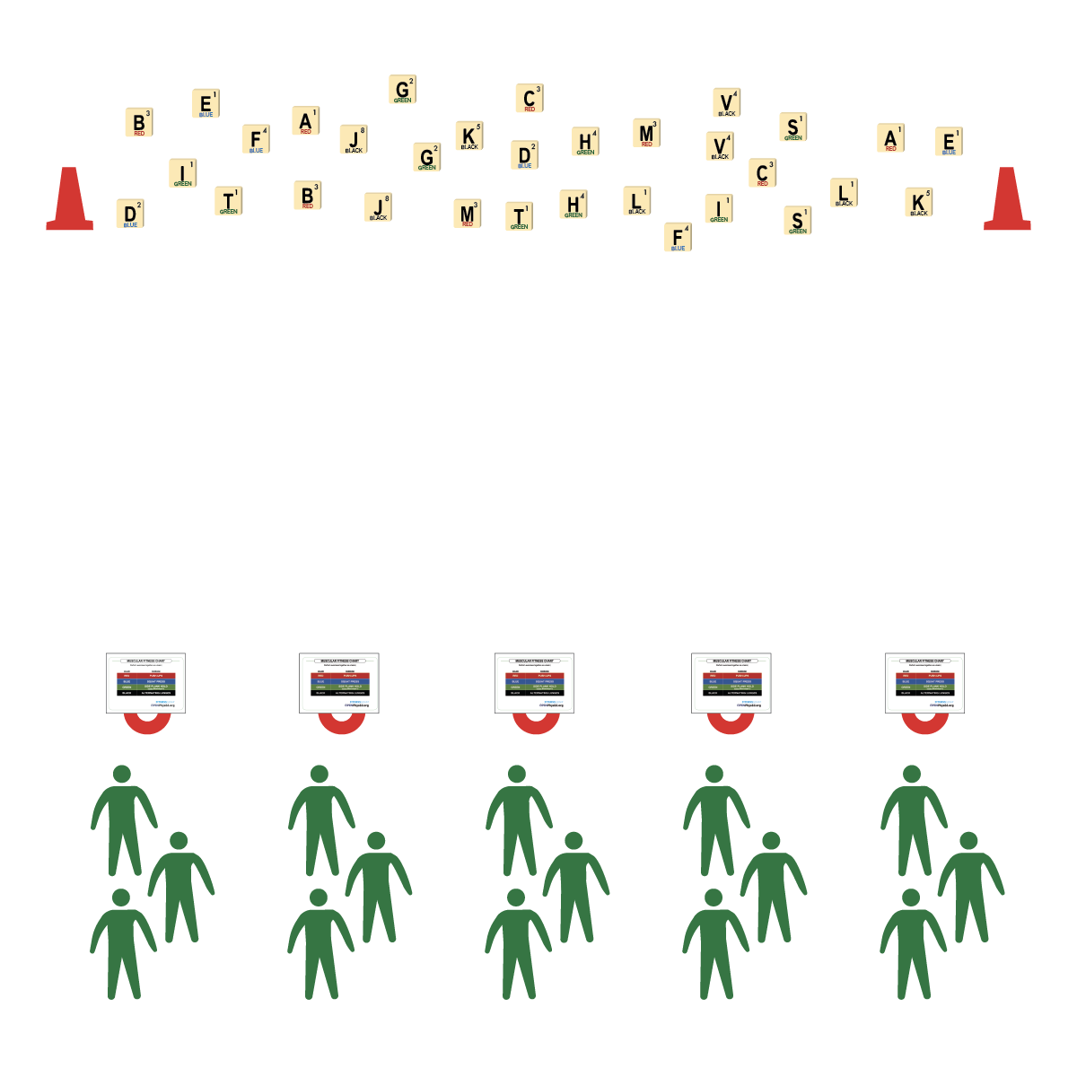

* **Skill:** I will perform muscular fitness exercises at an intensity level that safely challenges me.
* **Cognitive:** I will discuss how muscular fitness exercises can be a part of my overall wellness plan.
* **Fitness:** I will discuss how being physically active with friends can help improve my mental health.
* **Personal & Social Responsibility:** I will demonstrate physical activity etiquette and respect for my classmates.

**Activity Procedures:**

1. Today’s activity is called Words with Friends. We’ll be focusing today’s game on Muscular Fitness. (Aerobic fitness and flexibility charts are also available.)
2. The object of the game is for your team to create as many words as you can using the Words with Friends letter tiles. Each tile has a letter, a color, and a number on it.
3. On the start signal, the first player on the team will run and bring back the letter tile, place it down, and then perform the movement associated with the card with their entire team. (Example: Red, A, 1 = 1 Push-up)
4. Once complete, the next student runs and grabs another letter tile, returns, and performs the movement as a team.
5. During and after game play, collected letter tiles will be used to create words. Each word will be worth the total number of points identified on the letter tiles. Teams earn double points for creating words that focus on fitness or personal well-being.

**Grade Level Progression:**

**Level-Up!** Provide blank Muscular Fitness Charts to each team and prompt them to create new charts by choosing their favorite exercises.

**Equipment:**

* 1 low-profile cone per group of 2-4 students
* 1 set of Words with Friends Letter Cards
* 2 large cones
* 1 Words with Friends Activity Chart per group

**Set-Up:**

1. Create 2 parallel lines 20 meters apart.
2. Along 1 line, place 2 large cones on each end with Letter Cards scattered between the cones. Along the other line, spread low profile cones evenly as a home base for each team.
3. Create teams of 2-4 students, each team at a home base with an Activity Chart.

**FITNESS WORDS WITH FRIENDS**

* Focus on Form
* Keep Exercise Movements Smooth – Don’t Rush

**FITNESS WORDS WITH FRIENDS**



* **Values Physical Activity [Personal Challenge]:** (HS) Chooses an appropriate level of challenge to experience success and a desire to participate in self-selected physical activity while working toward personal fitness goals.
* **Fitness Knowledge [Fitness Programming]:** (HS) Creates and implements a life-style plan that includes fitness, nutrition, emotional and mental health, and career/productivity goals.
* **Responsible Behaviors [Etiquette]** (HS) Exhibits proper etiquette, respect for others, and teamwork while engaging in physical activity and/or social dance.



* **DOK 1:** In your own words, what is muscular fitness and why is it important?
* **DOK 2:** How can you add muscular fitness exercises into your overall wellness plan?
* **DOK 3:** How is your personal fitness related to your mental health?
* **DOK 4:** Can we create a list of strategies and ideas that can help you be physically active with friends and family? Can we include ideas that promote muscular fitness?



* Modify the Muscular Fitness Charts to provide the appropriate exercises and intensity levels for your students.
* Provide visual and auditory cues for each exercise on the Muscular Fitness Chart.



Muscular Fitness, Intensity, Challenge



**Identify critical content:** By answering the questions above, students will be prompted to think about muscular fitness as an important part of their overall personal wellness. These questions also tie muscular fitness to both physical and mental health and to the importance of being active with friends and family. Support students as they struggle in making these connections and highlight the important connections that they do make.