SET BALL

STUDENT TARGETS
- Skill: I will perform a volleyball set demonstrating control and accuracy.
- Cognitive: I will discuss the cues for a volleyball set.
- Fitness: I will remain actively engaged throughout the activity.
- Personal & Social Responsibility: I will use respectful and positive language with my classmates.

EQUIPMENT & SET-UP | 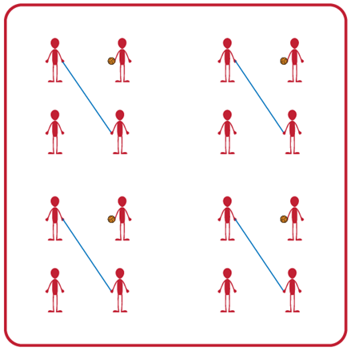
Equipment:
- 1 volleyball, volleyball trainer, or foam ball per group (Teachers: allow student choice of equipment when possible)
- 1 jump rope per group

Set-Up:
- Divide students into teams of 4.
- Two players begin by holding the jump rope to make a net for their team.
- Other two players begin on opposite sides of the net facing each other, with one student holding the foam ball and ready to serve after hearing the start signal.

ACTIVITY PROCEDURES
- This activity is called Set Ball. The object of the game is to set the ball over the net as many times in a row as you can. You do that by working together as a team to set the ball back and forth over the net (which is a jump rope held by two players).
- On the start signal, the player with the ball will begin with a self-toss, and then set the ball over the net. The two volleying players will continue setting the ball back and forth as many times in a row as they can. But each person can only hit the ball a max of three times on their side before it must go over the net.
- The two players holding the net can help the two volleying players be successful by moving their feet or altering the height of the net. The net holders and the volleying players will work together to achieve the highest possible team score! Any time the ball hits the ground or is hit more than three times on one side, the players will each rotate clockwise one spot (e.g., rope holders and volleying players get a new partner each time they switch roles).
- On the stop signal players will place the jump rope and the ball down on the ground. The two players who were holding the jump rope when you heard the stop signal will move to a new group before we play again.
- Teachers: If you have uneven numbers, create a rotation where the fifth player in the group acts as the line judge until they rotate into the game.

GRADE LEVEL PROGRESSION
- Grade 6: Play as described above.
- Grade 7: Students may only contact the ball twice on their side before it goes over the net.
- Grade 8: Students choose to have a cooperative or more competitive focus for their group. Groups can choose to work cooperatively and go for the longest rally or choose to play competitively 1v1 to score individual points.
SET BALL (continued…)

TEACHING CUES
- Cue 1: Body Position: knees bent, head up, feet shoulders width apart, hands ready, facing partner.
- Cue 2: Move feet to get under the ball so you can get the ball back to your partner for a longer rally.
- Cue 3: Net holders need to stay attentive & work together so they can move where needed during the rally.

UNIVERSAL DESIGN ADAPTATIONS
- UDL 1: Increase/decrease the size of activity space.
- UDL 2: Allow students to participate seated vs. standing if needed.
- UDL 3: Use modified equipment as needed (e.g., balloon or beach ball with a bell attached).
- UDL 4: Use verbal cues and visual aids along with demonstrations.
- UDL 5: Use peer partners as appropriate.

ACADEMIC LANGUAGE
Set, Volley, Communication, Body Position, Cooperation

PRIORITY OUTCOMES
Working with Others:
- (Grade 6) Accepts differences among classmates in physical development, maturation, and varying skill levels by providing encouragement and positive feedback.
- (Grade 7) Demonstrates cooperation skills by establishing rules and guidelines for resolving conflicts.
- (Grade 8) Responds appropriately to participants’ ethical and unethical behavior during physical activity by using rules and guidelines for resolving conflicts.

DEBRIEF QUESTIONS
- DOK 1: Was there a communication strategy that your team used during this activity?
- DOK 2: Sometimes we use a strategy during a game or activity, and it doesn’t work well. Was there a communication strategy that you tried during this game that didn’t work very well? What did you do differently if you realized a communication strategy wasn’t working for your team?

HULA HOOP VOLLEYBALL

STUDENT TARGETS
- Skill: I will demonstrate correct technique for volleyball passes.
- Cognitive: I will discuss the cues for a volleyball bump and set.
- Fitness: I will remain actively engaged throughout the activity.
- Personal & Social Responsibility: I will use encouraging language with my classmates.

EQUIPMENT & SET-UP | 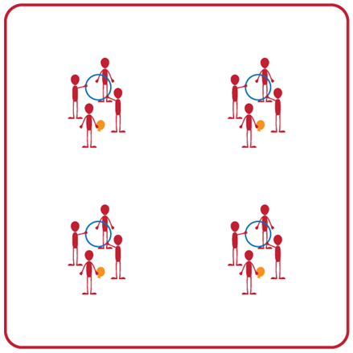
Equipment:
- 1 hula hoop per group
- 1 beach ball or balloon per group

Set-Up:
- Divide students into groups of 4. Each group will begin with one hula hoop and one beach ball or balloon.
- Two students will be the hula hoop holders. The remaining 2 students will stand on opposite sides of the hula hoop facing each other (the hoop will be held vertically between them). One student will begin with either a beach ball or a balloon.

ACTIVITY PROCEDURES
- This activity is called Hula Hoop Volleyball. The object of the game is to continuously pass the beach ball (or balloon) through the hula hoop with your partners.
- On the start signal, the student with the beach ball (or balloon) will toss the ball through the hoop to begin the rally. Students will begin passing the beach ball (or balloon) back and forth through the hoop using either a bump or a set. You will determine the type of pass to use (bump or set) based on where the ball is when it comes through the hoop. Teammates holding the hula hoop can move and adjust the hoop to help the partners successfully pass as many times in a row as possible!
- Students are allowed a maximum of three hits to return the beach ball (or balloon) through the hoop. If it hits the ground or is not returned through the hoop in three tries, student will alternate positions with one of the hoop holders.
- On the stop signal the students holding the hula hoop will place their hoop on the ground and find a new group to play again.

GRADE LEVEL PROGRESSION
- Grade 6: Play as described above.
- Grade 7: Students holding the hula hoop cannot move their feet or the hula hoop.
- Grade 8: Divide students into groups of 6. Have students play doubles and both partners must hit the ball before it goes through the hoop (with a maximum of 3 hits as a team).

TEACHING CUES
- Cue 1: Use the cue charts to review correct technique for the bump and set.
- Cue 2: Move feet to get under the ball so you can pass back to your partner for a longer rally.
- Cue 3: Hoop holders need to stay attentive & work together so they can move where needed during the rally.
HULA HOOP VOLLEYBALL (continued…)

UNIVERSAL DESIGN ADAPTATIONS
- UDL 1: Increase/decrease the size of activity space.
- UDL 2: Allow students to participate seated vs. standing if needed.
- UDL 3: Use modified equipment as needed (e.g., balloon or beach ball with a bell attached).
- UDL 4: Use verbal cues and visual aids along with demonstrations.
- UDL 5: Use peer partners as appropriate.

ACADEMIC LANGUAGE
Bump, Set, Teamwork, Rally, Communication

PRIORITY OUTCOMES
Working with Others:
- (Grade 6) Accepts differences among classmates in physical development, maturation, and varying skill levels by providing encouragement and positive feedback.
- (Grade 7) Demonstrates cooperation skills by establishing rules and guidelines for resolving conflicts.
- (Grade 8) Responds appropriately to participants’ ethical and unethical behavior during physical activity by using rules and guidelines for resolving conflicts.

Social Interaction:
- (Grade 6) Demonstrates respect for self and others in activities and games by following the rules, encouraging others, and playing within the spirit of the game or activity.
- (Grade 7) Demonstrates the importance of social interaction by helping and encouraging others, avoiding trash talk, and providing support to classmates.
- (Grade 8) Demonstrates respect for self by asking for help and helping others in various physical activities.

DEBRIEF QUESTIONS
- DOK 1: What would you include on a list of movement concepts related to this activity?
- DOK 2: How did you apply those movement concepts when deciding to pass with a bump or a set?
- DOK 3: How could you adapt this activity to make it more challenging? To make it less challenging?

SIT & SET

STUDENT TARGETS
- Skill: I will set the volleyball over the net demonstrating control and accuracy.
- Cognitive: I will state the teaching cues for a volleyball set.
- Fitness: I will stay actively engaged in the activity for the duration of the class.
- Personal & Social Responsibility: I will show respect for all classmates and equipment during this activity.

EQUIPMENT & SET-UP | 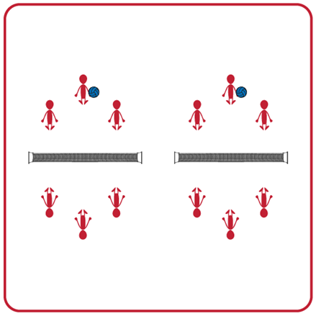
Equipment:
- 1 Featherlite Volleyball per group
- 1 net (modified net approximately waist high of a standing student) per group
- 4 boundary cones per group

Set-Up:
- Divide students into equal teams (e.g., 2v2 or 3v3).
- Two equal teams will play against one another. Divide the space for each set of two teams into equal areas with a net in the middle and 4 cones to set the boundaries.
- Students will all begin sitting, with the teams facing each other on opposite sides of the net in their activity space.
ACTIVITY PROCEDURES
- This activity is called Sit & Set. The object of the activity is to work with your teammates on the accuracy and technique of your overhead pass (set). Practicing your set while sitting allows you to focus on your arm position and technique.
- On the start signal, the student with the volleyball for their group will underhand toss the ball to their teammate. You are trying to get the ball high enough for your teammate to catch above their head in order to successfully set it over the net to the other team.
- The receiving team will catch the ball once it goes over the net. They will repeat the process of underhand tossing the volleyball to a teammate for them to set it back over the net.
- Each team gets one toss and one set to successfully get the volleyball over the net. Your team gets one point for each successful set that goes over the net and is inside the boundary cones.
- On the stop signal, the team who has the volleyball will stay and the opposing team will move and find a new group before we play again.

GRADE LEVEL PROGRESSION
- Grade 6: Play as described above.
- Grade 7: Have teams receive and set the volleyball back over the net without catching it first.
- Grade 8: Have two groups of teams join together (there will now be a total of 4 equal teams in a group). Create a grid of 4 activity spaces with the nets (similar to 4-square) for the activity.

TEACHING CUES
- Cue 1: Create a triangle with your pointer fingers and thumbs near your forehead before each set.
- Cue 2: Extend your arms and push the ball up as you set.
- Cue 3: Remember to toss the ball high enough that your teammate will be under it and can get their arms into position before the set.
SIT AND SET (continued…)

UNIVERSAL DESIGN ADAPTATIONS
- UDL 1: Increase/decrease the size of target/activity space
- UDL 2: Use modified equipment as needed (e.g., balloon or beach ball with a bell attached).
- UDL 3: Use verbal cues and visual aids along with demonstrations.
- UDL 4: Use peer partners as appropriate.

ACADEMIC LANGUAGE
Set, Follow Through, Accuracy, Teamwork, Growth Mindset

PRIORITY OUTCOMES
Personal Challenge:
- (Grade 6) Recognizes individual challenges and copes in a positive way, such as extending effort, asking for help/feedback, and/or modifying the tasks.
- (Grade 7) Generates positive strategies such as offering suggestions/assistance, leading/following others, and/or providing possible solutions when faced with a group challenge.
- (Grade 8) Develops a plan of action and makes appropriate decisions based on that plan when faced with a challenge.

DEBRIEF QUESTIONS
Growth Mindset Question Set:
- DOK 1: What is a challenge? Can you give examples of a challenge that someone might face?
- DOK 2: How would you apply growth mindset to facing a challenge?
- DOK 3: Describe what someone might learn from facing a difficult challenge.

Teamwork Question Set:
- DOK 1: How did you demonstrate teamwork when you faced today’s challenge?
- DOK 2: How would you summarize your entire team’s performance today?
- DOK 3: How was teamwork related to that performance?

PASS AND GO

STUDENT TARGETS
- Skill: I will apply cues for the forearm pass (bump) during this activity.
- Cognitive: I will identify strategies and tactics to attempt to win points for my team.
- Fitness: I will stay actively engaged for the duration of this activity.
- Personal & Social Responsibility: I will provide encouragement and safely cooperate with my peers.
EQUIPMENT & SET-UP | 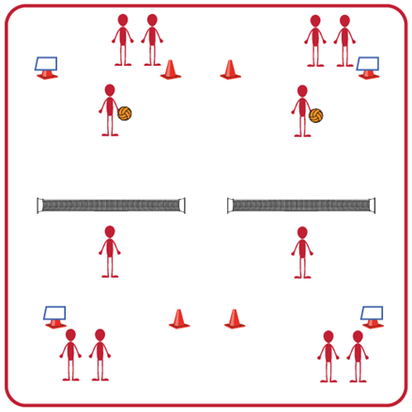
Equipment:
- 1 volleyball, volleyball trainer, or foam ball per group (Teachers: allow student choice of equipment when possible)
- 1 net per group
- 4 boundary cones per group
- Task Tent and Volleyball Cue Charts per group
Set-Up:
- Divide students into groups of 6. Each group splits into even teams (i.e., 3v3) with teams beginning on opposite sides of the net.
- Set up 1 court per group of 6 students. Place cones and task tents with cue charts beside each court.
- Each team begins in a line on their side of the court. The 1st player in line begins on the court, and the others wait to rotate in.
ACTIVITY PROCEDURES
- This activity is called Pass and Go. The object of the game is to continually forearm pass (bump) the volleyball over the net for your team while quickly rotating onto and off of the court.
- The game will begin with 1 player from each team on the court, ready to face off. 1 player will underhand serve the ball over the net to begin play. After the ball is served, the server immediately goes to the end of their line and the next player from their team steps onto the court.
- The player who receives the serve will bump it back over the net, and then immediately move to the end of their line so that the next player can step onto the court and get ready to receive the ball. Each player will be on the court for one attempt, regardless of whether it is successful or not, and then move to the end of their team’s line.
- Teams score a point each time the opposite team doesn’t get the ball over the net, or they hit it out of bounds. But remember, play doesn’t stop while players rotate in/out so you will need to move quickly and be ready to step onto the court if you are the next player in line!
- On the stop signal the team with the most points will stay and their opponents will find a new court to play again.

GRADE LEVEL PROGRESSION
- Grade 6: Play as described above.
- Grade 7: Students can use a bump or a set. They still only get to strike the volleyball one time before it goes over the net but get to choose between a bump or a set.
- Grade 8: Have 2 students from each team on the court at all times. A student will rotate out each time they serve or bump the ball for their team.

PASS AND GO (continued…)

TEACHING CUES
- Cue 1: Make sure you move quickly onto the court when it is your turn and get into ready position.
- Cue 2: Remember the power comes from your legs not your arms.
- Cue 3: Keep your thumbs pointing down and your arms straight.

UNIVERSAL DESIGN ADAPTATIONS
- UDL 1: Increase/decrease the size of the court as needed.
- UDL 2: Use floor lines or jump ropes rather than a net.
- UDL 3: Use modified equipment as needed (e.g., balloon or beach ball with a bell attached).
- UDL 4: Use verbal cues and visual aids along with demonstrations.
- UDL 5: Use peer partners as appropriate.
- UDL 6: Allow a toss to begin the game vs. a serve if needed.

ACADEMIC LANGUAGE
Bump, Control, Cooperation, Accuracy, Pass

PRIORITY OUTCOMES
Locomotor Skills:
- (Grade 6) Safely and purposefully uses mature locomotor skills in rhythms and patterns in dance, fitness, and sport environments.
- (Grade 7) Combines mature locomotor and manipulative skills in dance, fitness, and sport environments.
- (Grade 8) Combines locomotor skills with movement concepts in dance, fitness, and sport environments.

Etiquette:
- (Grade 6) Identifies the rules and etiquette for physical activities/games and dance activities.
- (Grade 7) Demonstrates knowledge of rules and etiquette by self-officiating modified physical activities/games or following parameters to perform, create, or modify a dance.
- (Grade 8) Applies rules and etiquette by acting as an official for modified physical activities/games or creating dance routines within a given set of parameters.

DEBRIEF QUESTIONS
- DOK 1: What is a strategy?
- DOK 2: What is a volleyball strategy or tactic you or your team used today during this activity?
- DOK 3: If your strategy was not successful, what changes did you make the next time it was your turn to bump the ball for your team?

VOLLEYBALL FOURSQUARE

STUDENT TARGETS
- Skill: I will pass and set to a strategic space.
- Cognitive: I will describe the strategies used to strike with control.
- Fitness: I will actively engage and work to improve my bumping/setting skills.
- Personal & Social Responsibility: I will use positive language and challenge my partner(s) to improve.

EQUIPMENT & SET-UP | 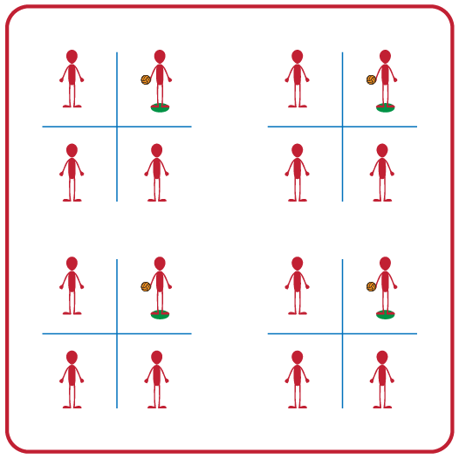
Equipment:
- 1 foam ball or beach ball per group of 4 students
- 2 Jump ropes per group of 4 students
- 1 Spot marker per group of 4 students
- 1 Volleyball Crossnet (optional)

Set-Up:
- Divide students into groups of 4.
- Use 2 Jump Ropes to create a grid of 4 squares (or a Volleyball Crossnet)
- Assign one student to each square.
- Designate one square as the server square and place a spot marker in that square.
- Student in designated server square will begin with the ball.

ACTIVITY PROCEDURES
- This activity is called Volleyball Foursquare. The object of the game is to successfully bump or set the ball into one of your opponent's squares.
- On the start signal, the server will begin the game by underhand tossing the ball to another player who will forearm pass (bump) or overhead pass (set) the ball to another square. Each player gets one attempt to pass the ball to another player without the ball hitting the ground. Play continues as long as the ball is passed in the air from square to square without hitting the ground. If a ball lands on one of the ropes you will replay the point.
- When a score occurs (the ball hits the ground) all players rotate clockwise and the new server begins a new round.
- Teachers: If you have groups with more than 4 students, you can have a student waiting to rotate into the game act as the official until they enter the game.

GRADE LEVEL PROGRESSION
- Grade 6: Play as described above.
- Grade 7: Students must alternate between a bump or a set for each hit.
- Grade 8: Utilize a Crossnet (or modified net that is raised off the ground) vs. the jump ropes on the ground.

TEACHING CUES
- Cue 1: Be in ready position at all times when the ball is in play.
- Cue 2: Remember the power comes from your legs not your arms.
- Cue 3: Get under the ball when it comes into your square.

VOLLEYBALL FOUR SQUARE (continued…)

UNIVERSAL DESIGN ADAPTATIONS
- UDL 1: Increase/decrease the size of the court as needed.
- UDL 2: Allow the game to be played seated vs standing.
- UDL 3: Use modified equipment as needed (e.g., balloon or beach ball with a bell attached).
- UDL 4: Use verbal cues and visual aids along with demonstrations.
- UDL 5: Use peer partners as appropriate.

ACADEMIC LANGUAGE
Bump, Set, Control, Force

PRIORITY OUTCOMES
Etiquette:
- (Grade 6) Identifies the rules and etiquette for physical activities/games and dance activities.
- (Grade 7) Demonstrates knowledge of rules and etiquette by self-officiating modified physical activities/games or following parameters to perform, create, or modify a dance.
- (Grade 8) Applies rules and etiquette by acting as an official for modified physical activities/games or creating dance routines within a given set of parameters.

DEBRIEF QUESTIONS
- DOK 1: Can you remember the cues for forearm (bump) and overhead (set) passing?
- DOK 2: Which of the passing cues affect accuracy the most?
- DOK 3: How is being actively engaged related to accuracy and performance during a 4-Square game?

PEER COACHING

STUDENT TARGETS
- Skill: I will overhead pass (set) with accuracy.
- Cognitive: I will write and verbally communicate corrective feedback to my partner using positive language.
- Fitness: I will actively engage and work to improve my underhand serving.
- Personal & Social Responsibility: I will use positive language when giving feedback and appropriate responses when receiving feedback.

EQUIPMENT & SET-UP | 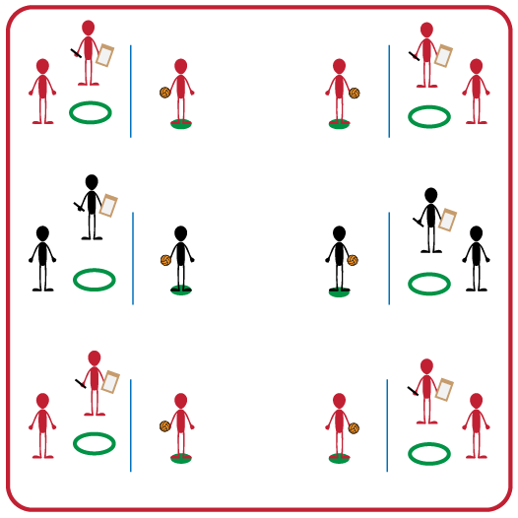
Equipment:
- Volleyball (1 per group)
- Net (1 per group)
- Hula Hoop (1 per group)
- Spot Marker (1 per group)
- Clipboard (1 per group)
- Pencil (1 per group)
- Peer Coaching Feedback Form (1 per group)
Set-Up:
- Divide students into groups of 3.
- Each group will set up their net. There will be a spot maker on one side and a hula hoop on the opposite side.
- Each group will have a clipboard with a Peer Feedback Form and pencil.

ACTIVITY PROCEDURES
- This activity is called Peer Coaching. The object of this activity is to work cooperatively in your group to perform and provide feedback to a peer for the volleyball set. This gives each of you the opportunity to both demonstrate a proper set and apply the cues to provide feedback to classmates.
- Each person in your group will have one of three positions: Tosser, Setter, or Peer Coach.
- On the start signal, the Tosser will underhand toss the ball to the Setter. The Tosser should use a soft toss that finishes above the Setter’s head. The Setter will set the ball back over the net so that it lands in the hula hoop target (repeat this process 5 times). The Peer Coach is observing each of the five set attempts and filling out the feedback form as accurately as possible. Students will rotate until everyone in the group has had a chance to complete all 3 positions.
- On the stop signal you will place the feedback form and ball into the hula hoop so we can discuss our successes and challenges before we play again. During the second round, we will see if your scores can improve by using the feedback you were given.
GRADE LEVEL PROGRESSION
- Grade 6: Play as described above.
- Grade 7: Tosser will toss the ball so that it is a foot or two in front of the setter to force them to move to the ball before setting it over the net.
- Grade 8: Students must analyze results and feedback in order to set a GREAT goal on how they can improve their setting skills.
TEACHING CUES
- Cue 1: Use positive language with your classmates when giving feedback.
- Cue 2: Position yourself under the ball with knees bent.
- Cue 3: Make a triangle with pointer fingers/thumbs near forehead, then extend arms to push ball up.
PEER COACHING (continued…)

UNIVERSAL DESIGN ADAPTATIONS
- UDL 1: Increase/decrease the distance from hoop to spot marker as needed.
- UDL 2: Use modified equipment as needed (e.g., foam ball, balloon or beach ball with bell attached).
- UDL 3: Use verbal cues and visual aids along with demonstrations.
- UDL 4: Use peer partners as appropriate.
- UDL 5: Modify Peer Feedback Form to meet needs of all students, including use of assistive technology or ability to dictate feedback vs. writing it down.

ACADEMIC LANGUAGE
Cues, Feedback, Positive Language, Goal

PRIORITY OUTCOMES
Accepting Feedback:
- (Grade 6) Demonstrates self-responsibility by implementing specific corrective feedback to improve performance.
- (Grade 7) Provides corrective feedback to a peer, using teacher-generated guidelines, and incorporating appropriate tone, and other communication skills.
- (Grade 8) Provides encouragement and feedback to peers without prompting from the teacher.

Social Interaction:
- (Grade 6) Demonstrates respect for self and others in activities and games by following the rules, encouraging others, and playing within the spirit of the game or activity.
- (Grade 7) Demonstrates the importance of social interaction by helping and encouraging others, avoiding trash talk, and providing support to classmates.
- (Grade 8) Demonstrates respect for self by asking for help and helping others in various physical activities.

DEBRIEF QUESTIONS
- DOK 1: How can you recognize corrective feedback?
- DOK 2: How is positive language related to corrective feedback?
- DOK 3: How would you compare and contrast corrective feedback and negative criticism?

PASS, SET, HIT RALLY

STUDENT TARGETS
- Skill: I will work with my partner to score points for our team during this activity.
- Cognitive: I will discuss strategies that helped my team be successful.
- Fitness: I will stay actively engaged throughout each game in order to increase my heart rate.
- Personal & Social Responsibility: I will show integrity by playing fair and communicating using positive language.

EQUIPMENT & SET-UP | 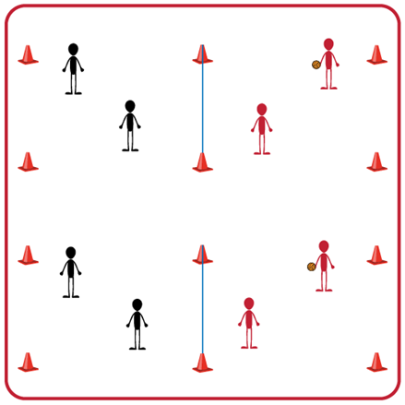
Equipment:
- 1 volleyball, volleyball trainer, or foam ball per group of two teams (Teachers: allow student choice of equipment when possible)
- 1 net per two teams
- 4 boundary cones per two teams

Set-Up:
- Divide students into teams of 2.
- Pair each team of 2 with another team (for a group of 4).
- Divide the space for each group into equal areas using a volleyball net or elevated line. Use 4 boundary cones for each group’s activity area.

ACTIVITY PROCEDURES
- This activity is called Pass, Set, Hit Rally. The object of the game is to work together with your teammate to score points on the opposing team. You do that by keeping the ball from hitting the ground on your side of the net and hitting the ball onto your opponent's side of the net.
- On the start signal the serving team will underhand serve the ball over the net and play begins. Players can use bumps, sets, and overhead hits (spikes) to rally with the other team. Your team will work together to hit the ball over the net to the other team before it hits the ground on your side. You and your teammate can hit the ball a maximum of 3 times on your side before it must go over the net.
- If the ball hits the ground on your opponent's side your team gets a point. If a team hits the ball out of bounds the opponent gets the point.
- On the stop signal, place the ball on the ground. We will rotate the teams every 5 minutes to give everyone a variety of opponents. The team who has the ball when you hear the stop signal will stay, and the other team will rotate to another court.
GRADE LEVEL PROGRESSION
- Grade 6: Play activity as described above. Allow for a throw to begin the game if needed.
- Grade 7: Students must utilize at least 2 different types of passes during each rally.
- Grade 8: Students must use a bump, set, and overhead hit (spike) each series of their rally or point is awarded to opponents.
TEACHING CUES
- Cue 1: Body in Ready Position (knees bent, head up, feet shoulders width apart, hands ready).
- Cue 2: Move feet to get under the ball so you can prevent it from hitting the ground on your side of the net.
- Cue 3: Stay attentive, communicate, and work together with your teammate(s).

PASS, SET, HIT RALLY (continued…)

UNIVERSAL DESIGN ADAPTATIONS
- UDL 1: Increase/decrease the size of activity space/court.
- UDL 2: Use modified equipment as needed (e.g., foam ball, balloon or beach ball with bell attached).
- UDL 3: Use verbal cues and visual aids along with demonstrations.
- UDL 4: Use peer partners as appropriate.

ACADEMIC LANGUAGE
Volley, Rally, Technique, Spike, Spirit of the Game

PRIORITY OUTCOMES
Manipulative Skills:
- (Grade 6-8) Refines manipulative skills to improve performance in dance, fitness, and sport activities.

Working with Others:
- (Grade 6) Accepts differences among classmates in physical development, maturation, and varying skill levels by providing encouragement and positive feedback.
- (Grade 7) Demonstrates cooperation skills by establishing rules and guidelines for resolving conflicts.
- (Grade 8) Responds appropriately to participants’ ethical and unethical behavior during physical activity by using rules and guidelines for resolving conflicts.

DEBRIEF QUESTIONS
- DOK 1: How would you describe the spirit of the game to a new student in our school?
- DOK 2: What do you know about the spirit of the game? (Think beyond the definition.)
- DOK 3: How would you describe a game played with the spirit of the game? How would you describe a game played without it?

- DOK 1: Can you define the word “strategy”?
- DOK 2: What do you know about volleyball offensive strategies? What about defensive strategies?

ROYAL COURT POINTS ROTATION

STUDENT TARGETS
- Skill: I will demonstrate a variety of volleyball skills during small-sided games.
- Cognitive: I will discuss the importance of integrity with respect to enjoyment of play.
- Fitness: I will demonstrate a variety of skill-related fitness components.
- Personal & Social Responsibility: I will demonstrate respect for myself and my classmates by following the rules of the game and encouraging others.

EQUIPMENT & SET-UP | 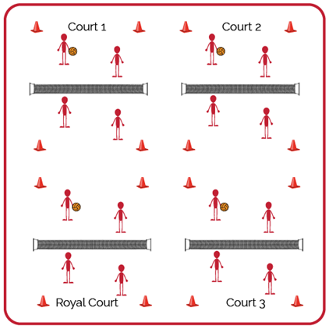
Equipment:
- 1 volleyball per group of 4 students (doubles)
- 1 net per court (or cones/jump ropes if needed)

Set-Up:
- Create enough courts so the entire class can play doubles matches.
- Number each court, with court 1 as the starting court and the highest number court as the “Royal Court.”
- Create teams for doubles and send students to courts. If you have more teams than courts, you can have a team waiting to rotate into a court.

ACTIVITY PROCEDURES
- Today’s activity is called Royal Court Points Rotation. This tournament will be a way to test our skills and have fun with our friends.
- The goal of today’s tournament is to compete with a positive attitude and to work your way to the Royal Court, while your team accumulates as many points as possible. We’ll play 3-minute games. The winner of each game will earn 1 point and move to a higher court. The losing team or player will move down to a lower court and will not earn any points for that round.
- On the start signal, you will play an opposing team for 3 minutes. The winner will move up 1 court toward the Royal Court. The winner on the Royal Court will stay and defend her/his position. The team that loses the match will move 1 court away from the Royal Court. The team that loses on court 1 will stay and try again. If the score is tied on any court when the 3-minute time expires, play Rock, Paper, Scissors to determine the winner.
- We will continue to play until time runs out. The team who earned the most points and ended on the Royal Court will be the winners!

GRADE LEVEL PROGRESSION
- Grade 6: Pair students of similar skill levels and skip the royal court rotation. Instead, rotate students with a focus on setting them up for challenge, success, and fun.
- Grade 7: Play as described above.
- Grade 8: Play as described above.

ROYAL COURT POINTS ROTATION (continued…)

TEACHING CUES
- Cue 1: Apply the volleyball skill cues we have focused on.
- Cue 2: Help and encourage others by demonstrating sportsmanship.
- Cue 3: Play with purpose but have fun!

UNIVERSAL DESIGN ADAPTATIONS
- UDL 1: Increase/decrease the size of activity space/court.
- UDL 2: Use modified equipment as needed (e.g., foam ball, balloon or beach ball with bell attached).
- UDL 3: Use verbal cues and visual aids along with demonstrations.
- UDL 4: Use peer partners as appropriate.

ACADEMIC LANGUAGE
Rotation, Serve, Teamwork, Integrity

PRIORITY OUTCOMES
Manipulative Skills:
- (Grade 6-8) Refines manipulative skills to improve performance in dance, fitness, and sport activities.

Etiquette:
- (Grade 6) Identifies the rules and etiquette for physical activities/games and dance activities.
- (Grade 7) Demonstrates knowledge of rules and etiquette by self-officiating modified physical activities/games or following parameters to perform, create, or modify a dance.
- (Grade 8) Applies rules and etiquette by acting as an official for modified physical activities/games or creating dance routines within a given set of parameters.

DEBRIEF QUESTIONS
- DOK 1: What is integrity?
- DOK 2: Why is integrity important in physical activity or competitive settings?
- DOK 3: How is integrity related to the enjoyment of everyone playing a game of Volleyball?

