SET BALL

STUDENT TARGETS
- Skill: I will perform a volleyball set demonstrating control and accuracy.
- Cognitive: I will discuss the cues for a volleyball set.
- Fitness: I will remain actively engaged throughout the activity.
- Personal & Social Responsibility: I will use respectful and positive language with my classmates.

EQUIPMENT & SET-UP | 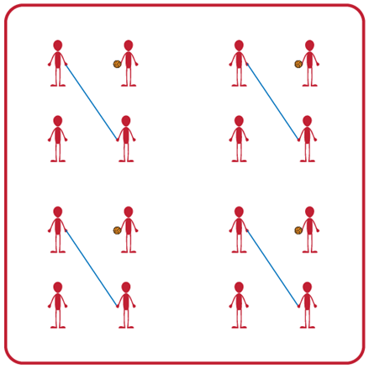
Equipment:
- 1 volleyball, volleyball trainer, or foam ball per group (Teachers: allow student choice of equipment when possible)
- 1 jump rope per group

Set-Up:
- Divide students into teams of 4.
- Two players begin by holding the jump rope to make a net for their team.
- Other two players begin on opposite sides of the net facing each other, with one student holding the foam ball and ready to serve after hearing the start signal.

ACTIVITY PROCEDURES
- This activity is called Set Ball. The object of the game is to set the ball over the net as many times in a row as you can. You do that by working together as a team to set the ball back and forth over the net (which is a jump rope held by two players).
- On the start signal, the player with the ball will begin with a self-toss, and then set the ball over the net. The two volleying players will continue setting the ball back and forth as many times in a row as they can. But each person can only hit the ball a max of three times on their side before it must go over the net.
- The two players holding the net can help the two volleying players be successful by moving their feet or altering the height of the net. The net holders and the volleying players will work together to achieve the highest possible team score! Any time the ball hits the ground or is hit more than three times on one side, the players will each rotate clockwise one spot (e.g., rope holders and volleying players get a new partner each time they switch roles).
- On the stop signal players will place the jump rope and the ball down on the ground. The two players who were holding the jump rope when you heard the stop signal will move to a new group before we play again.
- Teachers: If you have uneven numbers, create a rotation where the fifth player in the group acts as the line judge until they rotate into the game.

GRADE LEVEL PROGRESSION
- Grade 6: Play as described above.
- Grade 7: Students may only contact the ball twice on their side before it goes over the net.
- Grade 8: Students choose to have a cooperative or more competitive focus for their group. Groups can choose to work cooperatively and go for the longest rally or choose to play competitively 1v1 to score individual points.
SET BALL (continued…)

TEACHING CUES
- Cue 1: Body Position: knees bent, head up, feet shoulders width apart, hands ready, facing partner.
- Cue 2: Move feet to get under the ball so you can get the ball back to your partner for a longer rally.
- Cue 3: Net holders need to stay attentive & work together so they can move where needed during the rally.

UNIVERSAL DESIGN ADAPTATIONS
- UDL 1: Increase/decrease the size of activity space.
- UDL 2: Allow students to participate while sitting down if needed.
- UDL 3: Use modified equipment as needed (e.g., beeper ball, balloon, beach ball).
- UDL 4: Use verbal cues and visual aids along with demonstrations.
- UDL 5: Use peer partners as appropriate.

ACADEMIC LANGUAGE
Set, Volley, Communication, Body Position, Cooperation, Spirit of the Game

PRIORITY OUTCOMES
Working with Others:
- (Grade 6) Accepts differences among classmates in physical development, maturation, and varying skill levels by providing encouragement and positive feedback.
- (Grade 7) Demonstrates cooperation skills by establishing rules and guidelines for resolving conflicts.
- (Grade 8) Responds appropriately to participants’ ethical and unethical behavior during physical activity by using rules and guidelines for resolving conflicts.

DEBRIEF QUESTIONS
- DOK 1: Was there a communication strategy that your team used during this activity?
- DOK 2: Sometimes we use a strategy during a game or activity, and it doesn’t work well. Was there a communication strategy that you tried during this game that didn’t work very well? What did you do differently if you realized a communication strategy wasn’t working for your team?

