HULA HOOP VOLLEYBALL

STUDENT TARGETS
- Skill: I will demonstrate correct technique for volleyball passes.
- Cognitive: I will discuss the cues for a volleyball bump and set.
- Fitness: I will remain actively engaged throughout the activity.
- Personal & Social Responsibility: I will use encouraging language with my classmates.

EQUIPMENT & SET-UP | 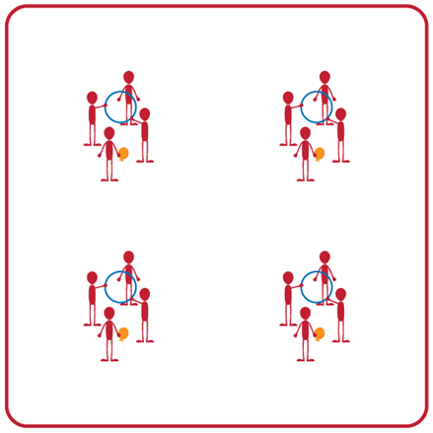
Equipment:
- 1 hula hoop per group
- 1 beach ball or balloon per group

Set-Up:
- Divide students into groups of 4. Each group will begin with one hula hoop and one beach ball or balloon.
- Two students will be the hula hoop holders. The remaining 2 students will stand on opposite sides of the hula hoop facing each other (the hoop will be held vertically between them). One student will begin with either a beach ball or a balloon.

ACTIVITY PROCEDURES
- This activity is called Hula Hoop Volleyball. The object of the game is to continuously pass the beach ball (or balloon) through the hula hoop with your partners.
- On the start signal, the student with the beach ball (or balloon) will toss the ball through the hoop to begin the rally. Students will begin passing the beach ball (or balloon) back and forth through the hoop using either a bump or a set. You will determine the type of pass to use (bump or set) based on where the ball is when it comes through the hoop. Teammates holding the hula hoop can move and adjust the hoop to help the partners successfully pass as many times in a row as possible!
- Students are allowed a maximum of three hits to return the beach ball (or balloon) through the hoop. If it hits the ground or is not returned through the hoop in three tries, student will alternate positions with one of the hoop holders.
- On the stop signal the students holding the hula hoop will place their hoop on the ground and find a new group to play again.

GRADE LEVEL PROGRESSION
- Grade 6: Play as described above.
- Grade 7: Students holding the hula hoop cannot move their feet or the hula hoop.
- Grade 8: Divide students into groups of 6. Have students play doubles and both partners must hit the ball before it goes through the hoop (with a maximum of 3 hits as a team).

TEACHING CUES
- Cue 1: Use the cue charts to review correct technique for the bump and set.
- Cue 2: Move feet to get under the ball so you can pass back to your partner for a longer rally.
- Cue 3: Hoop holders need to stay attentive & work together so they can move where needed during the rally.
HULA HOOP VOLLEYBALL (continued…)

UNIVERSAL DESIGN ADAPTATIONS
- UDL 1: Increase/decrease the size of activity space.
- UDL 2: Allow students to participate seated vs. standing if needed.
- UDL 3: Use modified equipment as needed (e.g., balloon or beach ball with a bell attached).
- UDL 4: Use verbal cues and visual aids along with demonstrations.
- UDL 5: Use peer partners as appropriate.

ACADEMIC LANGUAGE
Bump, Set, Teamwork, Rally, Communication

PRIORITY OUTCOMES
Working with Others:
- (Grade 6) Accepts differences among classmates in physical development, maturation, and varying skill levels by providing encouragement and positive feedback.
- (Grade 7) Demonstrates cooperation skills by establishing rules and guidelines for resolving conflicts.
- (Grade 8) Responds appropriately to participants’ ethical and unethical behavior during physical activity by using rules and guidelines for resolving conflicts.

Social Interaction:
- (Grade 6) Demonstrates respect for self and others in activities and games by following the rules, encouraging others, and playing within the spirit of the game or activity.
- (Grade 7) Demonstrates the importance of social interaction by helping and encouraging others, avoiding trash talk, and providing support to classmates.
- (Grade 8) Demonstrates respect for self by asking for help and helping others in various physical activities.

DEBRIEF QUESTIONS
- DOK 1: What would you include on a list of movement concepts related to this activity?
- DOK 2: How did you apply those movement concepts when deciding to pass with a bump or a set?
- DOK 3: How could you adapt this activity to make it more challenging? To make it less challenging?

