SIT & SET

STUDENT TARGETS
- Skill: I will set the volleyball over the net demonstrating control and accuracy.
- Cognitive: I will state the teaching cues for a volleyball set.
- Fitness: I will stay actively engaged in the activity for the duration of the class.
- Personal & Social Responsibility: I will show respect for all classmates and equipment during this activity.

EQUIPMENT & SET-UP | 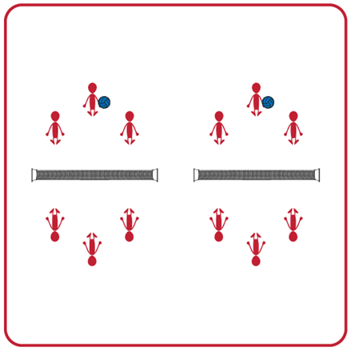
Equipment:
- 1 Featherlite Volleyball per group
- 1 net (modified net approximately waist high of a standing student) per group
- 4 boundary cones per group

Set-Up:
- Divide students into equal teams (e.g., 2v2 or 3v3).
- Two equal teams will play against one another. Divide the space for each set of two teams into equal areas with a net in the middle and 4 cones to set the boundaries.
- Students will all begin sitting, with the teams facing each other on opposite sides of the net in their activity space.
ACTIVITY PROCEDURES
- This activity is called Sit & Set. The object of the activity is to work with your teammates on the accuracy and technique of your overhead pass (set). Practicing your set while sitting allows you to focus on your arm position and technique.
- On the start signal, the student with the volleyball for their group will underhand toss the ball to their teammate. You are trying to get the ball high enough for your teammate to catch above their head in order to successfully set it over the net to the other team.
- The receiving team will catch the ball once it goes over the net. They will repeat the process of underhand tossing the volleyball to a teammate for them to set it back over the net.
- Each team gets one toss and one set to successfully get the volleyball over the net. Your team gets one point for each successful set that goes over the net and is inside the boundary cones.
- On the stop signal, the team who has the volleyball will stay and the opposing team will move and find a new group before we play again.

GRADE LEVEL PROGRESSION
- Grade 6: Play as described above.
- Grade 7: Have teams receive and set the volleyball back over the net without catching it first.
- Grade 8: Have two groups of teams join together (there will now be a total of 4 equal teams in a group). Create a grid of 4 activity spaces with the nets (similar to 4-square) for the activity.

TEACHING CUES
- Cue 1: Create a triangle with your pointer fingers and thumbs near your forehead before each set.
- Cue 2: Extend your arms and push the ball up as you set.
- Cue 3: Remember to toss the ball high enough that your teammate will be under it and can get their arms into position before the set.
SIT AND SET (continued…)

UNIVERSAL DESIGN ADAPTATIONS
- UDL 1: Increase/decrease the size of target/activity space
- UDL 2: Use modified equipment as needed (e.g., balloon or beach ball with a bell attached).
- UDL 3: Use verbal cues and visual aids along with demonstrations.
- UDL 4: Use peer partners as appropriate.

ACADEMIC LANGUAGE
Set, Follow through, Accuracy, Teamwork, Growth Mindset

PRIORITY OUTCOMES
Personal Challenge:
- (Grade 6) Recognizes individual challenges and copes in a positive way, such as extending effort, asking for help/feedback, and/or modifying the tasks.
- (Grade 7) Generates positive strategies such as offering suggestions/assistance, leading/following others, and/or providing possible solutions when faced with a group challenge.
- (Grade 8) Develops a plan of action and makes appropriate decisions based on that plan when faced with a challenge.

DEBRIEF QUESTIONS
Growth Mindset Question Set:
- DOK 1: What is a challenge? Can you give examples of a challenge that someone might face?
- DOK 2: How would you apply growth mindset to facing a challenge?
- DOK 3: Describe what someone might learn from facing a difficult challenge.

Teamwork Question Set:
- DOK 1: How did you demonstrate teamwork when you faced today’s challenge?
- DOK 2: How would you summarize your entire team’s performance today?
- DOK 3: How was teamwork related to that performance?

